A New Dual Output DC-DC Converter with Enhancing Output Voltage Level
Jafar Marjani  Department of Electrical Engineering  Shahid Beheshti University  Tehran, Iran  jafarmarjanipe@yahoo.com | Amir Imani  Department of Electrical Engineering  Shahid Beheshti University  Tehran, Iran  Amir.imani19@gmail.com | E. Afjei  Department of Electrical Engineering  Shahid Beheshti University  Tehran, Iran  Afjei@yahoo.com | - Hekmati  Department of Electrical Engineering  Shahid Beheshti University  Tehran, Iran  A_hekmati@sbu.ac.ir

Abstract—In this paper, a new dual output DC-DC converter is proposed. This topology is achieved from another dual output dc-dc converter with a little change. Conventional dual output converters provide two same level voltages in the outputs; but this topology provide two different voltage levels. In this topology, one of the output voltage gain has a considerable increment. This topology, uses two switches to perform the power conversion, without employing any transformers. The proposed topology can be used instead of two single output power supplies. Steady state analysis is described in details and finally simulation result in MATLAB Simulink environment for verification the theoretical analysis is proposed.

Keywords—Dual output DC-DC converters; Voltage gain lifting; steady state analysis; voltage stress;

- introduction
Nowadays non isolated dc-dc converters are used in many applications, such as hand held portable devices, hybrid energy systems, hybrid vehicles, etc. . In a family of multi-output dc-dc converter with single inductor has been proposed. In this family, the second or other outputs, are created from additional paths, provided by switches and diodes to output capacitors. Actually, the basic output voltage is shared. Two multi-output dc-dc boost and buck/boost converters are proposed in . In addition, in these topologies, the output voltage levels are decreased too. In a multi-input single output converter is proposed according to the combination of a boost converter and several buck-boost converters. This MISO topology can increase voltage gain. An integrated single input multi output converter is introduced in which able to have a boost and multi buck outputs. In the structure of this converter, instead of single switch of conventional boost converter, several seri switches are applied, also the topology is extended by means of adding LC filters. Besides, the drawbacks of aforementioned topology are switches duty cycle regulation and voltage level restriction .In a dual output buck-boost converter with positive and negative output voltages fed by sin-
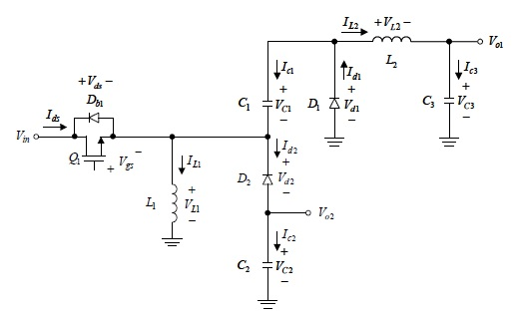
Figure 1. Dual output using same gain voltage

-gle positive voltage source is proposed. Fig.1 displays the structure of this topology. The proposed converter has provided two same voltage level with different polarity and has employed just single switch to provide the outputs. In this
paper a new dual output dc-dc converter is derived with a little change on the aforementioned structures. As shown in Fig.2 this topology is obtained by adding a switch and a diode to initial structure. The voltage gain in first output has a considerable rise. Operating principles of this topology is described in details in next section. Eventually, simulation results are given to verify theoretical analysis.

proposed converter topology

Fig.2 displays the proposed dual output DC DC converter. As seen in Fig.2 the structure of proposed converter consists of two switches S and S₁, two inductors L₁ and L , three capacitors C , C₁ and C₂ , three diodes D , D₁ and D₂ .
Figure 2. Proposed dual output DC-DC converter

Converter structure and operation principles
As previously mentioned, in [7] a dual output buck-boost converter is presented. The proposed converter is a single input dual output converter (SIDO) providing two different polarities and same voltage level in the outputs. On the other hand, in this structure applying just single diode and one switch synchronized with previous one could be applicable. Since the proposed converter has two synchronous switches, the circuit will have just two sub circuits. The switching strategy is shown in Fig.3.

Figure 3. Switching strategy of proposed DC-DC converter

Regarding to this switching strategy, Fig.4 illustrated two sub circuits of this topology. Also, the current flow paths in each sub circuit is shown in Fig.4. For discovering the steady state equations of this topology both sub circuits are discussed as follows:

Switching state 1(0<t<DT)
In this state both switches are ON, consequently diodes are OFF. Since switch S is ON, input source feeds the circuit. Inductor L is charged by input source and inductor L₁ charged by input source, capacitors C and C₂, whereas capacitors in the circuit are discharging. In this state inductor current increases. Equivalent circuit of proposed converter in this state is shown in Fig.4. Steady state equations in this mode are as follows:

Figure 4. Current flow paths of equivalent circuit in switching state 1

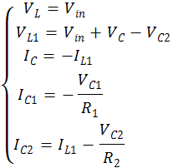 | (1)

Switching state 2(DT<t<T)
In this state both switches are turned OFF. Because of continuous current in inductors, diodes are turned on. Fig.5 shows equivalent circuit for this mode. In this state inductors are discharged and transfer their stored energy to load resistance and capacitors. As seen in Fig.5 in this state the capacitors C and C₂ has become parallel. So no equation has been written for current values determination, while the current direction is specified. As the consequence. In the next part the capacitors current equations will be presented. Steady-state equations of this sub circuit will be as follows:
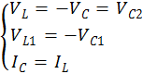 | (2)

Figure 5. Current flow paths of equivalent circuit in switching state 2

Discovering steady-state equations
The steady state equations of the proposed converter are obtained using volt-second and ampere-second laws using equations (1) and (2). So the steady state analyses are given as follows:
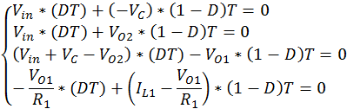 | (3)

After simplification of above equations we can obtain:
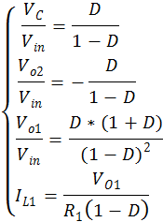 | (4)

On the other hand, the equations of C and C₂ applying ampere-second law are as follows:
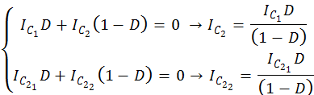 | (5)

In the above equation and are the currents of C in the state 1 and state 2. In addition 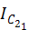 and 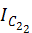 denote the current of C₂ in state 1 and state 2, respectively.
Regarding to the above equation and are undefined. These two capacitor currents of sub circuit 2 are obtained by substituting (1) in (5). The results of these substitution are as follows:
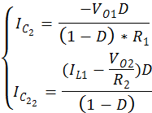 | (6)

In this analysis all the elements considered ideal. Therefore, input power equals output power. So we can write:

Figure 6. Voltage stress calculation using Kirchhoff Law in determined paths

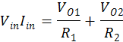 | (7)

Hence, the average input current is calculated as follow:

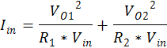 | (8)

Then we can obtain:

(9)

As the result, the current of inductor L equals:

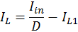 | (10)

Calculating switches voltage stress

Now by applying the Kirchhoff voltage loop law on the determined paths of Fig 5, the voltage stress on the switches and diodes is obtained. The switches voltage stress is calculated when the diodes are ON and vice versa. As the switches and diodes are ideal, consequently their voltage drop equals zero while they are ON. So voltage stress of switches S and S₁ equal to the diodes D, D₂ and D₁ respectively.

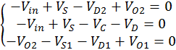 | (11)

From (4) and (11) the switches voltage stress is obtained depending on the input voltage of the converter:

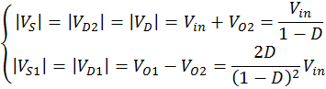 | (12)

simulation results

The proposed dual output converter topology in both modes of switches operation has been investigated completely. In this section the proposed converter has been validated through simulation in MATLAB Simulink environment. Simulation study has been carried out for input source V_{in}=12v to provide the 35 and 250 watt loads. The used parameters value of the converter are shown in TABLE.1. The switches are IGBT/Diode with constant switching frequency of 100 kHz have been considered. In addition, Output current has been considered 1 ampere. Regarding to the output voltage level and steady state equations the duty cycles of switches are taken as D=0.75. The switches gate-source voltage waveform, inductors voltage and current and capacitors current shown in Fig.8. Also the output voltage waveforms displayed in Fig.9.The simulation results verify the analytical analysis of the converter.
- parameters value of simulation
Parameters | values
L | 160mH
L₁ | 160mH
C | 470µF
C₁ | 220 µF
C₂ | 220 µF

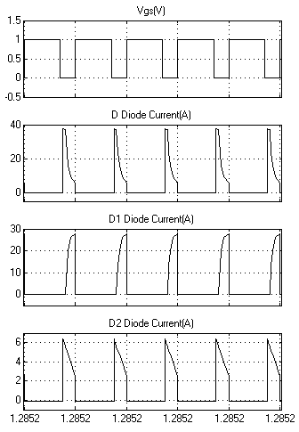
Figure 7.Gate-source voltage of synchronous switches and diodes current obtained of simulation result

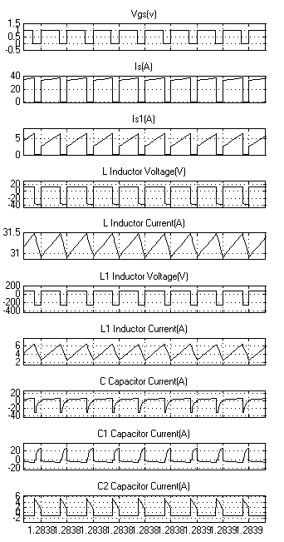
Figure 8. The inductors voltage and current and capacitors current waveforms obtained of simulation results

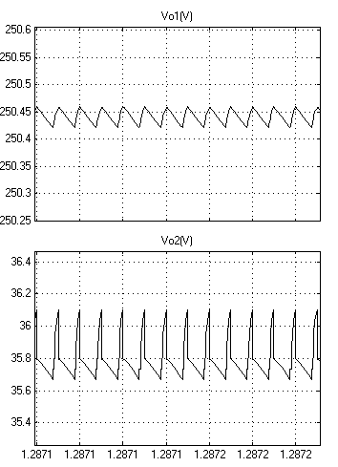
Figure 9. The outputs voltage waveform obtained of simulation result

conclusion

In this paper a new dual output DC-DC converter has been proposed. One of the remarkable advantage of this topology is the ability of having negative and positive output voltage. Furthermore this structure has considerable voltage gain rather than the conventional dual output converters. The switching strategy has been investigated in two different modes according to the volt-second and ampere-second laws. Besides, the voltage stress of switches have been calculated to ensure the feasibility of proposed converter. The proposed converter has been satisfactorily validated through computer simulation in MATLAB Simulink environment.

REFERANCES
[1] Z. Rehman, I. Al-Bahadly, and S. Mukhopadhyay, "Multiinput DC–DC converters in renewable energy applications–An overview," Renewable and Sustainable Energy Reviews, vol. 41, pp. 521-539, 2015.
[2] R.-L. Lin, C.-R. Pan, and K.-H. Liu, "Family of single-inductor multi-output DC-DC converters," in Power Electronics and Drive Systems, 2009. PEDS 2009. International Conference on, 2009, pp. 1216-1221.
[3] A. Nami, F. Zare, A. Ghosh, and F. Blaabjerg, "Multi-output DC–DC converters based on diode-clamped converters configuration: topology and control strategy," IET power electronics, vol. 3, pp. 197-208, 2010.
[4] A. A. Boora, F. Zare, and A. Ghosh, "Multi-output buck–boost converter with enhanced dynamic response to load and input voltage changes," IET power electronics, vol. 4, pp. 194-208, 2011.
[5] M. R. Banaei, H. Ardi, R. Alizadeh, and A. Farakhor, "Non-isolated multi-input–single-output DC/DC converter for photovoltaic power generation systems," IET Power Electronics, vol. 7, pp. 2806-2816, 2014.
[6] O. Ray, A. P. Josyula, S. Mishra, and A. Joshi, "Integrated dual-output converter," Industrial Electronics, IEEE Transactions on, vol. 62, pp. 371-382, 2015.
[7] K. Hwu, Y. Yau, and J.-J. Shieh, "Dual-output buck-boost converter with positive and negative output voltages under single positive voltage source fed," in Power Electronics Conference (IPEC), 2010 International, 2010, pp. 420-423.

