SWSiNTs: DOS variations due to mechanical deformations

Mehdi Pakkhesal
Student of Ph.D.
Department of Electrical Engineering
Ferdowsi University
Mashhad, Iran
Email: pakkhesal_mahdi@yahoo.com

2nd Author
Position
Department
University
City, Country, Zip code
Email: email address

Seyed Ebrahim Hosseini
Associate Professor of Electrical Engineering
Department of Electrical Engineering
Ferdowsi University
Mashhad, Iran
Email: ehosseini@um.ac.ir

Abstract— In this paper we investigate the density of states of hexagonal silicon nanotubes. We use tight binding model to calculate density of states (DOS), and investigate the effects of two types of mechanical deformations, namely uniaxial and torsional strains on the DOS of Single Walled Silicon Nanotubes (SWSiNTs). It is shown that uniaxial and torsional strains in some cases cause the DOS near the band gap to increase, in some other ones to decrease and in some certain cases does not change the DOS near the band edge.
Keywords-Silicon nanotube; density of states; tight binding; strain

Introduction
Silicon is the most important material in developing electronic devices and silicon crystal has been used as the basic material of the electronic transistors. From a chemical point of view silicon forms four covalent σ bonds in tetragonal coordination (sp³ hybridization) and typically crystallizes in a diamond-like structure. It is theoretically shown that silicon can either be crystalized in other different forms e.g. nanotubes [1-5]. It is also synthetized by different methods e.g. chemical vapor deposition (CVD) [6] or growth of the tubes by molecular beam epitaxy on porous alumina [7]. The growth of silicon nanotubes (SiNTs) from silicon mono oxide using the method of self-assembling is also reported [8]. SiNTs exist in different forms with sp³ or sp² hybridizations. Either purely made of silicon or hydrogen-terminated [9,10]. Among the pure SiNT structures there are two types that are more important than others, namely, hexagonal nanotubes (h-NTs) and gear-like nanotubes (g-NTs). The first type is theoretically made of a Silicene (silicone sheet) that is rolled over into a cylinder so that the beginning and the end of a vector called “lattice vector” touch each other. In such a structure, the silicon atoms are bonded by sp² hybridization. The second type (g-NT) is the same of the first type except instead of silicene the sheet of Si (111) is used. The silicon atoms are bonded by sp³ hybridization in this type of SiNTs.
Electronic properties of SiNTs have been discussed by several authors [11,12]. Most of the efforts are concentrated on the band structure [13,14]. In this paper we are to discuss the density of states (DOS) of the hexagonal nanotubes under uniaxial and torsional strains.

Method
As can be seen in Fig. 1 one can write the lattice vector C as , where and are the unit lattice vectors. This vector is along the circumference of the Silicone nanotube (SiNT) and the can be defined as the unit vector in this direction such that . Similarly, is defined as the unit vector along the translational direction (perpendicular to vector C), such that 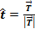. Having vector C at hands, vector T is readily acquired such that . Therefore and we can extract such that . Next, we solve and for and , then we work out the following relations:
(1-a)
(1-b)
(1-c)
From the continuum mechanics we know that:
for uniaxial strain (2-a)
(i = 1,2,3) for torsional strain
(2-b)

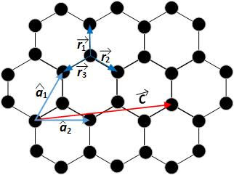
Fig. 1. The silicon sheet of (111) lattice with the vectors a₁, a₂, r₁ , r₂ , r₃ and C are illustrated.

where θ is the angle of shear and σ_{t} is the percent of uniaxial strain. Therefore, replacing (1-a) to (1-c) in (2-a) and (2-b) we have:
(3-a)
(3-b)
where and . Here, r₀ is the silicone-silicone bonding distance and . Equation (1-c) is still valid, but regarding new values of and under strain. Next, we need to extract unit lattice vectors, and , under strain from (6-a) and (6-b). From Fig. 1:
(4-a)
(4-b)
Then we know that in according to tight-binding method we have:
(5-a)
(5-b)
(5-c)
where φ_{Ak} and φ_{Bk} are the two basis functions and and χ(r-R_{A}) and χ(r-R_{B}) are the normalized p_{z} atomic orbital wave functions for atomic sites A and B, respectively. Here, ψ_{k} (r) is the electron wave function in the 2D silicone lattice ((111) sheet). Next, the effect of small percent of uniaxial and a few degrees of torsional strain is given by [13,15]:
(6)
where .
It is well known that, the contribution of a single doubly degenerate 1D band ε(k) to the density of states ,, can be expressed as:
(7)
where l is the length of one dimensional Brillouin zone that is equal to the total area of the first Brillouin zone () divided by the interline spacing that can be worked out from Born-von Karman boundary condition as the following:
(8-a)
or
(8-b)
where q is a natural number. Thus:
(9)
Now, dividing the total area of the first Brillouin zone (), by Δk_{c} yields:
(10)
Noting that:
(11)
Before applying Eq. (7) to Eq. (6), we note that each line in the vicinity of k_{F} (Fig. 2) will have two points at any given energy E(k), and, in addition to these two points two more equivalent points in the vicinity of the point located by -k_{F} will contribute to the DOS at this energy. In all, regarding Eq. (10) and (11), we can then write the DOS per silicone atom, as:
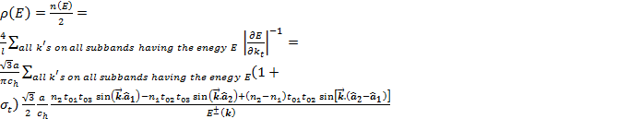 (12)

Application and results
In this section we have simulated DOS per energy per silicon atom for a number of chiral vectors. As is illustrated in Fig. 3 the uniaxial strain is applied in amounts of 0, 1, 2 and 3 percent. In this figure, (5,0) is a semiconductor zig-zag nanotube, (5,5) is a metallic armchair nanotube, (6,0) is a metallic zig-zag nanotube and (7,0) is also a semiconductor zig-zag nanotube and the DOS is illustrated at band edges.

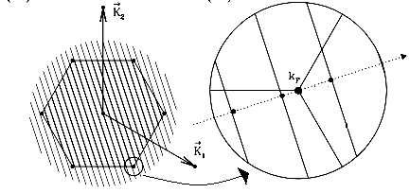

Fig. 2. Hexagonal central Brillouin zone of silicene

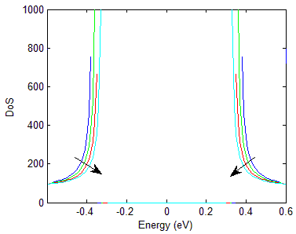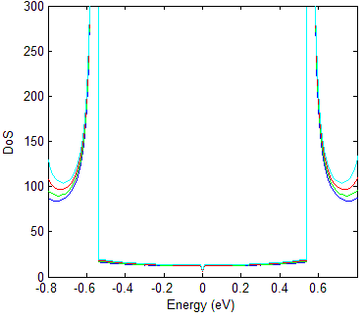
(a) (b)
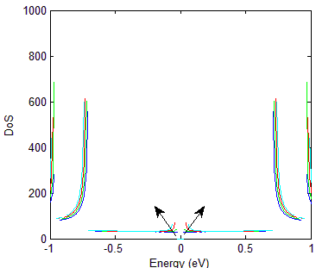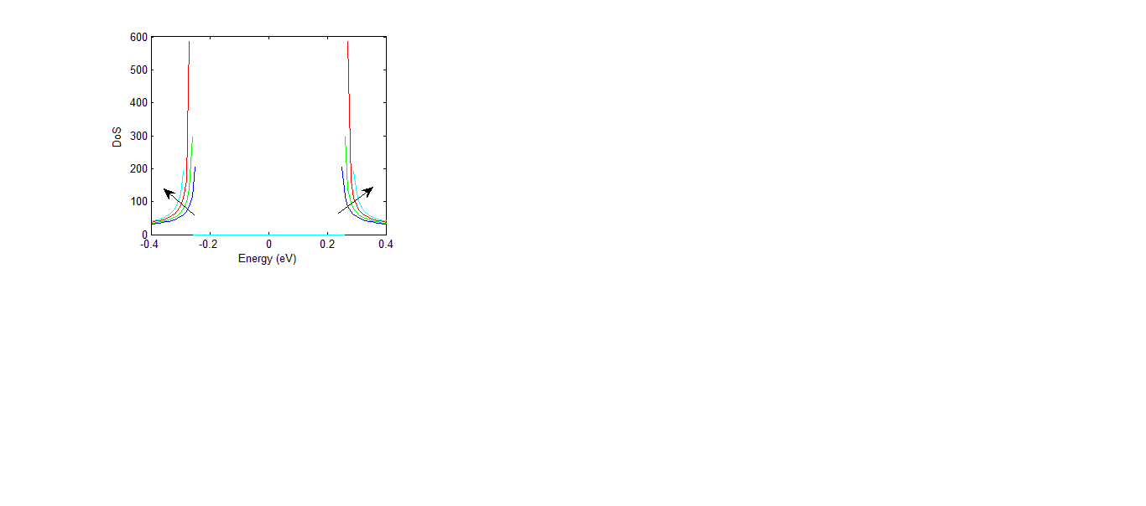
(c) (d)
Fig 3. Density of States (DOS) per energy per silicon atom calculated for a number of chiral vectors for zero (blue), one (green), two (red) and three (cyan) percent of uniaxial strain. The points of discontinuities happened due to the value of infinity due to our calculating software. (a) DOS diagram for (5,0), (b) DOS diagram for (5,5), DOS diagram for (6,0) and DOS diagram for (7,0) chiral vector. The direction of arrows show the direction of the effect of increasing strain on the curves of DOS.

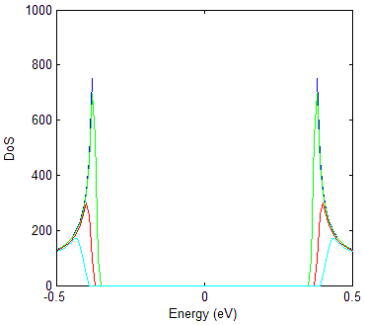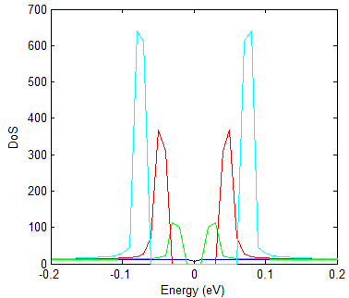
(a) (b)
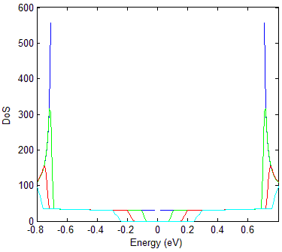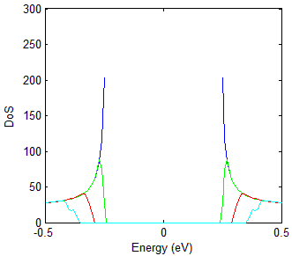
(c) (d)
Fig. 4. Density of States (DOS) per energy per silicon atom calculated for a number of chiral vectors for zero (blue), one (green), two (red) and three (cyan) degrees of shear. The points of discontinuities happened due to the value of infinity due to our calculating software. (a) DOS diagram for (5,0), (b) DOS diagram for (5,5), DOS diagram for (6,0) and DOS diagram for (7,0) chiral vector.

It is worth mentioning that the points of discontinuities correspond to van-Hove singularities.
From the band gap point of view (points of zero DOS around the zero energy), our investigations show that the magnitude of the band gap change for zig-zag cases (for example Fig. 3 (a), (c),(d)) is approximately equal to 3t₀ and for armchair tubes (for example Fig. 3 (b)) the uniaxial strain does not change the band gap which confirms those of reference [13] for SiNTs and reference [15] for CNTs (as similar lattices).
After verifying our results, we examine the figure for the DOS values. Our simulations shows that for the case of uniaxial strain, for semiconductor nanotubes the rule of ”(n1 – n2) mod 3 ” [13,15] not only determines the direction of band gap change but also it simultaneously affects the direction of DOS changes with increasing strain. For example, it can be seen from Fig. 3(a) that the increasing strain causes DOS of (5,0) tube to decrease with increasing strain at band edges while it causes DOS of (7,0) tube to increase with increasing strain at band edges.
For the armchair tubes the application of uniaxial strain causes no changes to the DOS at band edges while it may cause changes at the depth of conduction or valence bands as is shown in Fig. 3(b). In the case of non-armchair metallic nanotubes our investigations show that the application of uniaxial strain not only opens a band gap but the increasing strain causes the DOS at band edges to increase as is illustrated in Fig. 3(c).
Now, we examine Fig. 4 for the DOS values under torsional strain. As can be seen in this figure the application of the torsional strain in some cases widens band gap (Fig. 4(a) and (d)). In these cases the density of states in the same energy near the band edge remains approximately unchanged with application of shear strain (considering that this energy is not located in the band gap!). The points of abrupt changes of DOS again correspond to van-Hove singularities.
In cases of metallic nanotubes, the application of torsional strain causes the opening of band gap as is shown in Fig. 4(b) and (c).

Conclusion
In this article we analytically treated the DOS of SWSiNTs, for uniaxial and torsional strains. We showed that for the case of uniaxial strain in some of special cases DOS increases with increasing uniaxial strain while in some other ones it decreases with increasing uniaxial strain. For the case of torsional strain however, the DOS at a certain energy remains approximately unchanged if it is near the band edge. In the cases of metallic nanotube, whether armchair or not, it opens a bandgap and this band gap widens with increasing values of torsion for small values of shear.

References

- G. Seifert, Th. Kçhler, H. M. Urbassek, E. HernHndez, Th. Frauen- heim, ” Tubular structures of silicon”, Phys. Rev. B, vol 63, pp. 193409, 2001
- S. B. Fagan, R. J. Baierle, R. Mota, A. J. R. da Silva, A. Fazzio, “Ab initio calculations for a hypothetical material: Silicon nanotubes”, Phys. Rev. B, vol. 61, pp. 9994, 2000
- M. Zhang, Y. H. Kan, Q. J. Zang, Z. M. Su, R. S. Wang, Chem. Phys. Lett., “Why silicon nanotubes stably exist in armchair structure?”, vol. 379, pp. 81-86, 2003
- J. Bai, X. C. Zeng, H. Tanaka, J.Y. Zeng, “Metallic single-walled silicon nanotubes”, Proc. Natl. Acad. Sci. USA, vol. 101, pp. 2664-2668, 2004.
- R. Q. Zhang, A.T. Lee, C. K. Law, W. K. Li, B. K. Teo, Chem. Phys. Lett., “Silicon nanotubes: Why not?”, vol. 364, pp. 251-258, 2002.
- J. Sha, J. Niu, X. Ma, J. Xu, X. Zhang, Q. Yang, D. Yang, “Silicon Nanotubes”, Adv. Mater., vol. 14, pp. 1219-1221, 2002.
- S.Y. Jeong, J.Y. Kim, H. D. Yang, B. N. Yoon, S.-H. Choi, H. K. Kang, C.W.Yang, Y. H. Lee, “Synthesis of Silicon Nanotubes on Porous Alumina Using Molecular Beam Epitaxy”, Adv. Mater., vol. 15, pp. 1172-1176, 2003.
- Y.W. Chen, Y. H. Tang, L. Z. Pei, C. Guo, “Self-Assembled Silicon Nanotubes Grown from Silicon Monoxide”, Adv. Mater., vol. 17, pp. 564-567, 2005
- X. B. Yang, J. Ni, “Electronic properties of single-walled silicon nanotubes compared to carbon nanotubes”, Phys. Rev. B, vol. 72, pp. 195426, 2005
- R. Q. Zhang, H. L. Lee, W. Li, B. Teo, “Investigation of Possible Structures of Silicon Nanotubes via Density-Functional Tight-Binding Molecular Dynamics Simulations and ab Initio Calculations”, J. Phys. Chem. B, , vol. 109, pp 8605–8612, 2005
- R. Chegel, S. Behzad, “Electronic Properties of SiNTs Under External Electric and Magnetic Fields Using the Tight-Binding Method”, J. Elec. Mater., vol.43, pp. 329-340, 2014
- J. E. Bunder and James M. Hill, “Electronic properties of silicon nanotubes with distinct bond lengths”, Phys. Rev. B, vol. 79, pp. 233401, 2009
- G. Shan, W. Huang, “Energy band and band-gap properties of deformed single-walled silicon nanotubes”, Front. Phys. China, vol. 5, pp. 183-187, 2010
- G. G. Guzman-Verri, L. C. Lew Yan Voon, “Electronic Structure of Silicon-Based Nanostructure”, Phys. Rev. B, vol. 76, pp. 075131, 2007
- L. Yang, M. P. Anantram, J. Han, J. P. Lu, “Band-gap change of carbon nanotubes: Effect of small uniaxial and torsional strain”, phys. Rev. B, vol. 60, pp. 13874-13878, 1999

