A Two level Probabilistic Topic Model

Marziea Rahimi
School of Computer and IT Engineering
University of Shahrood
Shahrood, Iran, 3619995161
marziea.rahimi@shahroodut.ac.ir

Morteza Zahedi
School of Computer and IT Engineering
University of Shahrood
Shahrood, Iran, 3619995161
zahedi@shahroodut.ac.ir

Hoda Mashayekhi
School of Computer and IT Engineering
University of Shahrood
Shahrood, Iran, 3619995161
hmashayekh@shahroodut.ac.ir

Abstract— In this paper a new probabilistic topic model is introduced which can provides two levels of topics called specific and general topics. LDA model as a basic probabilistic topic model suffers from over-generalization and to the best of our knowledge this problem is unsolved. By adding another level of topics we tried to overcome this problem. The proposed model is applied to a corpus of 250 documents and 6143 unique words. The results show that the proposed model can produce more specific topics and also can produce clusters that are more similar to human-assigned categories.
Keywords-probabilistic topic modeling; LDA; Gibbs sampling; over-generalization

Introduction
In recent decades, the amount of digitalized text data have been continuously growing and today we are faced with challenge of how to represent and explore this vast amount of data. Probabilistic topic models provide researchers with a way to address this challenge. Probabilistic topic models like Probabilistic latent semantic analysis (PLSA) [1] and latent Dirichlet allocation (LDA) [2] are unsupervised methods for modeling documents which assumes a topic to be distribution over vocabulary words.
LDA is considered as the state-of-the-art of probabilistic topic models and has improved in many directions. Several attempts have been done to relax some of the model assumptions like document exchangeability [3] and word exchangeability [4]. A supervised probabilistic topic model has been introduced in [5]. Efforts have been made for finding faster algorithms for extracting model parameters like [5, 6] and several to incorporate prior knowledge into the model for instance [7]. Recent research [8, 9] has shown that it is highly probable for LDA to produce over-general topics. It means that LDA topics consist of terms that are not discriminative for example consider the topics below. The first is generated by LDA. As mentioned before, in probabilistic topic models each topic is a distribution over words but each topic is shown with its first most probable words which we call them descriptor words in this paper. The example topics are shown with their first 8 most probable words.
As one can see in the example, the LDA topic is more general. The two topics are about logical circuits but appearance of words like "university", "computer" or "information" in LDA topic makes it less specific and even a document about computers which is not related to logical circuits can be strongly relevant to this topic. Logical circuits can be considered as a sub-topic of the general topic, computer. One can say that the LDA topic is about computers and logical circuits but the second topic is specifically about logical circuits. The second topic is generated by the proposed model.
- LDA: pin information point computer university supply voltage input
- Proposed model: pin input supply latch voltage data led omitted
In this paper we introduce a model which tries to decrease the possibility of over-generalization by adding another level to topics. It means that in the new model each word belongs to two kinds of topics called general and special topics. .

Latent Dirichlet Allocation
As mentioned before LDA can be considered as a basic probabilistic topic model therefore has to be discussed in more detail. Suppose we have documents where each document consists of words and there are topics and unique words denoted by set. Each word in each document is assigned to a topic denoted by . Each topic is a distribution over words where the words are exchangeable, i.e., each document is a bag of words. Documents are also exchangeable. Each document is a distribution over topics which shows how the topics have been mixed to produce the document and is denoted by . Each word in each document is extracted from distribution of its assigned topic denoted by. Model parameter is a set of multinomial distributions over unique vocabulary words where is and the probability of topics is a set of multinomial distributions over topics where for each document, . The graphical model shown in figure 1 is a representation of LDA.
Figure 1. Graphical model of LDA
For LDA, we want to calculate model parameters in a way that maximizes the probability of words or in the other word probability of corpus shown in equation 1.
But this probability cannot be calculated directly because of the coupling between and . So the model parameters have to be estimated. One of the best approaches for estimating these parameters is Gibbs sampling [10] which we also used for estimating the proposed model parameters.

Proposed model
As we mentioned before, we want to provide a model which is able to overcome the issue of over-generalization and produce topics that their descriptor words are more discriminative. In basic LDA model, it is expected that by increasing the number of words the topics become less general but in practice, increasing the number of topics causes the topics to be more correlated and the number of common descriptor words between topics increases.
Figure 2. The proposed model

For overcoming the problem of over-generalization we assume another level of topics for each document. It means that each document consists of general and specific topics and each word belongs to a general topic and also a specific topic.
We assume a new hidden variable in document level which is responsible to capture stricter relationships between words. We denote this variable by and it follows a multinomial distribution which its parameter is denoted by. The multinomial parameter follows a Dirichlet distribution with parameter . The other settings are as the same as what mentioned in section I.A for LDA. The proposed model can be represented by the graphical model showed in figure 2.

Parameter Estimation
The model parameters are estimated by Gibbs sampling. To apply Gibbs sampling we need where is an instance of in position of document and denotes all the other positions except the current position. Using Bayes rule we have:
We first calculate the numerator and then cancel everything related to denominator out. According to the graphical model shown in figure 2 the numerator can be calculated as follows.

We know that all the three parameters , and follow the Dirichlet distribution and we assume the hyperparameters to be symmetric therefore we can write each factor of the above product as follows where and are the number of words assigned respectively to specific and general topic and in document and is the number of times a word has been assigned to specific and general topics and in the whole corpuse.
Cancelling down the fraction gives the following equation where is the number of times specific topic is assigned to a word in document except the current word in positionand is the number of times any topics (.) has been assigned to a word in document except the current word in positionand so on.

According the above equations, after a suitable number of iterations, the model parameter can be calculated by computing the counts without ignoring the current position follows.

Hyperparameters
Hyperparameters (Dirichlet parameters) have a smoothing effect on multinomial parameters. Lowering the values of these parameters causes their respective multinomial distributions to be sparser. Sparseness of , or in the other words assuming a small , means that the model prefers to assign few general topics to each document, likewise sparseness of , controlled by , means that the model prefers to represent each document with few specific topics. It is obvious that the number of specific topics have to be more than the number of general topics therefore we set larger values for than . The values of these parameters are related to each other mutually. For more information see [10] and [11].

EXPERIMENTS AND RESULTS
The proposed model has been applied on a set of 200 documents as training set an 50 documents as test set which are randomly selected from 20-newsgroups [12] train and test sets respectively. The results are evaluated by perplexity of test set and Variation of Information (VI) distance [11] which is a suitable for calculating the distance between two clustering even with different number of clusters. The results are compared with the results of LDA. Some example of generated topics by both model are also provided for more clarification. The perplexity of the proposed model is calculated by the equation below. We use perplexity foe deciding on the most suitable number of topics for both models. The method we used for calculating perplexity is not suitable for comparing two models because it depends on and favors the model which is calculated for.
Where can be calculated as fallows.

Dataset
200 and 50 documents have been randomly selected form 20-newsgroups test and train sets respectively. URLs and email addresses and some headers were removed from the documents. Numbers, signs and stop-words were filtered. Terms were converted to lower case and finally the low-frequency words occurring in less than 5 documents were excluded. We did not use stemming. The resulted corpus comprises 6143 unique words. The corpus 20-newsgroups consists of 20 category where each documents belongs only to one category we used this categorization for evaluating the models by VI distance. For the models we can consider the topic proportions and as soft clusterings for documents. We compared this clustering by the original categories provided for the corpus.

Quantitative Results
For evaluating the model we need to decide on the values of hyperparameters and also the number of topics in each model. Good model qualities is reported by [11] for and. These values have been widely used in literatures. Therefore we use this values for LDA and similarly, and for the proposed model. For deciding on the best value for in LDA we calculated the perplexity of the test set. Figure 3 shows the results of these experiments. According to the results the changes in the value of perplexity becomes slow after and also as we mentioned earlier, by further increasing the value of the general words begins to show up more frequently in the topic descriptor words and therefore we use as the best value for LDA.
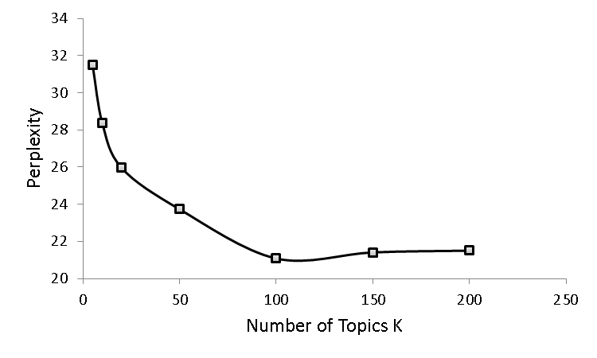
Figure 3. Perplexity of test set for defernt values of K in LDA

For the proposed model we assume that the number of specific topics is proportional to the number of general topics. According to our observations is a good choice. Then we calculated the perplexity of several values of as shown in figure 4 and according to the results selected the value and therefore for the proposed model.
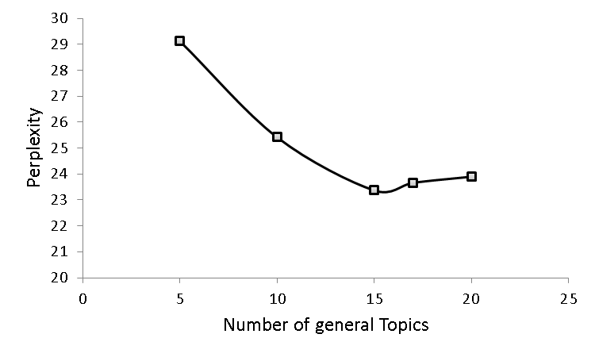
Figure 4. Perplexity of test set for defernt values of K in the proposed model

For all the experiments below a single Markov chain is run for 200 iterations. The first 50 samples have been discarded and from the remaining, 15 samples were selected (lag = 10).
As mentioned before, the topic proportions can be considered as a soft clustering of document. For the proposed model we consider the specific topic proportions as the clustering of the documents. Then we calculate the VI distance of these two clustering with the original clustering provided for dataset. The results are shown in table 1.
Table 1. VI distance for LDA and proposed model
model | VI distance
LDA | 9.65
Proposed model | 7.801

As shown in the table the clustering provided by the proposed model is more similar to the original categorization (news groups) which we consider a correct clustering provided by the human users.

Some Examples
Some similar topics generated by LDA and the proposed model are shown in table 2. Comparing these topics, we can claim that the proposed model generates more specific topics. For example consider the two first rows. Words "world" and "real" are very general words that are likely to appear as descriptor words of other topics. In the LDA model amongst the 100 topics the word "real" has been appeared in 4 other topics and "world" in 2 other topics. One can say that the word "things" in the word descriptors of the proposed model is also a general word which is true but the number of this kind of words in the descriptors of the proposed model is lower than LDA. On the other hand, the topic generated by LDA containing these words seems to be a combination of several topics but the topic generated by the proposed model is more specific. These matters are also observable in the two other examples.
Table 2. Some example topics of the proposed models and LDA
LDA | people god jesus day ca world real mother
Proposed model | jesus bible people god things start ca claiming
LDA | drugs kids parents drug teens today years survey
Proposed model | drugs parents teens drug kids survey alcohol students
LDA | phone key clipper chip encryption sounds buy high
Proposed model | clipper key chip phone privacy data crypto manufactured

CONCUSION
In this paper we introduced a model which can overcome the problem of over-generalization in LDA. This model uses an extra hidden variable in document level which provides the model with the ability to detect both general and specific topics in a corpus. Specific topics encodes stricter relationships between words and It means that words have to be more co-occurred to be placed in the same topic while general topics capture looser relationships. The proposed model is compared with LDA model according to VI distance and also by some examples of the two models. This comparisons show that the proposed model is successful to overcome the problem.

References
- Hofmann, Thomas. "Probabilistic latent semantic indexing." Proceedings of the 22nd annual international ACM SIGIR conference on Research and development in information retrieval. ACM, 1999.
- Blei, David M., Andrew Y. Ng, and Michael I. Jordan. "Latent dirichlet allocation." the Journal of machine Learning research 3 (2003): 993-1022.
- Blei, David M., and John D. Lafferty. "Dynamic topic models." Proceedings of the 23rd international conference on Machine learning. ACM, 2006.
- Mcauliffe, Jon D., and David M. Blei. "Supervised topic models." Advances in neural information processing systems. 2008.
- Anandkumar, Anima, et al. "A spectral algorithm for latent Dirichlet allocation." Advances in Neural Information Processing Systems. 2012.
- Porteous, Ian, et al. "Fast collapsed gibbs sampling for latent dirichlet allocation." Proceedings of the 14th ACM SIGKDD international conference on Knowledge discovery and data mining. ACM, 2008.
- Andrzejewski, David, Xiaojin Zhu, and Mark Craven. "Incorporating domain knowledge into topic modeling via Dirichlet forest priors." Proceedings of the 26th Annual International Conference on Machine Learning. ACM, 2009.
- O’Callaghan, Derek, et al. "An analysis of the coherence of descriptors in topic modeling." Expert Systems with Applications 42.13 (2015): 5645-5657.
- Chemudugunta, Chaitanya, and Padhraic Smyth Mark Steyvers. "Modeling General and Speciﬁc Aspects of Documents with a Probabilistic Topic Model." Advances in Neural Information Processing Systems 19: Proceedings of the 2006 Conference. Vol. 19. MIT Press, 2007.
- Griffiths, Thomas L., and Mark Steyvers. "Finding scientific topics." Proceedings of the National Academy of Sciences 101.suppl 1 (2004): 5228-5235.
- Heinrich, Gregor. Parameter estimation for text analysis. Technical report, 2005.
- Lang, Ken. "Newsweeder: Learning to filter netnews." Proceedings of the 12th international conference on machine learning. 1995.

