Investigation and Analysis of Single Layer Phosphorene Properties Based on Tight-Binding and Green’s Function Formalism

Hojjatollah Sarvari
PhD Student
Electrical & Computer
University of Kentucky
Lexington, United States, 40506
Email: hojjat.sarvari@uky.edu
Zhi David Chen
Professor
Electrical & Computer
University of Kentucky
Lexington, United States, 40506
Email: zhichen@engr.uky.edu
Parham Shenavar
PhD Student
Electrical & Computer
Shiraz University
Shiraz, Iran, 71569
Email:
parham@shirazu.ac.ir

Rahim Ghayour*
Professor
Electrical & Computer
Shiraz University
Shiraz, Iran, 71569
Email: rghayour@shirazu.ac.ir

Abstract—Black phosphorous is a layered semiconductor material which shows interesting electronic and optical properties. Few layer black phosphorous named as phosphorene is the new two-dimensional semiconductor material demonstrated in 2014. In this paper, we use tight-binding method to implement a matrix representation for single layer and multilayer phosphorene nanoribbon structures. By this approach, the Hamiltonian of the system is defined to ease study of the electronic and optical properties of these materials. Additionally, it is very helpful in studies of phenomena such as quantum transport in large-scale phosphorene field effect transistors. Then, we use the defined matrix representation to study the effect of modulated electric field on the electronic properties of armchair phosphorene nanoribbon structures. We have applied both constant and sine wave electric fields across the width and along the length of phosphorene nanoribbon with different number of atoms in its width. Then, the band gap energy and transmission through the material under electrical field are studied using the non-equilibrium Green’s function formalism. Strength of electric field can change the band structure of phosphorene effectively which can be used to tune the band gap of material for particular applications.
Keywords:phosphorene nanoribbon; tight-binding; electric field; Green’s function;
- Introduction
Two dimensional (2D) semiconductor materials have been the center of many research studies since a few years ago. Graphene defined as two dimensional sheet of carbon atoms with thickness of only one atom is the first real 2D material discovered in 2004, which got a lot of attention in semiconductor industry particularly in electronic devices, interconnects, and energy storage [1-4].
Black phosphorous in a layered form shows interesting electronic; semiconducting and optical properties. Few layer black phosphorous named as “phosphorene” is a new 2D semiconductor material demonstrated in 2014. Like graphene, black phosphorous can be reduced to one single atomic layer because its bulk crystal composed of many individual layers stacked together by van der Waals force that can be reduced to the single atom layer in the direction perpendicular to the 2D plane. Therefore, the single layer black phosphorous should have physical properties much different from the bulk black phosphorous. Phosphorene as a single layer thick material demonstrates encouraging electronics and optical properties which have been studied by several research groups since its discovery [5-8].
The phosphorene nanoribbons can be obtained by cutting a monolayer phosphorene along its armchair or zigzag directions in the same way that of the graphene nanoribbon. Therefore, the armchair phosphorene nanoribbons (A-PNRs) or zigzag phosphorene nanoribbons (Z-PNRs) can be identified by the number of dimer lines or the zigzag chains across the ribbon width, respectively [7].
Both armchair and zigzag phosphorene nanoribbons have positive and much smaller formation energies compared to the graphene nanoribbons which means their experimentally synthesizes is quite accessible [9]. According to the research history of previous two-dimensional materials such as graphene and MoS₂, the theoretical and simulation research studies of PNRs are necessary for future experimental researches, however PNRs have not been fabricated [10].
The tight-binding parameters describe the band structure of phosphorene materials very accurately specially in the low energy regime, where its results are comparable to the first-principle calculations based on the density functional theory. Here, we use tight-binding method to implement a matrix representation for single layer and multilayer phosphorene nanoribbon structures. We define the Hamiltonian in order to facilitate the study of electronic and optical properties of these materials. It also is very helpful in the large-scale studies of materials such as quantum transport studies in phosphorene field effect transistors.
Tight-binding parameters for phosphorene materials are proposed for the first time by Rudenko et al [11]. This method shows pretty accurate energy band structure for single layer phosphorene comparable to the result of first principle calculations based on density functional theory. This is specially reliable in the low energy regime which shows the band gap of 1.60 eV [11] close to 1.52 eV resulted from the experimental works [12].
We have used these tight-binding parameters to form the matrix representation of armchair and zigzag phosphorene nanoribbon structures. We investigate the bandgap of different material structures to confirm that the Hamiltonian matrix representation of the structure is well defined and its results are in well-agreement with the previous reports.
This representation can be used to study the effect of different types of field or to study the effect of atom vacancies on the electronic structure and band energy of multilayer phosphorene materials. Thus, we use this representation to investigate the electronic properties of phosphorene under two different types of electric fields; constant and sine wave electric fields. We will discuss on the material bandgap and carrier transmission through the material under electrical fields.
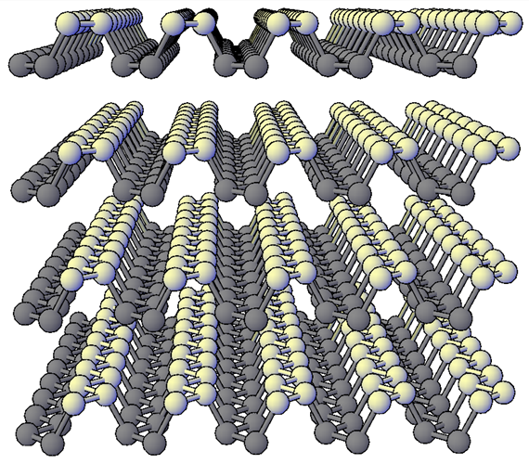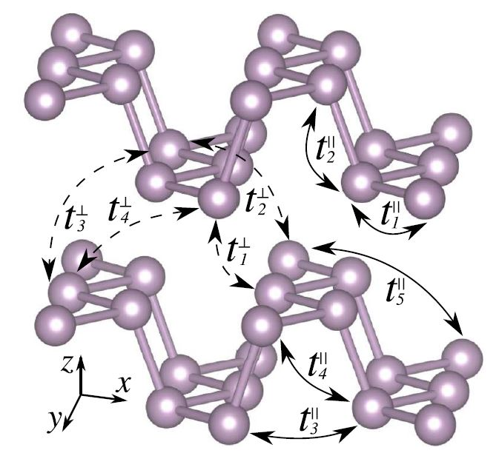
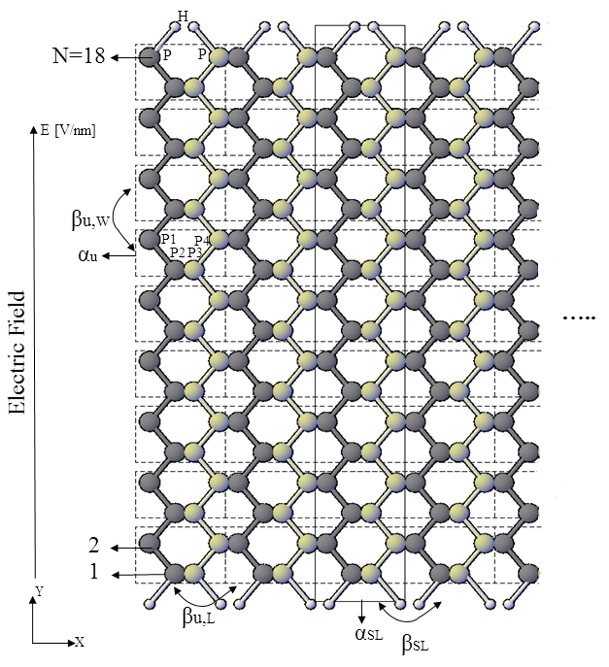
Figure 1. (Top left) Front view of ball-stick model of atomic structures of 18-A-PNR. The edge dangling bonds are passivated by hydrogen atoms (in white). (Top right) Front view of bilayer phosphorene structure showing inlayer and interlayer tight-binding interaction parameters [11]. (Bottom) Top view of single layer of 18-A-PNR in a linear electric field E [V/nm]. The unit cells α_{u}’s are marked by dashed rectangles.
The following matrix representation of phosphorene structure can be used for all single layer and multilayer phosphorene nanoribbons with an even number of phosphorus atoms in the width of the material. One can easily make some modification to the matrices to add the edge effect on the Hamiltonian of structure.
The tight-binding formulas for single layer and multilayer phosphorene materials are defined as follows, respectively [11]:
(1-1)
(1-2)
The first term in both formulas is on-site energy of individual atoms which can be used to add the electric field potentials. The second term stands for the inlayer interactions between phosphorus atoms and the third term in second formula describes the interactions between atoms belonging to different layers.
First, we define a unit-cell includes four phosphorus atoms as shown in Fig. 1(b) to distribute it in the transverse direction to make a large unit-cell and then distribute the new unit-cell along the transports direction in order to construct the full Hamiltonian matrix, H, of the PNR structure. Table 1 provides the tight-binding parameters for inlayer and interlayer interactions in phosphorene multilayer structures [11].
TABLE I. Inlayer (t||) and interlayer (t┴) hopping parameters for monolayer and bilayer BP. d denotes the distances between the corresponding interacting lattice sites. The hopping parameters are schematically shown in fig. 1 [11].
 | Inlayer |  | Interlayer
No. | t|| (eV) | d||(A°) | t┴ (eV) | d┴(A°)
1 | −1.220 | 2.22 | 0.295 | 3.60
2 | 3.665 | 2.24 | 0.273 | 3.81
3 | −0.205 | 3.34 | −0.151 | 5.05
4 | −0.105 | 3.47 | −0.091 | 5.08
5 | −0.055 | 4.23 | 0.000 | 5.44
Using the phosphorene structure and unit cell shown in fig. 1, we have α_{u} for each individual unit cell as follows:
(2)
β_{u,W} is a matrix with the same size as α_{u} describes the interactions between each two neighbor unit cells in the direction along the width of phosphorene nanoribbon.
(3)
β_{u,L} describes the interactions between each two neighbor unit cells in the direction along the transport direction or length of phosphorene nanoribbon. Other matrices are also defined in the same way.
(4)
Now, we can define a super unit cell which is one single column of each individual unit cell in the width of ribbon (y-direction) with only one unit cell length in the transport direction (x-direction) called α_{SL} as shown in fig. 1. The same thing can be used for interaction matrix β_{SL} which is another single column matrix describes the connections between two super unit cells of α_{SL}. By using α_{SL}, we can work on the problem as a one dimensional system.
(5)
which N is the number of phosphorus atoms in the width of nanoribbon. Therefore, the total number of atoms inside the channel of device equals to 2N times the number of unit cells in the transport direction (length of ribbon) named N_{T}. Thus, the size of Hamiltonian H is 2N*N_{T}.
(6)
For multilayer phosphorene nanoribbon structures, the same method can be used. Here we define the interaction matrices between adjacent layers by γ. When we have interaction between two layers, the size of smallest matrices will be 8*8 because of two unit cells in two different layers. Here γ_{W} and γ_{L} are defined in the same way as β_{W} and β_{L}, respectively but with different sizes and coefficients due to the increased number of phosphorene layers.
(7)
(8)

Finally, we can define α_{ML}, β_{ML}, and H_{ML} for AB-stacked multilayer phosphorene materials.
(9)
Using the time-independent Schrödinger equation and Bloch theorem in periodic structures, the band structure of the single layer or multilayer materials can be calculated using the following formulas for single layer and multilayer respectively [13]:
(10-1)
(10-2)
where k is the momentum. Finally, we can find the retarded Green’s function as follows [13, 14]:
(11)
where E is the energy, Σ_{e1/2} is the self-energy matrix of electrode 1 or 2 and I is identity matrix. U is the diagonal potential matrix which its diagonal elements are the potential of individual atoms with respect to the field. Having Green’s function matrix, one can easily calculate the density of states and transmission through the material [13, 14].
Here we consider the hydrogen atoms passivation for the edge phosphorus atoms to have a direct bandgap material [7, 9]. In addition, in order to make the calculation simple, we supposed that the electric field does not affect the rigid structure and tight-binding parameters. Therefore, the field is an effective one which only adds an electric potential U_{i} on the on-site energy of phosphorous atoms. This assumption is valid and already used for previous two dimensional materials such as graphene [15-17].
Based on the calculations of the above matrix representation, fig. 2 shows the band gap variation in A-PNRs with various numbers of atoms in the width of nanoribbon without any external electric fields. According to fig. 2, independent of the width of ribbon, all of the armchair phosphorene nanoribbons are direct bandgap semiconductor.
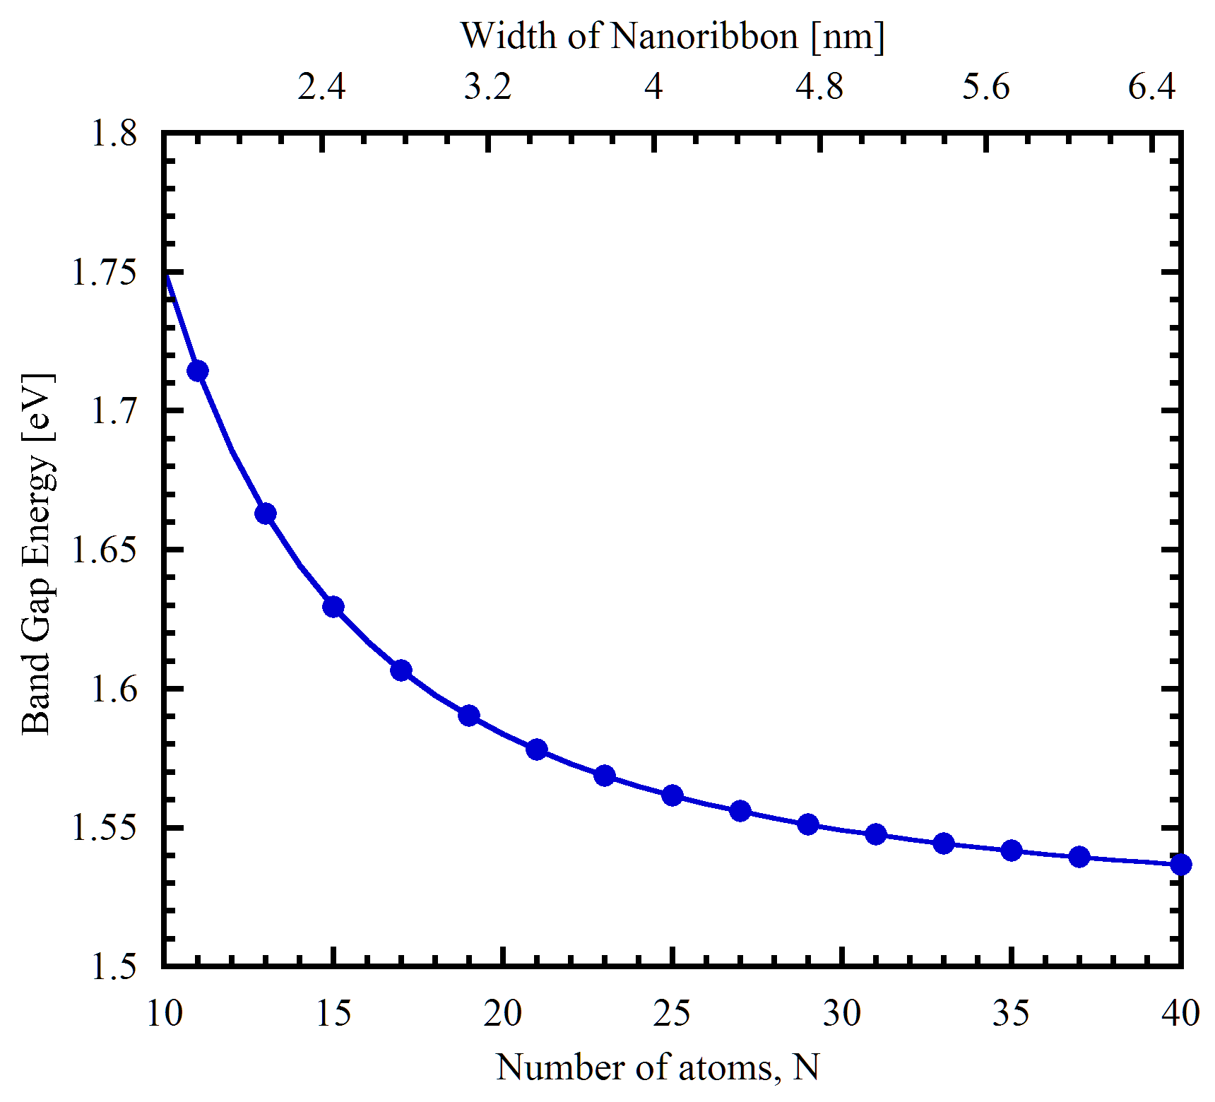
Figure 2. Band gap variation versus the width and the number of phosphorus atoms in the armchair phosphorene nanoribbons.
The results are in well agreement with the previous reports [11]. As we can see, A-PNR is a semiconductor material, where its band gap decreases due to the quantum confinement effect as the width of nanoribbon increases [18-20]. The band gap reaches a saturated value of 1.52 eV when the width of ribbon increases to infinity. That is of a two dimensional phosphorene sheet reported by theoretical works based on first principle calculations and experimental works as well [12, 21-23]. We have also calculated the band structure of zigzag-PNR which are in correlation with that of the previous studies and show a metallic material properties [24, 25].
Here, we investigate the electronic properties of A-PNRs under an external electric field in the direction along the width of ribbon as shown in fig. 1. The potential at each atom site is a function of its distance from the electric field source. In this case, we have E = -V/d in the y-direction, while the transport direction is along the x axis.
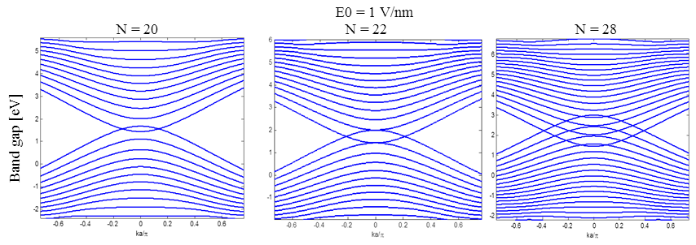
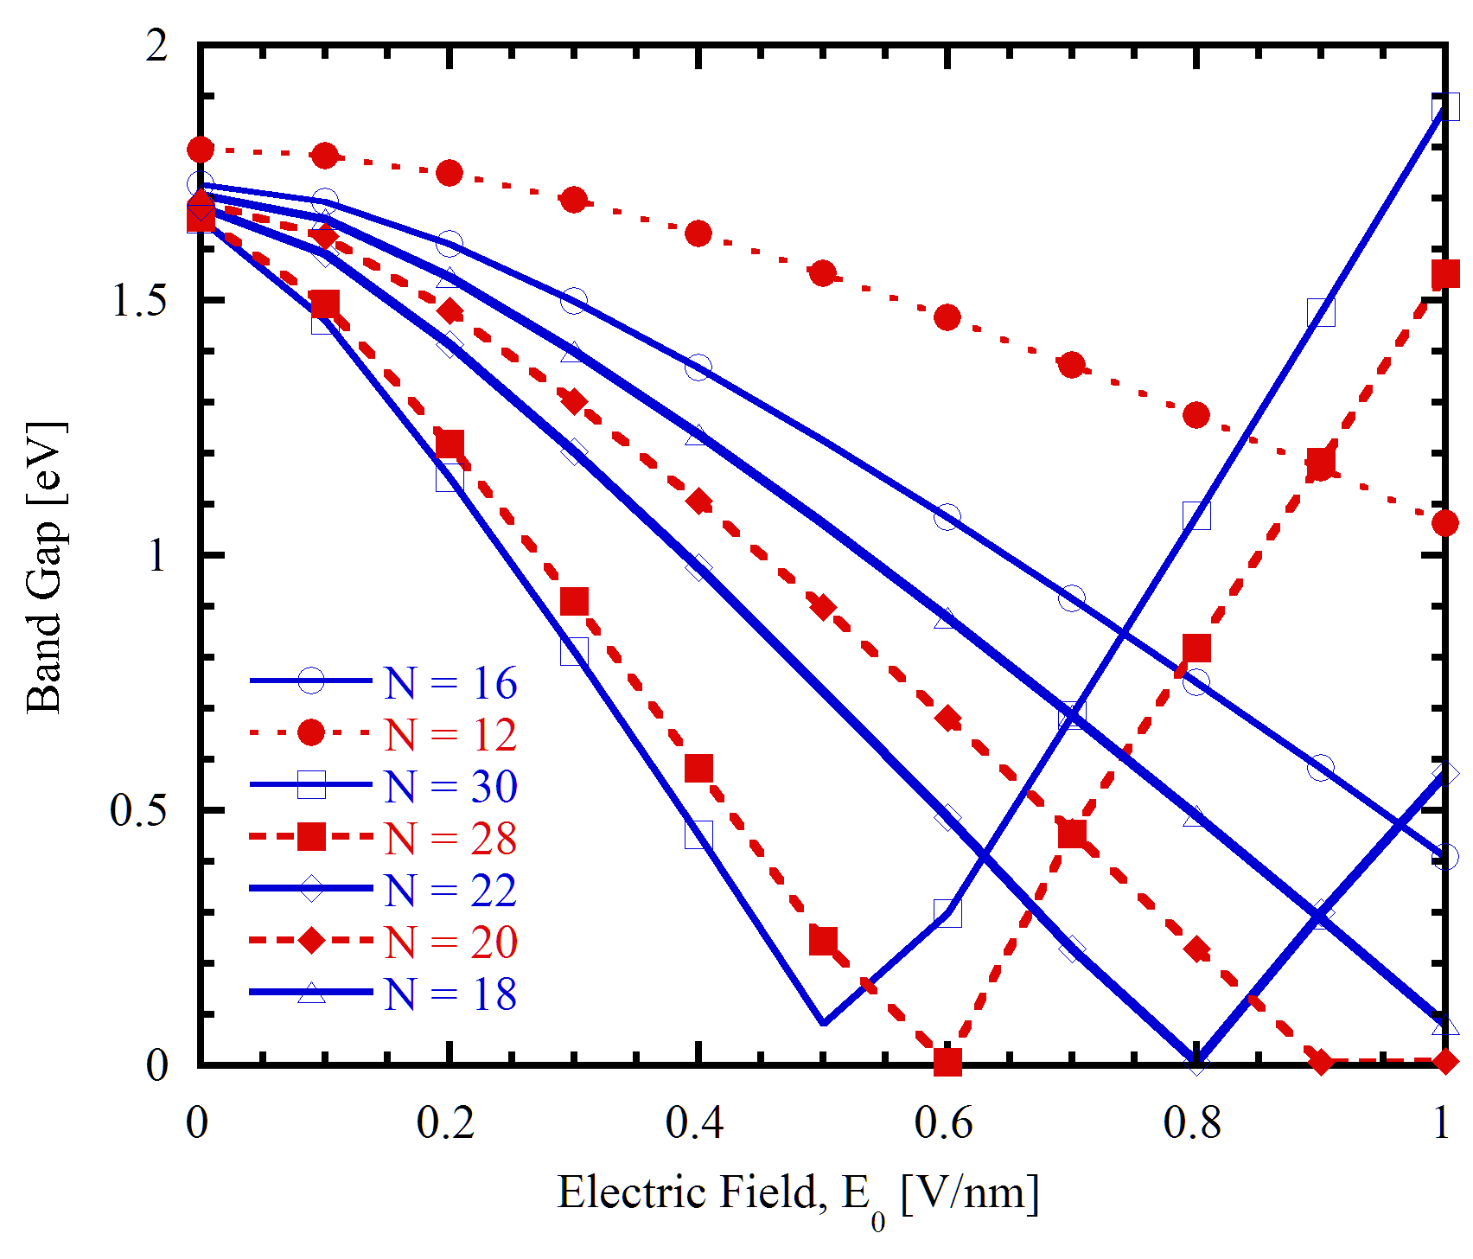
Figure 3. (Top) Conduction and Valance bands of A-PNR with N=20, 22, and 28 in an external electric field with 1V/nm strength. (Bottom) variation of the band gap (absolute value) of A-PNR versus transverse external electric field applied on different ribbon widths.
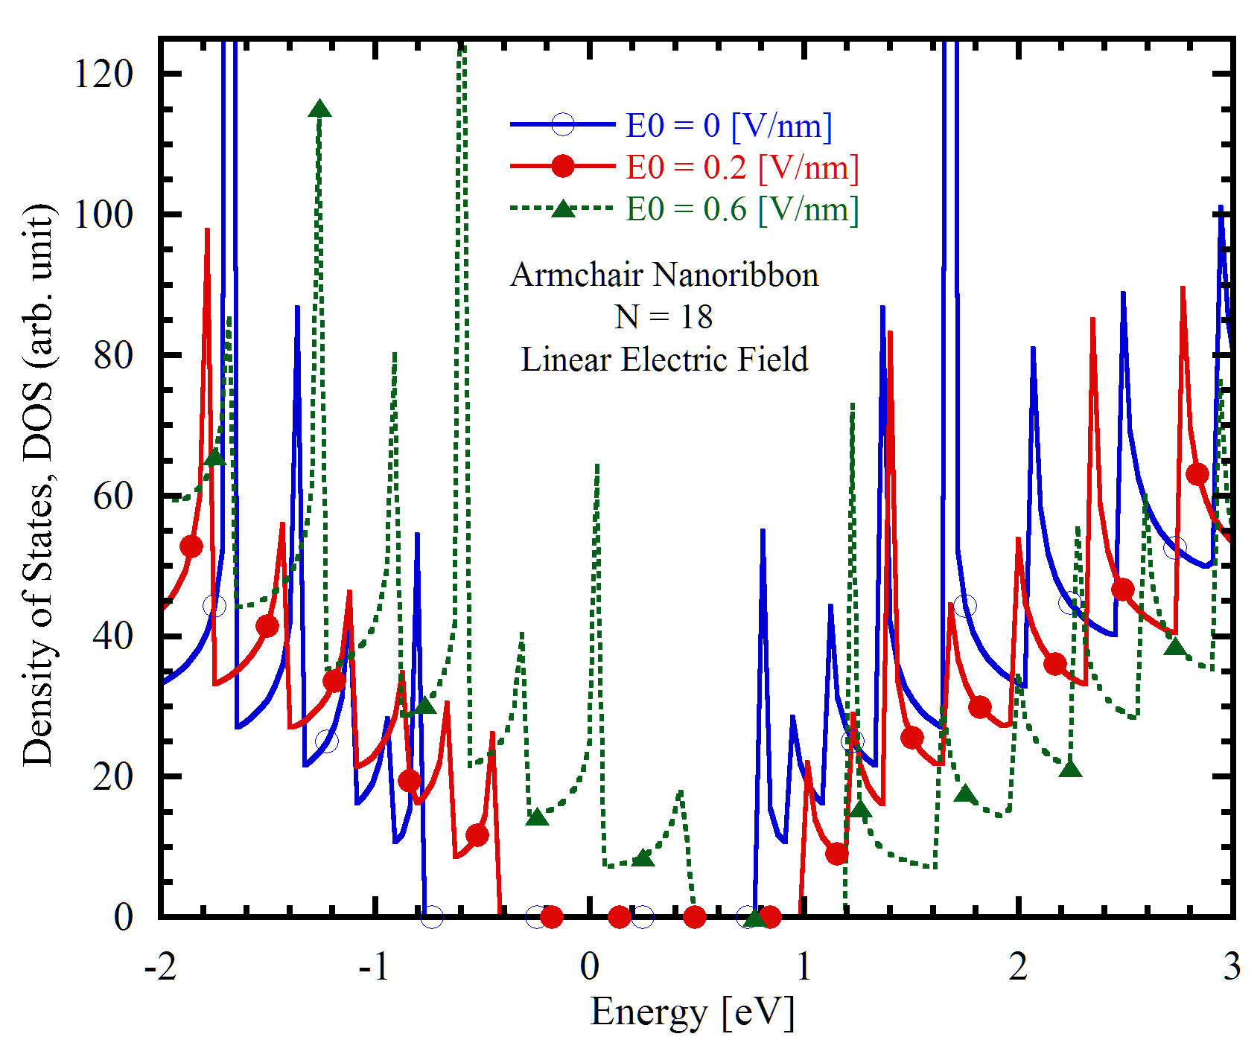
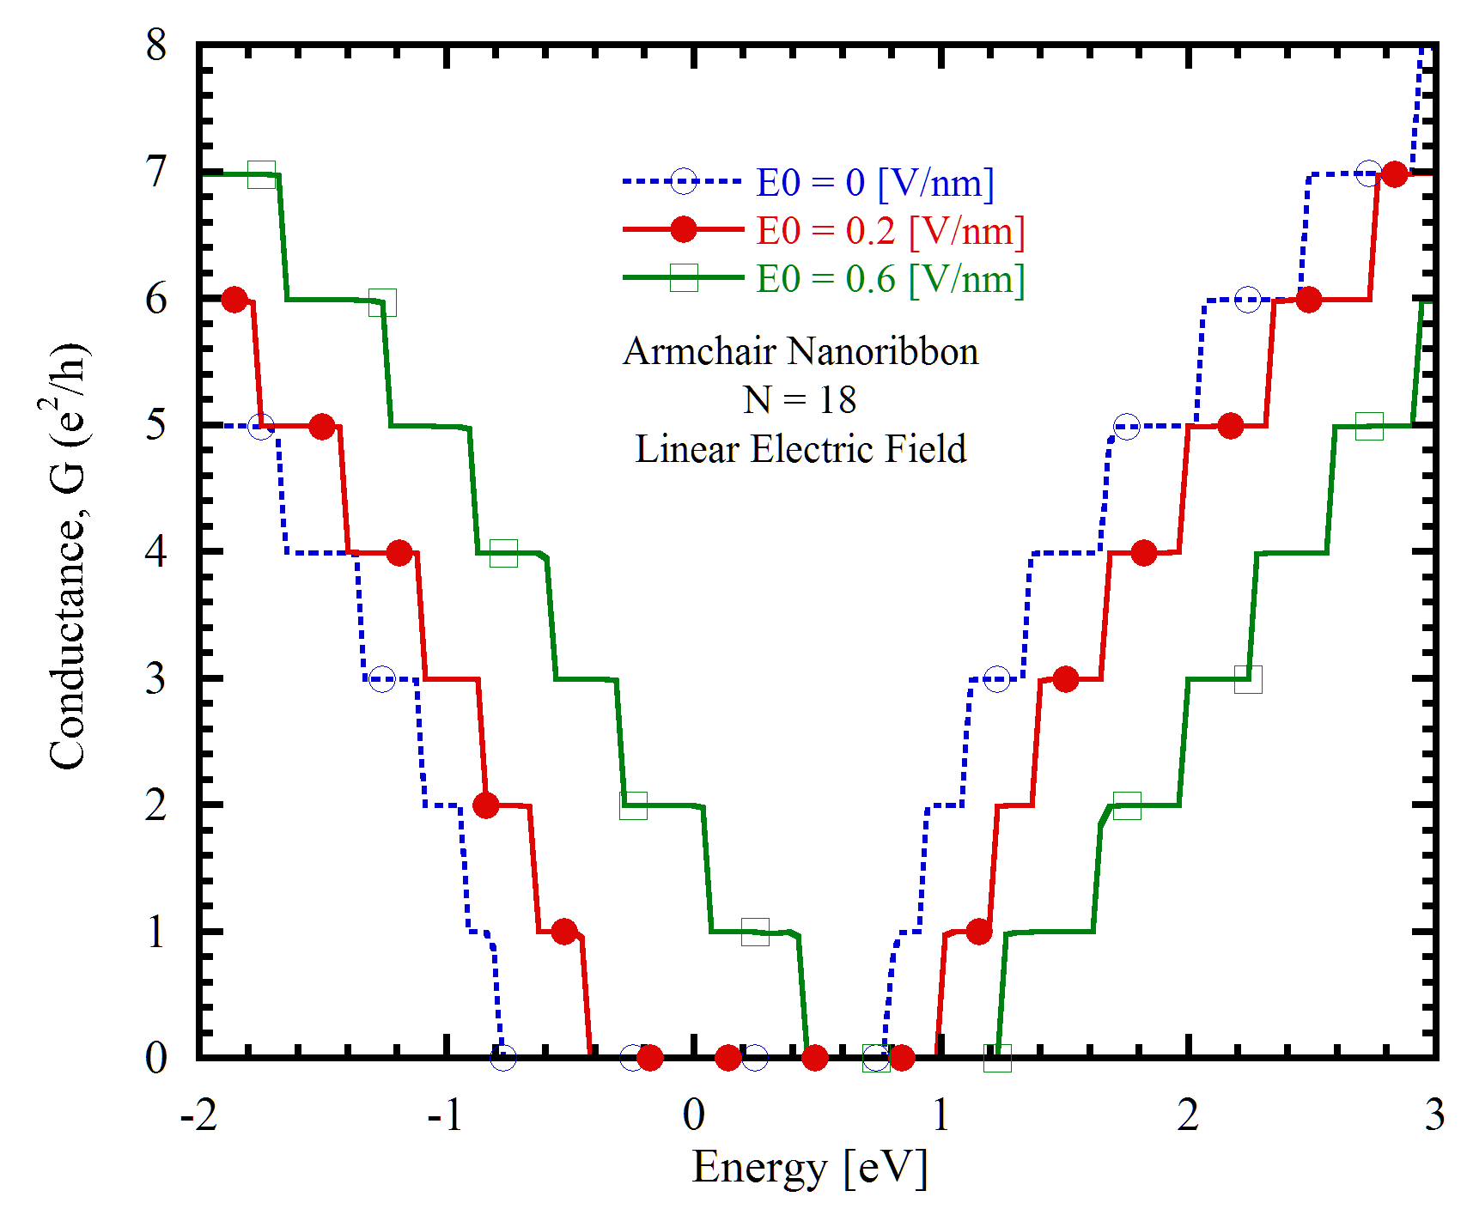
Figure 4. (Top) Density of states (Bottom) Conductance for 18-A-PNR with in transverse linear electric field with various E₀.
When a transverse electric field applies along the width of nanoribbon, states corresponding to the conduction band (electron states) will shift to the lower energies, whereas the states corresponding to the valance band (hole states) will shift to the higher energies. Fig. 3 shows the band structure of different A-PNRs at a transverse electric field of E₀=1 V/nm. Wider A-PNR shows more bands overlap as shown in fig. 3. As the field strength E₀ increases more, the two conduction and valance bands approach one another because of increased electrostatic difference between the opposite ribbon’s edges and thus the bandgap decreases as shown in the bottom plot of fig. 3.
We have also computed the density of states and conductance for 18-A-PNR (under the field) using Green’s function approach as shown in fig. 4. This figure clearly shows how electric field can shift the energy levels to the higher energy and confirms the field effect transistor-like behavior of PNRs.
Next, a spatially modulated sine wave electric field is applied to the material in the x direction as shown in fig. 5. In this case, we use the following formula which is almost similar the formula which has been used before in graphene material studies [26]:
(12)
which l_{E}=R_{E}*a₁ and a₁ is the length of unit-cell in the x-direction. Using this formula, we have investigate the effect of period through R_{E} and the strength of the field, E₀. The magnitude of Electric field is supposed to be in the direction perpendicular to the PNR sheet, z-axis. The period of the electric field can be changed by changing R_{E}. When we increase l_{E}, V(x) only changes the site energy values, but not the tight-binding parameters. So, the size of unit-cell only depends on the number of atoms in the width direction, N, and the R_{E}.
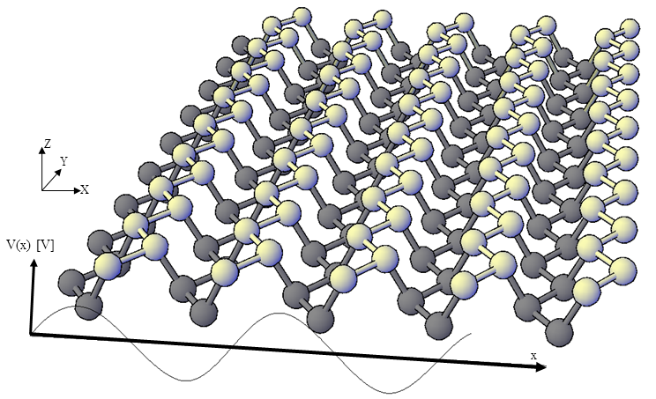
Figure 5. Single layer 18-A-PNR in a spatially modulated electric field along the armchair direction, x.
When we increase the R_{E} to 10, i.e increasing the unit cell length in x-direction, the band gap decreases much more than the case where R_{E} is small, i.e R_{E}=1 as shown in the top plot of fig. 6. Fig. 6 (bottom) also shows that band gap decreases as R_{E} increases. In addition, for a constant R_{E} and E₀, still band gap decreases with increasing the N but the rate is not as high as that for the field’s strength variation.
Fig. 7 (Top) shows the band structure of 18-A-PNR with R_{E}=1 in modulated electric field with various V₀. As we increase the strength of field, the band gap decreases by symmetric movement of conduction and valance bands toward center. In addition, applied electric field which is modulated like a sine wave could open two more gaps above and bottom of the central gap. The size of gaps increases as we increase the field strength which is in opposite way compare to the central gap variation against field strength. Moreover, DOS of 18-A-PNR with R_{E}=10 in modulated electric field along the armchair direction for various field strengths is plotted in fig. 7 bottom which is in agreement with band structure variation due to the modulated field.
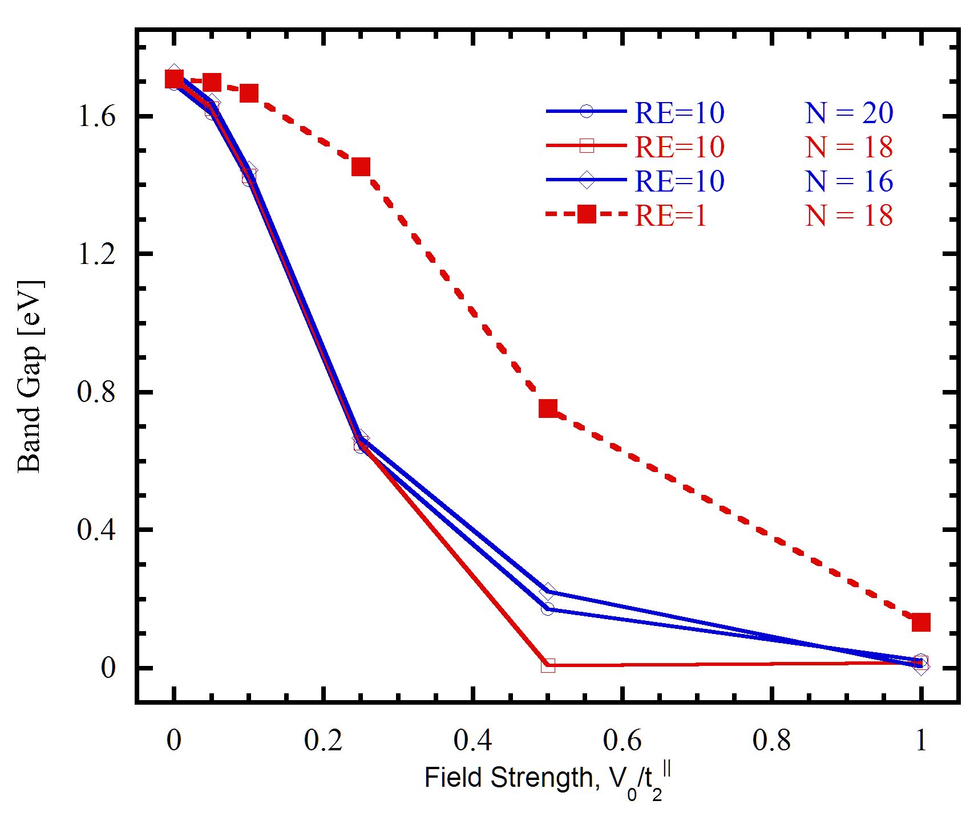
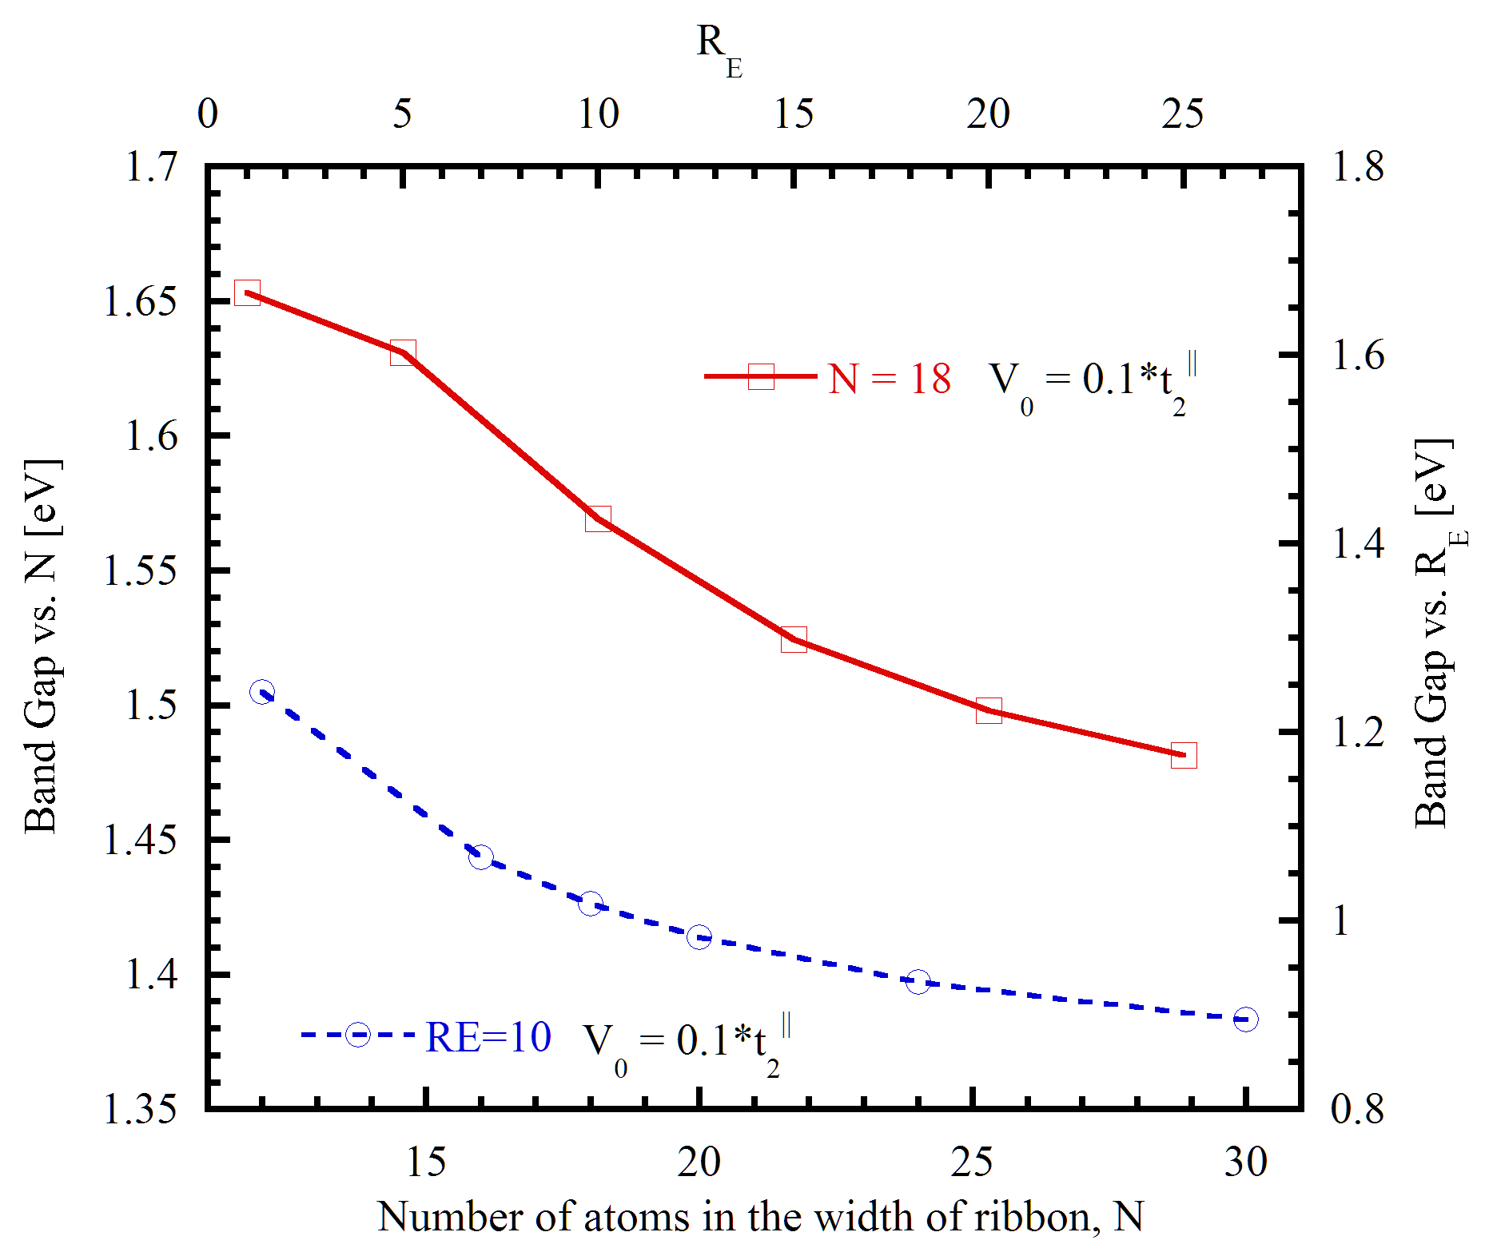
Figure 6. (Top) Band gap variation versus the spatially modulated field strength for 16, 18, 20-A-PNRs. (Bottom) Band gap variation versus N and R_{E} for 18-A-PNR with in a spatially modulated electric field.
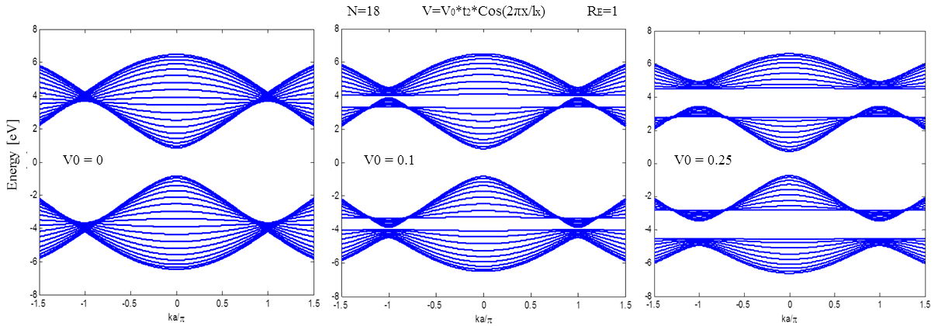
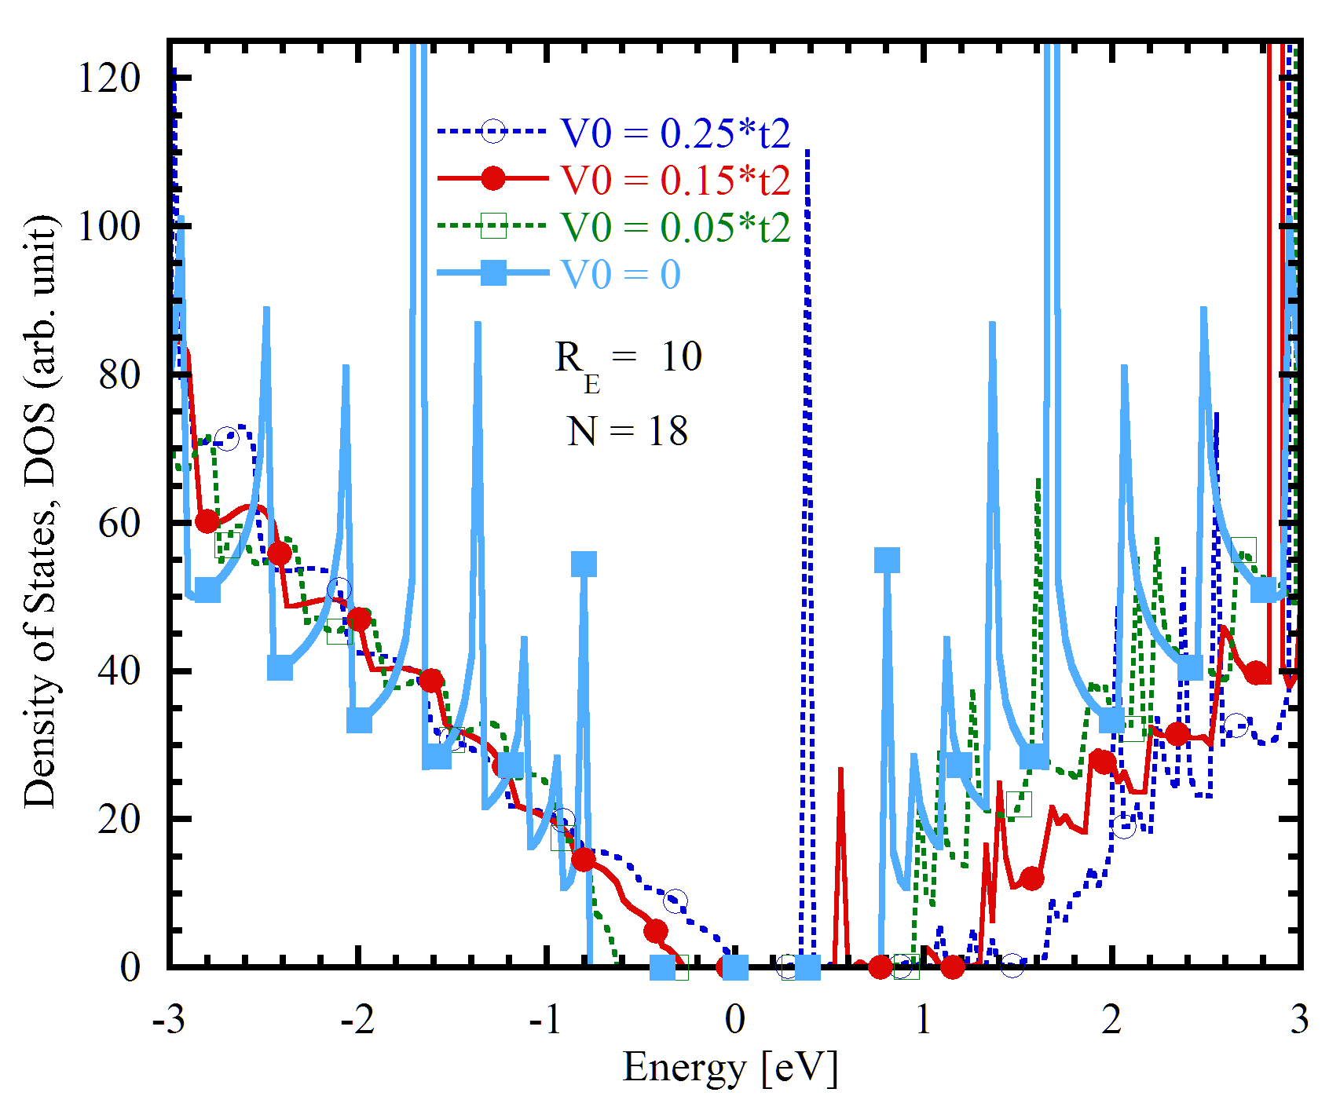
Figure 7. (Top) Conduction and valance bands of 18-A-PNR in a spatially modulated electric field at different strengths. (Bottom) Density of states of 18-A-PNR with R_{E}=10 in a spatially modulated electric field with various field strengths.

Conclusion
In summary, using the recently published tight-binding parameters of phosphorene materials, we have provided a matrix representation of phosphorene nanoribbons which can be used for multilayer phosphorene materials. Then, we used the method to investigate the effect of both linear and spatially modulated electric fields on the electronic properties of phosphorene nanoribbons. Density of states has been calculated using the non-equilibrium Green’s function formalism. Other than direct bandgap property, the Bandgap is also tunable with an external field that suggests phosphorene as a good candidate for particular applications.

Acknowledgment
We would like to thank the University of Kentucky Information Technology department and Center for Computational Sciences for computing time on the Lipscomb High Performance Computing Cluster and for access to other supercomputing resources.
References:

[1] R.-H. Kim, M.-H. Bae, D. G. Kim, H. Cheng, B. H. Kim, D.-H. Kim, M. Li, J. Wu, F. Du, and H.-S. Kim, “Stretchable, transparent graphene interconnects for arrays of microscale inorganic light emitting diodes on rubber substrates,” Nano letters, vol. 11, no. 9, pp. 3881-3886, 2011.
[2] M. Pumera, “Graphene-based nanomaterials for energy storage,” Energy & Environmental Science, vol. 4, no. 3, pp. 668-674, 2011.
[3] P. Avouris, “Graphene: electronic and photonic properties and devices,” Nano letters, vol. 10, no. 11, pp. 4285-4294, 2010.
[4] H. Sarvari, R. Ghayour, and E. Dastjerdy, “Frequency analysis of graphene nanoribbon FET by Non-Equilibrium Green's Function in mode space,” Physica E: Low-dimensional Systems and Nanostructures, vol. 43, no. 8, pp. 1509-1513, 2011.
[5] A. Castellanos-Gomez, L. Vicarelli, E. Prada, J. O. Island, K. Narasimha-Acharya, S. I. Blanter, D. J. Groenendijk, M. Buscema, G. A. Steele, and J. Alvarez, “Isolation and characterization of few-layer black phosphorus,” 2D Materials, vol. 1, no. 2, pp. 025001, 2014.
[6] L. Li, Y. Yu, G. J. Ye, Q. Ge, X. Ou, H. Wu, D. Feng, X. H. Chen, and Y. Zhang, “Black phosphorus field-effect transistors,” Nature nanotechnology, vol. 9, no. 5, pp. 372-377, 2014.
[7] V. Tran, and L. Yang, “Scaling laws for the band gap and optical response of phosphorene nanoribbons,” Physical Review B, vol. 89, no. 24, pp. 245407, 2014.
[8] F. Xia, H. Wang, and Y. Jia, “Rediscovering black phosphorus: A unique anisotropic 2D material for optoelectronics and electronics,” arXiv preprint arXiv:1402.0270, 2014.
[9] J. Zhang, H. Liu, L. Cheng, J. Wei, J. Liang, D. Fan, J. Shi, X. Tang, and Q. Zhang, “Phosphorene nanoribbon as a promising candidate for thermoelectric applications,” Scientific reports, vol. 4, 2014.
[10] E. T. Sisakht, M. H. Zare, and F. Fazileh, “Scaling laws of band gaps of phosphorene nanoribbons: A tight-binding calculation,” Physical Review B, vol. 91, no. 8, pp. 085409, 2015.
[11] A. N. Rudenko, and M. I. Katsnelson, “Quasiparticle band structure and tight-binding model for single-and bilayer black phosphorus,” Physical Review B, vol. 89, no. 20, pp. 201408, 2014.
[12] S. Zhang, J. Yang, R. Xu, F. Wang, W. Li, M. Ghufran, Y.-W. Zhang, Z. Yu, G. Zhang, and Q. Qin, “Extraordinary photoluminescence and strong temperature/angle-dependent Raman responses in few-layer phosphorene,” ACS nano, vol. 8, no. 9, pp. 9590-9596, 2014.
[13] S. Datta, Quantum transport: atom to transistor: Cambridge University Press, 2005.
[14] E. Dastjerdy, R. Ghayour, and H. Sarvari, “3D quantum mechanical simulation of square nanowire MOSFETs by using NEGF method,” Central European Journal of Physics, vol. 9, no. 2, pp. 472-481, 2011.
[15] C. Lu, C.-P. Chang, Y.-C. Huang, R.-B. Chen, and M. Lin, “Influence of an electric field on the optical properties of few-layer graphene with AB stacking,” Physical Review B, vol. 73, no. 14, pp. 144427, 2006.
[16] M. Araidai, Y. Nakamura, and K. Watanabe, “Field emission mechanisms of graphitic nanostructures,” Physical Review B, vol. 70, no. 24, pp. 245410, 2004.
[17] C.-P. Chang, Y.-C. Huang, C. Lu, J.-H. Ho, T.-S. Li, and M.-F. Lin, “Electronic and optical properties of a nanographite ribbon in an electric field,” Carbon, vol. 44, no. 3, pp. 508-515, 2006.
[18] X. Zhao, C. Wei, L. Yang, and M. Chou, “Quantum confinement and electronic properties of silicon nanowires,” Physical review letters, vol. 92, no. 23, pp. 236805, 2004.
[19] L. Yang, C.-H. Park, Y.-W. Son, M. L. Cohen, and S. G. Louie, “Quasiparticle energies and band gaps in graphene nanoribbons,” Physical Review Letters, vol. 99, no. 18, pp. 186801, 2007.
[20] C.-H. Park, and S. G. Louie, “Energy gaps and stark effect in boron nitride nanoribbons,” Nano letters, vol. 8, no. 8, pp. 2200-2203, 2008.
[21] H. Guo, N. Lu, J. Dai, X. Wu, and X. C. Zeng, “Phosphorene nanoribbons, phosphorus nanotubes, and van der Waals multilayers,” The Journal of Physical Chemistry C, vol. 118, no. 25, pp. 14051-14059, 2014.
[22] J. Qiao, X. Kong, Z.-X. Hu, F. Yang, and W. Ji, “High-mobility transport anisotropy and linear dichroism in few-layer black phosphorus,” Nature communications, vol. 5, 2014.
[23] Y. Cai, G. Zhang, and Y.-W. Zhang, “Layer-dependent band alignment and work function of few-layer phosphorene,” Scientific reports, vol. 4, 2014.
[24] M. Ezawa, “Topological origin of quasi-flat edge band in phosphorene,” New Journal of Physics, vol. 16, no. 11, pp. 115004, 2014.
[25] A. Carvalho, A. Rodin, and A. C. Neto, “Phosphorene nanoribbons,” EPL (Europhysics Letters), vol. 108, no. 4, pp. 47005, 2014.
[26] Y. Ou, J. Sheu, Y. Chiu, R. Chen, and M. Lin, “Influence of modulated fields on the Landau level properties of graphene,” Physical Review B, vol. 83, no. 19, pp. 195405, 2011.

