The Impact of Blocking Layer Permittivity on the Electron Transfer Rate in Quantum Dot Sensitized Solar Cells

Mohammad Javad Fahimi
School of Electrical and Computer Engineering
Tarbiat Modares University (TMU)
Tehran, Iran
Email: mj.fahimi@modares.ac.ir

Davood Fathi
School of Electrical and Computer Engineering
Tarbiat Modares University (TMU)
Tehran, Iran, P.O. Box 14115-194
Corresponding author email: d.fathi@modares.ac.ir

Abstract— This paper models and simulates the impact of changes in the blocking layer permittivity on the electron transfer rate (from three quantum dots (QDs) of CdSe, CdS, CdTe to three metal oxides (MO) of TiO₂, ZnO, SnO₂ in porous-structured QDSSCs (Quantum Dot Sensitized Solar Cells) for different QD diameters and by the use of Marcus theory. Blocking layer is considered to be placed on top of QD and MO. The effective QD-blocking layer permittivity approximation is used to apply and incorporate the impacts of blocking layer to Marcus equation; changes in this equation, which is modified with respect to a new equivalent permittivity, are visible in the free energy of the system. The results show that trend of changes in with respect to QD diameters alters after crossing a particular permittivity threshold. For example, in TiO₂-CdS and ZnO-CdS combinations, for permittivities less than 7.5, increases with the increase of QD diameter, but for permittivities greater than 7.5, as QD diameter increases, decreases. These results can be used for better interpretation of experimental observations and also in the design and selection of MO-QD combinations including the blocking layer in QDSSCs.

Keywords-component; Electron transfer; Permittivity; Quantum dot; Metal oxide

Introduction
Excessive use of fossil fuels is the main cause of environmental pollution and global warming, and this has led to increasing focus on renewable energy sources [1, 2]. Among different mean of harvesting renewable energies, solar cells have proven to provide the most attractive solutions [3-5].
Currently, quantum dot based solar cell technologies with various structures (Quantum Dot Sensitized Solar Cells (QDSSCs), multilayer hybrid solar cells, etc.) can be utilized to increase the efficiency of solar cells [6-8]. Low cost of QDSSCs as the third generation of solar cells and their potential to achieve the Shockley–Queisser efficiency of 32% have attracted much attention to this technology [9-11]; but their efficiency is still low, and according to studies, has recently reached to a little over 8% [12].
Quantum dot semiconductors are considered as light-absorbing materials with features such as tunable band gap (achieved by changing their size) and multiple exciton generation per absorbed photon, which make them suitable for photovoltaic applications [9, 13, 14].
To reduce the amount of electron-hole recombination in QDSSCs, a blocking layer may be used in either of the following positions: i) on the electrode to prevent electrons from returning from the electrolyte back to the electrode [20-15]; ii) on the quantum dots (as light absorbing material) to reduce the return of electrons from QD to the electrolyte or on high band gap semiconductors (as the electron collector) to prevent the return of electrons to the valence band of quantum dots. This layer also prevents corrosion and protects the quantum dots, Metal Oxide (MO) and the electrode from the electrolyte [12, 21-31]. This layer plays an important role in enhancing the overall efficiency of the cell.
In 2008, Lee et al. used a ZnS blocking layer to increase the cell efficiency from 1.2 percent to 9.2 percent [32]. In 2009, Mora-Sero et al. used a ZnS blocking layer deposited on quantum dots and metal oxide and achieved a level of efficiency several times greater than what had been achieved without ZnS [23]. In 2011, Kim et al. used TiO₂ blocking layers with thicknesses of 7, 30 and 170 nm on the FTO and found that adding a blocking layer with a specific thickness (30 nm) increases cell efficiency from 0.23 percent to 0.52 percent [18].
In 2012, Chang et al. used different combinations of ZnS, ZnSe and Cu₂S blocking layer to increase the efficiency from 0.53 to 2.52 percent [30]. Also, in 2013, Choi et al. used ZnO blocking layer deposited on titanium dioxide to increase the efficiency from 0.53 percent to 0.7 percent [24]. In 2015, Yang et al. used ZnSe blocking layer deposited on the TiO₂ metal oxide with CdS quantum dots to increase the efficiency from 1.09 percent to 2.07 percent [25]. In the same year, Zhao et al. used ZnS and SiO₂ blocking layers separately to increase the efficiency from 2.53 percent to 6.37 percent and ultimately used a ZnS / SiO₂ hybrid blocking layer to achieve an efficiency of 8.21 percent [12].
Kamat et al. have reported that the electron transfer rate () between QD and TiO₂ is in the range of 10¹⁰10¹¹(1/s)[33, 34]. The process of electron transport through porous layer of TiO₂ is slower than the mechanism of electron transfer, so losses due to recombination can be considered an important factor in limiting the overall efficiency of the cells [35]. Therefore, the proper use of blocking layer can play an important role in reducing the recombination and increasing the cell efficiency.
In this paper we simulate the effect of blocking layer permittivity (up to 15 various different blocking layers) on from three quantum dots of CdSe, CdS, CdTe to three metal oxides of TiO₂, ZnO, SnO₂ by using the Marcus theory. Four widely-used blocking layers Al₂O₃ [36,37], ZnO [24,38] , TiO₂[9, 38-40] , and ZnS [12,21,23,30,32] with permittivities of 9.4 [41],9.9,10.5 [33], and 8.3 [42] are within the scope of our simulation. It should be noted that blocking layer acts as a barrier against the injection of electron from donor (QD) into the conduction band of acceptor (MO) and thus reduces . But as researches mentioned above have shown, the reduction in recombination (electrons not returning to the valence band of QD) and the increase in the density of acceptor atoms (due to the presence of blocking layer on MO) [38] can cause the presence of blocking layer to ultimately increase the cell’s overall efficiency. Thus, considering this issue (decreased ), we felt that it would be beneficial to assess the impact of changes in the blocking layer permittivity (i.e. different blocking layers) on and find the optimum rate, and then present the results in order to be used experimentally by our colleagues.
To assess the validity of simulation results, we compared them with the results of two other works in this field: a sample without blocking layer [33] whose results were obtained from our previous work [43]; and a sample with a blocking layer, whose transfer rate for a diameter of 2.6 nm was 5.75 × 10¹¹ (1 / s) [44]; our simulation obtained the same values with only 3 percent error (5.563 × 10¹¹ (1 / s)).

Structure, theory and modeling
The target structure is a QDSSC, where MO is formed spherically on a conductive glass substrate usually made of ITO (Indium tin oxide) or FTO (Fluorine tin oxide); a blocking layer with a specific thickness is then deposited on MO to protect it and prevent recombination; then come the spherical and porous quantum dots and again a blocking layer covers the entire structure. It has been experimentally shown that this method of blocking layer deposition yields the best efficiency. Creating a barrier between electron donor (QD) and acceptor (MO) will obviously reduce , but reduced recombination with electrolyte will increase the system’s open circuit voltage and will enhance the efficiency of the cell.
Here, the objective is to assess the impacts of blocking layer on . This assessment is conducted by considering QD diameters of 3.7, 3.8, 4.2, 4.8, 5.4 and 6 nm, blocking layer thickness of 0.2 nm, temperature of 300 degrees Kelvin, MO diameter of 20 nm and a 5 Å distance between QD and MO. Figure 1 shows the blocking layer layout and the flow path of electrons.
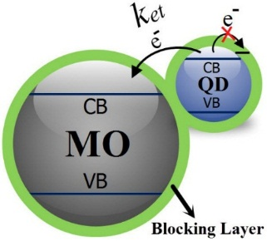

Figure 1. the layout of blocking layer considered for the structure.

Marcus equation shown below can be used to calculate

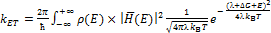 (1)
where is the electron transfer rate in 1 / sec, ℏ is the Planck's constant, ρ(E) is the density of states for MO, is the electronic coupling matrix for Acceptor-Donor, is the system reorganization energy in eV, k_{B} is the Boltzmann's constant, T is the system operating temperature in Kelvin, and is the system’s free energy in eV, which is the sum of charging, electronic and Coulomb energies [33].
The manner of incorporation of thermal effects and fixed parameters (such reorganization energy, crystal defects, etc.) is similar to our previous work (reference 43).
In 2012, Chatiar and Engheta modeled a sphere with a layer on top, in the form of a sphere with a new radius and effective permittivity and provided an equation to calculate the permittivity resulting from the layer [45]; here we use this approximation to model the blocking layer and incorporate its impacts into the Marcus equation of our structure.
Blocking layer deposited on both MO and QD is considered as a sphere with a new radius and permittivity (Figure 2); applying the effects of new radius on the QD conduction band edge and new permittivity on the free energy yielded the modified Marcus equation, where the effect of different parameters in the presence of blocking layer is demonstrated.

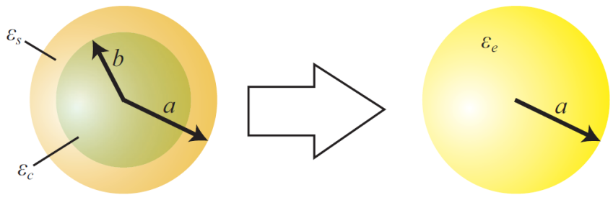
Figure 2. The equivalence of a core/shell semiconductor and a sphere with a new dielectric constant [45].

The effect of blocking layer deposited on MO can be ignored because of the MO large dimensions (bulk) and consequently its negligible effect on the relations. Our main focus therefore is the new permittivity resulted from QD and blocking layer. It should be noted that in addition to 5 Å distance assumed between the QD and MO, we also consider the thickness of blocking layer positioned between the two and incorporate it into our calculations (this weakens the coupling matrix). As is clear in Figure 2, the distance between a and b represents the thickness of blocking layer.
The impact of new permittivity on the free energy is as shown in Equation 2. Free energy is the sum of charging, electronic and Coulomb energies.

(2)

where is the MO conduction band edge energy, is the QD conduction band edge energy with respect to vacuum, e is the charge of electron, and are the dielectric constants of QD and MO, and h is the distance between QD and MO. According to the Brus equation, with considering the effective masses of electron and hole in QD, we can calculate the change in the QD conduction band edge as [46]

(3)

The new sphere has a radius of a (the sum of the thickness of blocking layer and the radius of QD); the new effective permittivity resulted from the blocking layer and QD, which we call , can be calculated by the following equation:

(4)

where is the dielectric constant of blocking layer, is the dielectric constant of QD, is the effective dielectric constant of new sphere, b is the radius of QD and (a-b) is the thickness of blocking layer [45].
After applying the new dielectric constant on the conduction band edge and free energy relationship, we modify the Equation (1) with respect to blocking layer to achieve the targeted results. If we apply the effect of blocking layer on the MO as an permittivity with new radius, new results will be largely similar to the previous approximation, with only a very little difference in ; hence the approximation considered here is a sound and logical approach.

Results
We changed the blocking layer permittivity (i.e. different blocking layers) from 0 to 15 for QD diameters of 3.7, 3.8, 4.2, 4.8, 5.4 and 6 nm and using the constants mentioned in the previous section, and then plotted the changes in with respect to changes in permittivity for 9 MO-QD combinations. Figure 3 shows this plot for TiO₂ metal oxide and three assessed QDs. As can be seen, in the case of TiO₂-CdSe, for small permittivities, large QD diameters lead to greater rates, but opposite occurs for large permittivities. In TiO₂-CdS, for permittivities less than about 7.5, greater QD diameters lead to greater rates, but we can see the opposite behavior for permittivities greater than 7.5. In TiO₂-CdTe smaller QD diameters lead to increasing rates. The reason behind the increase in rate with the increase in permittivity is that as the permittivity increases free energy of the system (ΔG) becomes more negative (Equation 2).

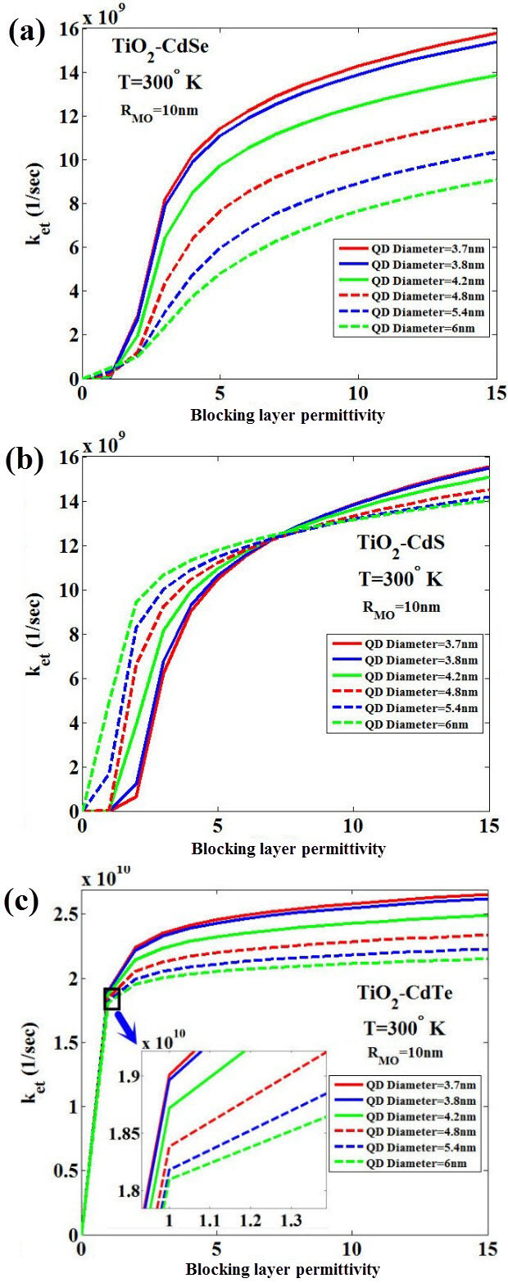
Figure 3. from QD to MO with respect to the blocking layer permittivity, for TiO₂ metal oxide with CdSe (a), CdS (b) and CdTe (c) quantum dots for 6 different QD diameters.
In the next step, we acquired the results of ZnO metal oxide for three quantum dots of CdSe, CdS and CdTe. In ZnO-CdSe, as diameter decreases, the rate increases with the increase in permittivity (here the small permittivities do not demonstrate opposite behavior). The behavior of rate in ZnO-CdS and ZnO-CdTe are as was seen in TiO₂-CdS and TiO₂-CdTe, respectively (Figure 4).
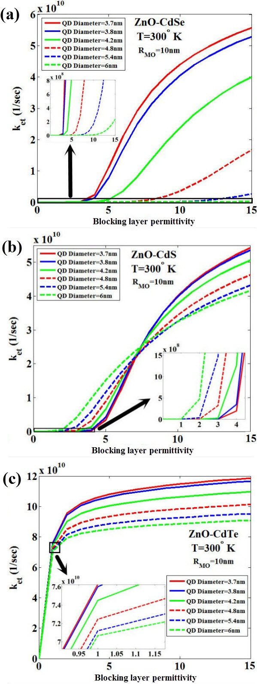
Figure 4. from QD to MO with respect to the blocking layer permittivity, for ZnO metal oxide with CdSe (a), CdS (b) and CdTe (c) quantum dots for 6 different QD diameters.
In the final step, we acquired the results of SnO₂ metal oxide for three mentioned quantum dots. In SnO₂-CdSe, for permittivities less than about 1.7, greater diameters of blocking layer lead to greater rates; the two other combinations show behaviors much like the previous combinations (Figure 5).
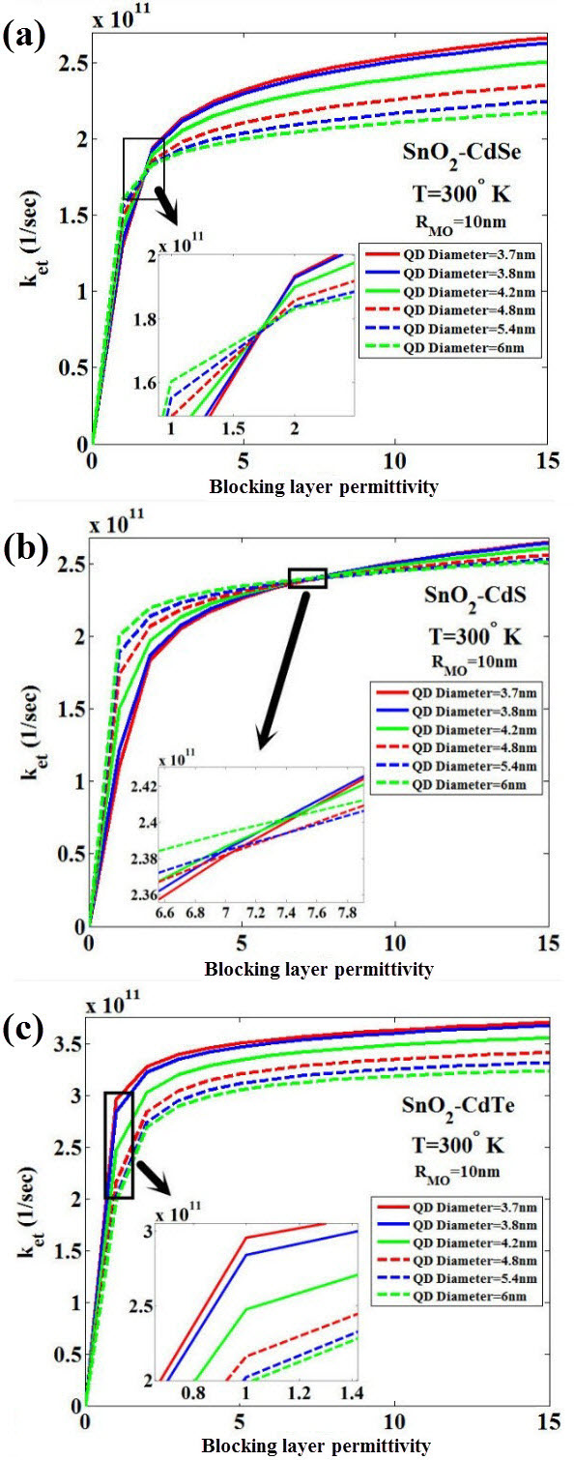
Figure 4. from QD to MO with respect to the blocking layer permittivity, for SnO₂ metal oxide with CdSe (a), CdS (b) and CdTe (c) quantum dots for 6 different QD diameters.
The positions of QD and MO conduction bands have an important role in changing the rates. a change in the permittivity, changes the QD-MO charge, electronic and Coulomb energies; this changes are so that as the QD conduction band becomes more positive as compared to MO’s (with respect to vacuum), increases (otherwise, it will decrease). For example, the increase that was seen in rates for TiO₂-CdS with a specific permittivity, for diameter of 3.7 nm as compared to diameter of 6 nm is because of increasing dominance of electronic energy between MO-QD.

Conclusion
In this paper we have modeled the impact of blocking layer positioned on MO (Metal Oxide) and QD (Quantum Dot) as a new sphere with a new permittivity, and then applied these effects on the QD conduction band edge and free energy of the system. We have obtained the electron transfer rate () from QD to MO for a QDSSC (Quantum Dot Sensitized Solar Cells) using the modified Marcus equation. The changes in versus the blocking layer permittivity were calculated and plotted for six different QD diameters. The obtained results show that, for all combinations of QD-MO, increases with increasing the blocking layer permittivity. For five combinations of QD-MO, the curves of for various QD diameters intersect at one point. For CdSe-TiO₂, CdSe-SnO₂ combinations, the intersection points are placed at small permittivities less than 2, whereas for three CdS-TiO₂, CdS-ZnO and CdS-SnO₂ combinations, the intersection points are placed at larger permittivities about 6.5-7.5.
According to our investigations, the study and simultaneously comparing several types of blocking layers have not been performed up to now. Therefore, the results presented in this research could be useful for better interpretation of experimental observations and also for the design and selection of QD-MO various combinations including the blocking layer in QDSSCs.

References

[1] J. P. Holdren, “Science and technology for sustainable well-being”, Science, Vol. 319, No. 5862, pp. 424-434, 2008.
[2] N. Lior, “Energy resources and use: The present situation and possible paths to the future”, Energy, Vol. 33, No. 6, pp. 842-857 2008.
[3] P. V. Kamat, “Meeting the clean energy demand: nanostructure architectures for solar energy conversion”, The Journal of Physical Chemistry C, Vol. 111, No. 7, pp.2834-2860, 2007
[4] K. W. J. Barnham, M. Mazzer, and B. Clive., ”Resolving the energy crisis: nuclear or photovoltaics?”, Nature materials, Vol. 5, No. 3t pp. 161-164, 2006.
[5] G. J. Meyer, “Molecular approaches to solar energy conversion with coordination compounds anchored to semiconductor surfaces”, Inorganic chemistry Vol. 44, No. 20, pp. 6852-6864, 2005.
[6] K. S. Leschkies, R. Divakar, J. Basu, E. Enache-Pommer, J. E. Boercker, C. B. Carter, U. R. Kortshagen, D. J. Norris, and E. S. Aydil., “Photosensitization of ZnO nanowires with CdSe quantum dots for photovoltaic devices”, Nano Letters, Vol. 7, No. 6, pp.1793-1798, 2007.
[7] W. Gongming, X. Yang, F. Qian, J. Z. Zhang, and Y. Li., “Double-sided CdS and CdSe quantum dot co-sensitized ZnO nanowire arrays for photoelectrochemical hydrogen generation”, Nano letters, Vol. 10, No. 3, pp. 1088-1092, 2010.
[8] K. S. Leschkies, A. G. Jacobs, D. J. Norris, and E. S. Aydil, “Nanowire-quantum-dot solar cells and the influence of nanowire length on the charge collection efficiency”, Applied Physics Letters, Vol. 95, No. 19, pp. 193103, 2009.
[9] P. V. Kamat, “Quantum dot solar cells. Semiconductor nanocrystals as light harvesters”, The Journal of Physical Chemistry C, Vol. 112, No. 48, pp. 18737-18753, 2008.
[10] H. K. Jun, M. A. Careem, and A. K. Arof., “Quantum dot-sensitized solar cells—perspective and recent developments: A review of Cd chalcogenide quantum dots as sensitizers”, Renewable and Sustainable Energy Reviews, Vol. 22, pp. 148-167, 2013.
[11] Zhenhua S., G. Sitbon, T. Pons, A. A. Bakulin, and Z. Chen, “Reduced Carrier Recombination in PbS-CuInS₂ Quantum Dot Solar Cells”, Scientific Reports, Vol. 5, 2015.
[12] K. Zhao, Z. Pan, I. Mora-Seró, E. Cánovas, H. Wang, Y. Song, X. Gong et al., “Boosting Power Conversion Efficiencies of Quantum-Dot-Sensitized Solar Cells Beyond 8% by Recombination Control”, Journal of the American Chemical Society, Vol. 137, No. 16, pp. 5602-5609, 2015.
[13] O. E., Semonin, J. M. Luther, S. Choi, H.-Y. Chen, J. Gao, A. J. Nozik, and M. C. Beard., “Peak external photocurrent quantum efficiency exceeding 100% via MEG in a quantum dot solar cell”, Science, Vol. 334, No. 6062, pp. 1530-1533, 2011.
[14] K. Žídek, K. Zheng, M. Abdellah, N. Lenngren, P. Chábera, and T. Pullerits, “Ultrafast Dynamics of Multiple Exciton Harvesting in the CdSe–ZnO System: Electron Injection versus Auger Recombination”, Nano letters, Vol. 12, No. 12, pp. 6393-6399, 2012.
[15] X. Lan, S. Masala, and E. H. Sargent., “Charge-extraction strategies for colloidal quantum dot photovoltaics”, Nature materials, Vol. 13, No. 3, pp. 233-240, 2014.
[16] M. H. Seo, W. P. Hwang, Y. K. Kim,J. K. Lee, and M. R. Kim, “Improvement of quantum dot-sensitized solar cells based on Cds and CdSe quantum dots”, Photovoltaic Specialists Conference (PVSC), pp. 002652-002655, 2011.
[17] M. A. Abbas, M. A. Basit, T. J. Park, and J. H. Bang., “Enhanced performance of PbS-sensitized solar cells via controlled successive ionic-layer adsorption and reaction”, Physical Chemistry Chemical Physics, Vol. 17, No. 15, pp. 9752-9760, 2015.
[18] J. Kim, H. Choi, C. Nahm, J. Moon, C. Kim, S. Nam, D.-R. Jung, and B. Park., “The effect of a blocking layer on the photovoltaic performance in CdS quantum-dot-sensitized solar cells”, Journal of Power Sources, Vol. 196, No. 23, pp. 10526-10531, 2011.
[19] K. Meng, P. K. Surolia, O. Byrne, and K. R. Thampi, “Efficient CdS quantum dot sensitized solar cells made using novel Cu₂ S counter electrode”, Journal of Power Sources, Vol. 248, pp. 218-223, 2014.
[20] Z. Du, H. Zhang, H. Bao, and X. Zhong., “Optimization of TiO₂ photoanode films for highly efficient quantum dot-sensitized solar cells”, Journal of Materials Chemistry A, Vol. 2, No. 32, pp. 13033-13040, 2014.
[21] Q. Shen, J. Kobayashi, L. J. Diguna, and T. Toyoda., “Effect of ZnS coating on the photovoltaic properties of CdSe quantum dot-sensitized solar cells”, Journal of Applied Physics, Vol. 103, No. 8, pp. 084304, 2008.
[22] J. S. Kang, M.-A. Park, J.-Y. Kim, S. H. Park, D. Y. Chung, S.-H. Yu, J. Kim et al., “Reactively sputtered nickel nitride as electrocatalytic counter electrode for dye-and quantum dot-sensitized solar cells”, Scientific reports, Vol. 5, 2015.
[23] I. Mora-Sero, S. Gimenez, F. Fabregat-Santiago, R. Gomez, Q. Shen, T. Toyoda, and J. Bisquert., “Recombination in quantum dot sensitized solar cells”, Accounts of chemical research, Vol. 42, No. 11, pp. 1848-1857, 2009.
[24] H. Choi, J. Kim, C. Nahm, C. Kim, S. Nam, J. Kang, B. Lee et al., “The role of ZnO-coating-layer thickness on the recombination in CdS quantum-dot-sensitized solar cells”, Nano Energy, Vol. 2, No. 6, pp. 1218-1224, 2013.
[25] L. Yang, C. McCue, Q. Zhang, E. Uchaker, Y. Mai, and G. Cao., “Highly efficient quantum dot-sensitized TiO₂ solar cells based on multilayered semiconductors (ZnSe/CdS/CdSe)”, Nanoscale, Vol. 7, No. 7, pp. 3173-3180, 2015.
[26] K. Zheng, K. Zidek, M. Abdellah, W. Zhang, P. Chabera, N. Lenngren, A. Yartsev, and T. Pullerits, “Ultrafast Charge Transfer from CdSe Quantum Dots to p-Type NiO: Hole Injection vs Hole Trapping”, The Journal of Physical Chemistry C, Vol. 118, No. 32, pp. 18462-18471, 2014.
[27] S. Jiao, Q. Shen, I. Mora-Seró, J. Wang, Z. Pan, K. Zhao, Y. Kuga, X. Zhong, and J. Bisquert, “Band Engineering in Core/Shell ZnTe/CdSe for Photovoltage and Efficiency Enhancement in Exciplex Quantum Dot Sensitized Solar Cells”, ACS nano, Vol. 9, No. 1, pp. 908-915, 2015.
[28] T. Bora, H. H. Kyaw, and J. Dutta., “Zinc oxide–zinc stannate core–shell nanorod arrays for CdS quantum dot sensitized solar cells”, Electrochimica Acta, Vol. 68, pp. 141-145, 2012.
[29] V. González-Pedro, X. Xu, I. Mora-Sero, and J. Bisquert., “Modeling high-efficiency quantum dot sensitized solar cells”, ACS nano, Vol. 4, No. 10, pp. 5783-5790, 2010.
[30] J.-Y. Chang, L.-F. Su, C.-H. Li, C.-C. Chang, and J.-M. Lin., “Efficient “green” quantum dot-sensitized solar cells based on Cu₂S–CuInS₂–ZnSe architecture”, Chemical Communications, Vol. 48, No. 40, pp. 4848-4850, 2012.
[31] C. Chen, Y. Xie, G. Ali, S. H. Yoo, and S. O. Cho., “Improved conversion efficiency of CdS quantum dots-sensitized TiO₂ nanotube array using ZnO energy barrier layer”, Nanotechnology, Vol. 22, No. 1, pp. 015202, 2011.
[32] Y.-L. Lee, B.-M. Huang, and H.-T. Chien., “Highly efficient CdSe-sensitized TiO₂ photoelectrode for quantum-dot-sensitized solar cell applications”, Chemistry of Materials, Vol. 20, No. 22, pp. 6903-6905, 2008.
[33] K. Tvrdy, P. A. Frantsuzov, and P. V. Kamat., “Photoinduced electron transfer from semiconductor quantum dots to metal oxide nanoparticles”, Proceedings of the National Academy of Sciences, Vol. 108, No. 1, pp. 29-34, 2011.
[34] V. Chakrapani, D. Baker, and P. V. Kamat., “Understanding the Role of the Sulfide Redox Couple (S_{2–}/Sn_{2–}) in Quantum Dot-Sensitized Solar Cells”, Journal of the American Chemical Society, Vol. 133, No. 24, pp. 9607-9615, 2011.
[35] J. Tian, and G. Cao., “Semiconductor quantum dot-sensitized solar cells”, Nano reviews, Vol. 4, 2013.
[36] H. Choi, R. Nicolaescu, S. Paek, J. Ko, and P. V. Kamat., “Supersensitization of CdS quantum dots with a near-infrared organic dye: toward the design of panchromatic hybrid-sensitized solar cells”, ACS nano, Vol. 5, No. 11, pp. 9238-9245, 2011.
[37] S. D. Sung, I. Lim, M. S. Kim, and W. I. Lee., “Effect of Ultrathin Al₂O₃ Layer on TiO₂ Surface in CdS/CdSe Co-Sensitized Quantum Dot Solar Cells”, BULLETIN OF THE KOREAN CHEMICAL SOCIETY, Vol. 34, No. 2, pp. 411-414, 2013.
[38] S. S. Rao, I. K. Durga, C. V. Gopi, C. V. Tulasivarma, S.-K. Kim, and H.-J. Kim., “The effect of TiO₂ nanoflowers as a compact layer for CdS quantum-dot sensitized solar cells with improved performance”, Dalton Transactions, Vol. 44, No. 28, pp. 12852-12862, 2015.
[39] Y. Tachibana, K. Umekita, Y. Otsuka, and S. Kuwabata., “Performance improvement of CdS quantum dots sensitized TiO₂ solar cells by introducing a dense TiO₂ blocking layer”, Journal of Physics D: Applied Physics, Vol. 41, No. 10, pp. 102002, 2008.
[40] K. Meng, P. K. Surolia, O. Byrne, and K. R. Thampi., “Quantum dot and quantum dot-dye co-sensitized solar cells containing organic thiolate–disulfide redox electrolyte”, Journal of Power Sources, Vol. 275, pp. 681-687, 2015.
[41] A. Chin, C. C. Liao, C. H. Lu, W. J. Chen, and C. Tsai., “Device and reliability of high-K Al₂O₃ gate dielectric with good mobility and low D_{it}”, VLSI Technology, pp. 135-136, 1999.
[42] D. N. ,Shevarenkov, and A. F. Shchurov., “Dielectric properties of polycrystalline ZnS”, Semiconductors, Vol. 40, No. 1, pp. 33-35, 2006.
[43] M. J. Fahimi, D. Fathi, and M. Ansari-Rad., “Accurate analysis of electron transfer from quantum Dots to metal Oxides in quantum DoT sensitized solar Cells”, Physica E: Low-dimensional Systems and Nanostructures, Vol. 73, pp. 148-155, 2015.
[44] P. K. Santra, P. V. Nair, K. G. Thomas, and P. V. Kamat., “CuInS₂-sensitized quantum dot solar cell. Electrophoretic deposition, excited-state dynamics, and photovoltaic performance”, The Journal of Physical Chemistry Letters, Vol. 4, No. 5, pp. 722-729, 2013.
[45] U. K. Chettiar, and N. Engheta., “Internal homogenization: Effective permittivity of a coated sphere”, Optics express, Vol. 20, No. 21, pp. 22976-22986, 2012.
[46] E.O. Chukwuocha, M.C. Onyeaju, T.S.T. Harry, World J. Condens. Matter Phys. 2 (2012) 96.

