A Novel Fast Algorithm for Detecting Out-of-Step Using Equal Area Criterion

Mohsen Aghazadeh
Graduated student of M.Sc. degree
Department of Electrical Engineering
Iran University of Science and Technology
Tehran, Iran
Email: m.aghazadeh.sh@gmail.com

Ahad Kazemi
Associated Professor
Department of Electrical Engineering
Iran University of Science and Technology
Tehran, Iran
Email: kazemi@iust.ac.ir

Abstract— In an electric power system there is a dynamic balance between generation and load in normal operating conditions. A disturbance, such as a power system fault, a sudden change of load or a trip of a generation unit may break the balance, cause the oscillations among the generator’s rotor angles and force them to adjust to a new operating condition. Due to the inertia of the generator prime movers, the adjustment will not happen instantaneously. When the disturbance is severe, the oscillations do not damp out and lead to an unstable operating conditions called out-of-step or loss of synchronism condition. A new fast algorithm is proposed in this paper to discriminate stable and out-of-step swings effectively. This algorithm uses local voltage and current measurements to classify the stable and out-of-step swings and is very fast (about 20 cycles for frequency of 60Hz) in determining an out-of-step situation compared to that of traditional time domain methods, especially for cases with long fault duration times. This method is a type of classic equal area criterion method mapped in the time domain. Using PSCAD software the proposed algorithm is tested on a single-machine infinite bus equivalent system. Simulation results studied on an equivalent system verify validity of the proposed algorithm.
Keywords- Equal area criterion; out-of-step; power swing; stability; relays.

Introduction
A wide range of small or large disturbances may occur to a power system during operating conditions. Some disturbances may cause loss of synchronism between a generator and the rest of the utility system. In a loss of synchronism situation, it is imperative that the generator or system areas operating asynchronously are separated immediately to avoid widespread outages and equipment damage [1]. Large power swings, stable or unstable, can cause unwanted relay operations at different network locations, which can aggravate further the power system disturbance and possibly lead to cascading outages and power blackouts [2]. Out-of-step protection is designed as an aid to system stability. Out-of-step relays detect the condition in which generators in one part of the system accelerate while generators in another part of the system decelerate; in the event of an out-of-step condition arising, the relay either isolates the generator or splits the system at predetermined points [3], [4]. The power angle (δ) during a power swing oscillates and results in the oscillation of electrical quantities such as frequency, voltage, current, impedance at various locations in the power system. Most of the methods for out-of-step detection are based on sensing the oscillations or the rate of change of one of the system quantities.
Conventional power swing detection schemes can be categorized as double blinders, R-Rdot (augmenting apparent resistance R measurement with rate-of-change of apparent resistance Rdot computation), SCV (Swing Centre Voltage) and its rate of change [5]. These conventional schemes are based on monitoring rate of change of impedance, rate of change resistance and magnitude of SCV and its rate of change respectively. One drawback of the conventional power swing detection methods is that sophisticated system studies are required to determine relay settings. Moreover, the settings are fixed, and will not adapt to ever-changing system operating conditions [5]. Fuzzy logic and artificial neural networks are used in [6] and [7] to detect out-of-step situations. These techniques need an enormous training process to train for all possible swing scenarios. So, by increasing the system interconnections, training process becomes tedious, and also the complexity of these techniques will increase. Recently, Phasor Measurement Unit (PMU) based approaches have been used in detecting out-of-step situations. These techniques need many communication devices at different locations of the system to gather information and are not based on local measurements [8].
Most of the methods mentioned above require an extensive system analysis for relay settings; hence creates a complex system study issue for relay settings for a multi machine power system. Besides this, the blinder scheme does not detect out-of-step condition for fast power swings, and the SCV does not perform well if the system impedance is not close to 90°. The method based on phase angle difference of generators requires extra communication devices [9].
An out-of-step detection technique based on the classical equal area criterion (EAC) in the power angle domain has been proposed in [10]. This technique requires pre- and post-disturbance power-angle (P_{e}-δ) curves of the system to be known to the relay. The P_{e}-δ curves depend on system configuration, so, many measurements and communication devices at various locations are required to gather the current system information. Also, the technique is directly applicable to single machine infinite bus system. Reference [11] extended this technique to a multi-machine system. An out-of-step detection technique using frequency deviation of voltage method has been proposed in [12]. The detection is based on electrical voltage signal which can change very rapidly and may result in false tripping during switching transients.
A novel out-of-step protection technique using the state-plane representation of the generator speed and power angle has been presented in [13]. The critical clearing angle is computed using the principle that the total energy of the system at the instant the fault is cleared should be equal to the maximum potential energy of the system. The critical clearing time corresponding to the value of critical clearing angle is obtained directly using the time calibration of the relative speed versus power-angle solution curve. This technique is accurate and does not need any offline studies. In [14], a new technique based on wavelet singular entropy (WSE) was proposed for fault detection and out-of-step blocking protection during power swing. This combines WT and Shannon entropy for providing a quantitative output, which can act as an automatic feature extractor for deriving the relaying function during power-swing situations. Local operation of distance relays needs to be blocked using out-of-step blocking (OSB) function. In order to separate different areas of power system at predetermined locations during an out of step phenomena, conventional blinder-based methods to implement the OSB function cannot detect a symmetrical fault once the relay is blocked during a power swing. Detection methods for power swing and symmetrical faults, based on mathematical morphology are described in [15].
Reference [16] applies the above concept of EAC modified to the time domain. The time domain EAC is based on the power-time (P_{e}-t) curves instead of the P_{e}-δ curves and uses only local electrical output power information. The time domain EAC technique does not need any other power system parameter information such as line impedances, equivalent machine parameters, etc. The electrical output power over time is calculated from local current and voltage information measured at the relay location. The transient energy, which is the area under the P_{e}-t curve, is computed, and the swing is classified as stable or out-of-step based on the areas computed. However, for longer fault duration times that lead to an out-of-step swing, this technique is not suitable and its response is very late. One disadvantage of this technique is that the unstable condition is again detected close to 180° and, hence, the opening of the breakers have to be delayed until the angle of separation between the two side voltages becomes a favorable angle (to reduce the re-striking voltage level).
In this paper this problem has been discussed broadly, and a new algorithm based on the same technique, i.e., EAC in the time domain is proposed; which is very fast (about 20 cycles for a frequency of 60Hz) in detecting an out-of-step situation. The effectiveness of the proposed algorithm has been studied on a single-machine infinite-bus (SMIB) equivalent system, and simulation results show that the algorithm is able to detect out-of-step situation very fast compared to that of expressed in [16].
This paper is organized as follows: EAC in the time domain is presented in section 2; the proposed algorithm is explained in section 3; in section 4 simulation results are presented, and finally conclusions are given in section 5.

EAC in the time domain
The area under the power curve is analogous to energy. So, this concept is based on the energy balance in the system during the transient. The EAC concept in the time domain is obtained from the swing equation. Fig. 1 shows the Pe-δ curves for an unstable system. The Pe-t curves corresponding to the Pe-δ curves are shown in Fig. 2.
EAC in time domain uses Pe-t curves to determine out-of-step or stable situations of the system. Based on EAC in δ domain, area A1 must be equal to area A2 for a stable system and area A2 occurs before π-δ0. For an unstable system the area A1 is greater than area A2, and the area A2 occurs at π-δ0. It is shown in [16] that mathematical expressions for evaluating A1 and A2 areas in time domain are derived from swing equation. The three phase power output of the generator is calculated is:
                 
Where, V_{p}^{i} represents peak voltage, I_{p}^{i} represents peak current, θ₁^{i} represents phase angle of voltage, θ₂^{i} represents phase angle of the i-th phase. The phasors of voltages and currents of three phases are determined based on DFT technique. For a stable condition:
         
and for an out-of-step condition:
         
where,
is the time when first occurs;
is the time when (stable)
Or the time when and
(Out-of-step)
where,

is the sampling interval.
While implementing using a digital hardware, for a stable system, the calculated area A does not become exactly equal to zero. Thus the condition is modified for a stable system as,
                
Based on this algorithm, decision regarding stable or out-of-step condition is always made at t_{max} (time corresponding to δ_{max}) with an error of ∆δ or less. The algorithm depends only on P_{e} which can be obtained from the point where the out-of step relay is installed. Thus, the proposed algorithm is entirely based on the local measurements. The flowchart of EAC in time domain is shown in Fig. 3. In this flowchart it is assumed that, disturbance occurs when change in P_{e} value is greater than 10%.
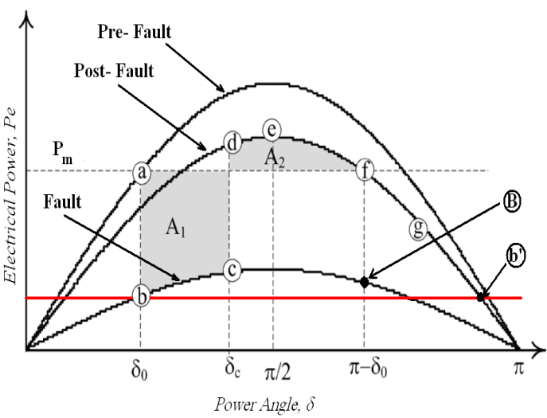

- P_{e}-δ curve for an unstable case
- P_{e}-t cure for an unstable case [16]

- Flowchart of common algorithm

Proposed Algorithm
EAC in the time domain has been studied in [16] in details to classify out-of-step and stable conditions. In this section we mention one drawback of that algorithm and propose a new algorithm to obviate this shortcoming. Fig. 4 shows a SMIB system configuration used to illustrate and compare these two algorithms. A three phase fault is applied at the middle of TL-II. The fault is cleared with some delay (point ‘c’ in Fig. 1) by simultaneously opening the two breakers ‘A’ and ‘B’.
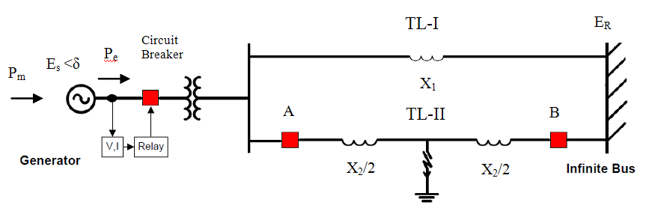

- Single-Machine Infinite Bus System
As shown in Fig. 1, fault is cleared at point ‘c’ and after some time intervals A1 and A2 areas are formed. After A1 and A2 areas are compared, common algorithm (used in [16]) makes a decision at point ‘f’ and classifies the situation as out-of-step or stable. In fact, process of this algorithm will end if and only if both areas (A1 and A2) are computed and compared. When area A2 is formed, it is compared to area A1 and decision is made, otherwise algorithm continues computing area A1.
Now assume that fault, instead of point ‘c’, is cleared at point B or angles greater than that point (Fig. 1. According to equal area criterion and Fig. 21, it is obvious that there will not be formed any area such as A2. Hence, the swing is out-of step. In this case, P_{e}-δ curve (or corresponding P_{e}-t curve, Fig. 5) first goes to ‘f’ and ‘g’, then moves down to adjust to a point which has an electrical power equal to point ‘b’, called ‘b'’. It is seen from Fig. 5 that after passing point ‘g’, P_{e}-t curve passes point ‘b'’ as well. The proposed algorithm is able to detect point ‘b'’ and after that, the algorithm will end and declare the out-of-step condition. In the common algorithm, it waits until point ‘M’ (when area A2 is formed and computed) and then decision is made. Point ‘b'’ is accessible earlier than point ‘M’ (see Fig. 5). Hence, the proposed algorithm is faster than the traditional one. Simulation results in the next section verify this conclusion.
Flowchart of the proposed algorithm is shown in Fig. 6. The dashed section is the part added to the common algorithm. In some cases when fault duration time is long and it is cleared at point ‘B’ or larger angles in Fig. 1, the proposed algorithm declares an out-of-step condition at point ‘b'’ (Fig .5) and is faster than the common algorithm. In Fig. 5 during P_{e} ≤ P_{m} and when the P_{e}-t curve has passed by point ‘b’, the first point which has an electrical power equal to the point ‘b’ will be named ‘b'’. Considering some errors in calculation of P_{e} , it is put (0.9)*P_{b'} as the criterion for the algorithm to end and determine the out-of-step situation, i.e. in the P_{e}-t curve when P_{e} reaches a point which has an electrical power equal to (0.9)*P_{b'} (after passing by point ‘b’). Then algorithm ends and determines an out-of-step situation.
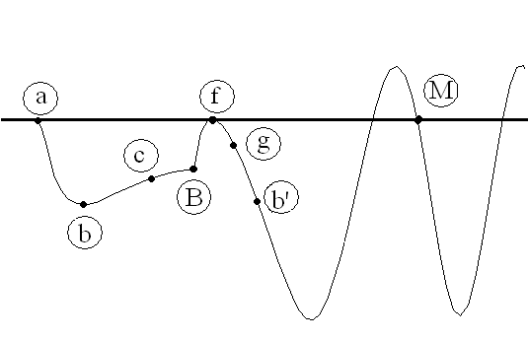
Electrical Power, P_{e}
Time, s

- P_{e}-t sample curve corresponding to P_{e}-δ curve shown in Fig. 2.

- Flowchart of the proposed algorithm.

Simulation Results
PSCAD software was used to carry out the simulations. First, a three phase fault is applied at the middle of TL-II (see Fig. 4). Then, fault is cleared with some delay by simultaneously opening the two breakers ‘A’ and ‘B’. The pre-fault power angle is set at 30 ̊ and six different simulations are carried out with fault duration times of 0.167, 0.233, 0.32, 0.4, 0.45 and 0.5s. Results as P_{e}-t curves are shown in Fig. 7. It is seen from Fig. 7 (a)-(f), by increasing fault duration time, swings becomes unstable.
The fault duration time of 0.167 s makes the system stable whereas the other fault duration times result in an out-of-step condition. The Pe-t curves are shown in Fig. 7. (a)-(f) and results are summarized in Table I. In this table ‘Old’ refers to common algorithm used in [16] and ‘New’ refers to the algorithm proposed in this paper.

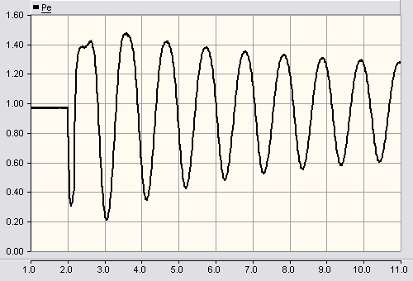
P_{e}, pu
Time, s
- t=0.167 s

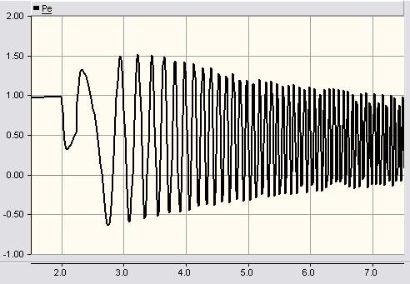
P_{e}, pu
Time, s
- t=0.233 s

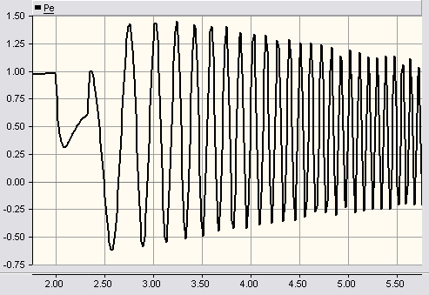
P_{e}, pu
Time, s
- t=0.32 s

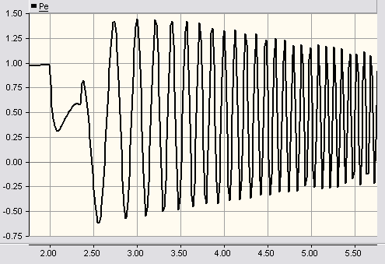
P_{e}, pu
Time, s
- t=0.35 s
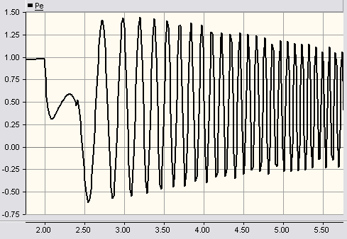
P_{e}, pu
Time, s
- t=0.4 s

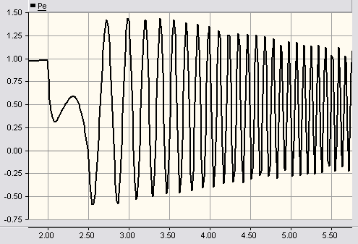
P_{e}, pu
Time, s
- t=0.5 s

- P_{e}-t curves of generator for various fault duration times

Only for fault duration time t=0.167 s, situation is stable. The corresponding P_{e}-t curve is shown in Fig. 7 (a). For fault duration times t=0.233 s and t=0.32 s, P_{e}-t curves are still able to form area A2, although for 0.32 s, area A2 is very small. For last three cases with fault duration times greater than 0.32 s, A2=0; it means that in this way out-of-step situation is determined before calculating area A2 and the proposed algorithm doesn't wait to calculate area A2. So, the proposed algorithm is very fast compared to the common algorithm (about 0.33 s earlier). 0.33 s is equal to about 20 cycles for a 60 Hz frequency. So, it is able to detect out-of-step swings for some cases (when fault clearing time is long and area A2 is not formed) about 20 cycles earlier than the common algorithm. In fact, for last three cases the common algorithm awaits P_{e}-t curve to reach point ‘M’ and form area A2, but it is too late to make the decision. Fig. 8 compares results obtained from simulations. It is seen that the new algorithm is very faster compared to the common algorithm. Note that, for first three cases when area A2 is formed and is not equal to zero, both algorithms have the same results and decision times are equal. But, when fault duration time gets larger, there is a big difference in decision times between two algorithms. The instability criterion discussed shows that this algorithm is simple to apply and is able to detect out-of-step situations easily.

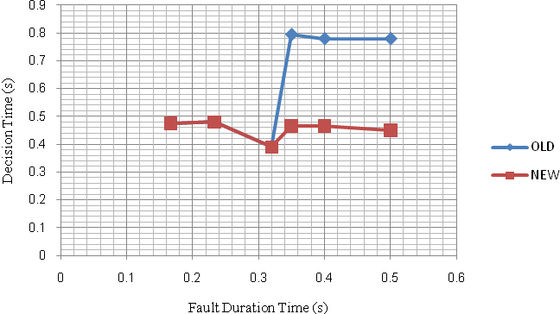

- Comparison of decision times for two algorithms

- Summary of stable and out-of-step swings on a SMIB system

Fault Duration Time, s | 0.167 |  | 0.233 |  | 0.32 |  | 0.35 |  | 0.4 |  | 0.5
Fault Duration Time, s | Old* | New** | Old | New | Old | New | Old | New | Old | New | Old | New
Area (A1) , pu-s | 0.1013 | 0.1013 | 0.13 | 0.13 | 0.1661 | 0.1661 | 0.4583 | 0.2133 | 0.4656 | 0.2295 | 0.4687 | 0.2185
Area (A2) , pu-s | -0.1038 | -0.1038 | -0.0514 | -0.0514 | -0.0009 | -0.0009 | -0.031 | 0 | -0.0298 | 0 | -0.0296 | 0
A=A1+A2 | -0.0025 | -0.0025 | 0.0787 | 0.0787 | 0.1652 | 0.1652 | 0.4273 | 0 | 0.4258 | 0 | 0.4391 | 0
Decision Time, s | 0.475 | 0.475 | 0.48 | 0.48 | 0.39 | 0.39 | 0.795 | 0.465 | 0.79 | 0.46 | 0.78 | 0.45
Decision | stable | stable | OS*** | OS | OS | OS | OS | OS | OS | OS | OS | OS

* Old: Common algorithm
**New: Proposed algorithm
***OS: Out-of-step

Conclusion
In this paper, a new algorithm for equal area criterion conditions in the time domain method is proposed to detect an out-of-step situation. The discrimination between stable and out-of step swings is done using the accelerating and decelerating energies, which represents the area under the P_{e}-t curve. The proposed algorithm is very fast in comparison to the common algorithm, about 20 cycles for frequency of 60 Hz, especially for cases where fault duration times are long.
The effectiveness of this algorithm was tested on a SMIB system and simulation results approved the conclusion. The proposed algorithm perfectly discriminated between stable and out-of-step swings based on the local voltage and current information available at the relay location. This algorithm does not require any line parameter information or off-line system studies and is easy to apply.

References
- Tziouvaras, Demetrios A., and Daqing Hou. "Out-of-step protection fundamentals and advancements." Protective Relay Engineers, 2004 57th Annual Conference for. IEEE, 2004.
- IEEE PSRC WG D6, “Power Swing and Out-of-setp Considerations On Transmission Lines." Final draft, June 2005.
- Kosterev, N. V., V. P. Yanovsky, and D. N. Kosterev. "Modeling of out-of-step conditions in power systems." Power Systems, IEEE Transactions on 11.2 (1996): 839-844.
- Machowski, Jan, Janusz Bialek, and Jim Bumby. Power system dynamics: stability and control. Wiley, 2011.pp. 184–215.
- Ambekar, Vinaya. A.; Dambhare, Sanjay. S.; , "Out of step detection using synchronized swing impedance and resistance measurement," Developments in Power Systems Protection, 2012. DPSP 2012. 11th International Conference on. IET , pp.1-4, 23-26 April 2012
- Abdelaziz, Almoataz Youssef, et al. "Adaptive protection strategies for detecting power system out-of-step conditions using neural networks."Generation, Transmission and Distribution, IEE Proceedings-. Vol. 145. No. 4. IET, 1998.
- Rebizant, W., and K. Feser. "Fuzzy logic application to out-of-step protection of generators." Power Engineering Society Summer Meeting, 2001. Vol. 2. IEEE, 2001.
- Bozchalui, M. Chehreghani, and M. Sanaye-Pasand. "Out of step relaying using phasor measurement unit and equal area criterion." Power India Conference, 2006 IEEE. IEEE, 2006.
- Sumit Paudyal, Out-of-step protection using energy equilibrium criterion in the time domain, M.Sc dissertation, University of Saskatvhewan: Canada, 2008.
- Centeno, V., et al. "An adaptive out-of-step relay [for power system protection]."Power Delivery, IEEE Transactions on 12.1 (1997): 61-71.
- Y. Xue, T. Van Custem, and M. Ribbens-Pavella, “Extended equal area criterion justifications, generalizations, applications,” IEEE Trans.Power Syst., vol. 4, no. 1, pp. 44–52, Feb. 1989.
- K. H. So, J. Y. Heo, C. H. Kim, R. K. Aggarwal, and K. B. Song, “Out-of-step detection algorithm using frequency deviation of voltage,” IET Gen., Transm. Distrib., vol. 1, no. 1, pp. 119–126, 2007.
- Shrestha, B.; Gokaraju, R.; Sachdev, M. “Out-of-Step Protection Using State-Plane Trajectories Analysis.”; IEEE T Power Delivery. 2013, 27, 1083-1093.
- Dubey, R.; Samantaray, S.R. “Wavelet Singular Entropy-based Symmetrical Fault-Detection and Out-of-Step Protection during Power Swing.”; IET Gener Transm Dis. 2013, 7, 11923-1134.
- Gautam, S.; Brahma, S.M. “Out-of-Step Blocking Function in Distance Relay Using Mathematical Morphology.”; IET Gener Transm Dis. 2012, 6, 313-319.
- Paudyal, Sumit, Gokaraju Ramakrishna, and Mohindar S. Sachdev. "Application of equal area criterion conditions in the time domain for out-of-step protection." Power Delivery, IEEE Transactions on 25.2 (2010): 600-609.

