Electric Arc Furnace Reactive Power Variations Modeling by Grey Systems

Haidar Samet**1** Aslan Mojallal**1**

samet@shirazu.ac.ir aslan.6889@gmail.com

**1**School of Electrical and Computer Engineering, Shiraz University, Shiraz, Iran

*Abstract*—One of the most significant sources of low frequency voltage fluctuations (known as flicker) in power systems is Electric Arc Furnace (EAF). Flicker has negative effect on power quality of system and is required to be mitigated. To this end, reactive power compensation devices like Static VAr Compensator (SVC) are employed. However, reactive power measurement and thyristor ignition delays limit SVC's ability to compensate flicker. In order to mitigate flicker further, prediction methods are employed to provide an accurate reference signal for these devices. In this paper, two Grey System models are proposed. These methods are GM(1,3) and GM(0,3). Finally, by employing flicker related indices the efficiency of these methods for flicker reduction is investigated.

Keywords— Electric arc furnace, Flicker reduction, Reactive power compensation, Grey system theory, Prediction

# Introduction

Electric arc furnaces (EAFs) act as major part in various branches of industry especially in the steel production process owing to their exceptional performance, accuracy and flexibility. However, the time-varying nature of EAFs introduces a phenomenon which is also known as flicker. Flicker is defined as low frequency (usually in a range around 0.5 to 25 Hz) fluctuations in voltage.

VAr compensators including Static VAr Compensators (SVCs) are widely employed to mitigate the influence of flicker. It should be noted that reactive power measurement and thyristor ignition delays can limit SVC's ability to compensate flicker. Faster devices of compensation, like static synchronous compensators (STATCOMs) can be employed to enhance the flicker reduction performance. However, these solutions are generally expensive. Therefore, it seems logical to develop approaches in order to compensate this delay and enhance the performance of SVC. These approaches are mainly based on prediction of EAF reactive power consumption for a half-cycle ahead [1]. In [2], the reactive power signal is considered as time series and the prediction is made by considering reactive power variations as an Auto Regressive Moving Average (ARMA) process. Time series are defined as a collection of data points which are sampled equally in time intervals. The process by which the future values are forecasted based on information obtained from past and present time is regarded as time series prediction. Mainly, there are two techniques for time series prediction, statistical and artificial intelligence based approaches. ARMA can be regarded as statistical models while neural network models are mainly perceived as artificial intelligence based approaches. Both of these techniques have some drawbacks. For instance, in non-linear problems, statistical models are not as accurate as neural network based approaches. They may also be too complex in order to predict future values of time series. Neural network models, on the other hand, can provide accurate results but the major criticism about them is that they require a great amount of training data.

Deng (1982) introduced Grey System Theory for the first time. Ever since this theory is broadly used in numerous branches of science including finance, agriculture, economics, engineering, etc [3-7]. The followings are a number of studies conducted into Grey System Theory: In [8], Grey system modeling is used to predict the yearly peak load of a power system. In [9], several different Grey system theory-based models are applied on the United States dollar to Euro parity. Furthermore, a combination of Grey System Theory and other prediction methods are used in order to enhance the accuracy of prediction. For instance in [10], a hybrid method is proposed to reduce the error of a dynamically tuned gyroscope using wavelet and linear regression techniques integrated into Grey system model. Additionally, fuzzification techniques are used in combination with Grey system theory to forecast the stock prices in [11].

In some research projects, prediction approaches are utilized to forecast reactive power consumption of an EAF. For example, in order to calculate ARMA coefficients to predict the reactive power of an EAF, stochastic approaches like adaptive filter methods Normalized Least Mean Square (NLMS) and Recursive Least Square (RLS) are employed in [12] while online genetic algorithm is employed in [13]. Using these methods improve the compensation process by SVC. In [14], a one variable and first order Grey system model*, GM (1,1),* is used to predict the reactive power compensation of EAFs. In [14], it is shown that in comparison with statistical models, Grey system is much faster and requires less computation cost, and also compared to neural network model it requires less data to predict. These advantages made Grey System models an excellent choice for predicting arc furnace reactive power consumption.

In this research effort, reactive power compensation of one phase of an EAF is predicted using the past and present reactive power values of all three phases. To this end, Actual data of Mobarakeh Steel Company (MSC), Isfahan, Iran is used. Furthermore, zero and first order of Grey System models are employed (*GM(0,3)* and *GM(1,3)*). The results of this research work demonstrate the superiority of *GM(0,3)* over *GM(1,3)* for EAF's reactive power prediction. The rest of this paper is categorized as follows. Zero and first order of Grey System models are defined section II. Data records employed in the prediction are introduced in section III. Indices which are used to evaluate the performance of prediction method are introduced in section IV. Prediction results are given in section V and conclusions are drawn in section VI.

# Grey System: GM(0,N) and GM(1,N)

The followings are the basic definitions and equations which are employed in order to predict using Grey system theory [15–16].

## Accumulated Generating Operation (AGO)

By performing AGO the raw data series that should be modeled and predicted, will transform into smoother and exponentially increasing time series. This alteration will makes it possible to use zero and first order differential equations to describe the behavior of system. The main goal of AGO is to transform irregular and random series of data into a smooth series with less random characteristics For example, consider the following sequence:

*X(0)=(2,4,7,5,9,1)*

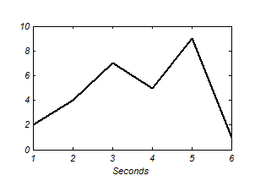

Fig. 1. The original set of data.

Now let X(1) be the first-order AGO of X(0). First-order AGO can be presented as:



So X(1) would become:

X(1)=(2,6,13,18,27,28)

Original data and the data that is processed by AGO are shown in Fig.1 and Fig.2. Clearly, AGO reduces the randomness of original data while turning this into a mono-increasing series.

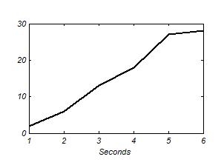

Fig. 2.The processed data by AGO.

## Zero-Order Grey System Model GM(0,N)

*GM(0,N)* denotes a Grey System model which employs zero-order differential equation while *N* stands for the number of variables. An important consideration when using *GM(0,N)* and *GM(1,N)* is that only non-negative raw data can be used. In other words, *X(1)* should become mono-increasing.

The following illustrates the implementation of *GM(0,N)* models. Assume the *i*th initial sequence of data as:

*Xi(0)=[ Xi(0)(1), Xi(0)(2), ... , Xi(0)(n)]* 

By applying AGO we have:

*Xi(1)=[ Xi(1)(1),Xi(1)(2), ... , Xi(1)(n)]* 

Now using *X(1)* we generate the mean sequence *Z(1)* which can be defined as:

*Zi(1)(k)=0.5Xi(1)(k)+0.5Xi(1)(k-1) , k=2,3,...,n.* 

The Grey model of *GM (0,N)* can be defined as:

*X1(1)(k) = b2X2(1) + b3X3(1) +… + bNXN(1) + a* 

Then the least square estimate of the parameter sequence (*b2 ,b3, … ,bN, a*):



where *B* and *Y* can be calculated as:





After determining the prediction parameters the prediction of *k+1* th value of *X1(1)* can be done using (5). Finally, the value of *k+1* the element of *X1(0)* can be obtained using:



For long input sequences with large amount of data another approach is conventional. In this method, which is called rolling Grey System, when a new entry is inserted the last data goes out and the number of samples which are used in the prediction process will remain constant. Due to large number of data samples, this method is employed in this study.

## First-Order Grey System Model GM(1,N)

The Grey model of *GM(1,N)* employs a first-order differential equation to model the relationship of one variable to *N* variables. This relationship can be presented as:



Equation (10) is regarded as *GM(1,N)* Grey differential equation. Using least square method, unknown parameters in (10) can be calculated:



where





As final step, *k+1* th value of *X1(1)* sequence can be obtained using:

|  |  |
| --- | --- |
|  |  |

And by performing inverse of AGO on (14) the predicted value of original time series can be acquired.

# Data records

In order to obtain an accurate model to predict system reactive power, a large amount of information about the nature of EAFs is required. In this paper actual voltage and current data of MSC are collected and used to calculate the reactive power. A single line diagram of the EAFs system is shown in Fig. 1. This plant includes a step-down transformer to reduce the voltage level from 400 kV to 66 kV for EAFs transformers and 33 kV for two SVCs that are aimed to mitigate the flicker problem. In practice each SVC includes a 108 MVAr TCR and 97.2 MVAr capacitor banks to filter the harmonics.

Voltage and currents values are measured at the primary side of arc furnace transformer and each data set is sampled with 128 μs sampling time (or the sample frequency is 7812.5 Hz). Data sets include records that cover 100 s of the EAF operation. For efficient operation of SVC, it should be provided with a signal that precisely indicates the fundamental reactive power of the furnace. One suitable option is the fundamental reactive power of the arc furnace calculated at each period with one cycle integration period and updated in each half cycle [17]. Therefore 100 s data records will produce time series of reactive power with 10000 (=100/0.01).

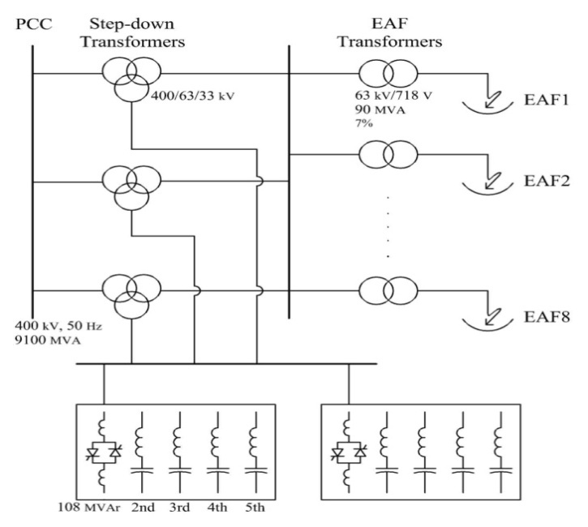

Fig. 3. Single line diagram of EAFs installed in MSC [17]

# Prediction performance evaluation

Because the main concern of this paper is the performance of compensators, like SVC, facing flicker produced by EAFs, some indices will be defined in order to assess the performance of SVC using different methods of prediction [12, 17]. These indices use PSD of prediction error signal *e* which is the difference between the forecasted value and the real value of EAF reactive power and is defined as [18]:



Where *N*, *PSD*, *f* and *fs*, denote the data record length, the value of *PSD* at frequency *f* and the sampling frequency (that is equal to 100Hz for reactive power time series) respectively. The first index is flicker mitigation factor (FMF) which basically considers weighted prediction error corresponding to each data record j and is defined as [17]:



where *PSDjq (f)* denotes the *PSD* associated with the *j* th source reactive power data record in the absence of SVC and *PSDjqs (f)* denotes the *PSD* associated with the *j* th source reactive power data record in the presence of SVC and *c(f)s* are the weighting flicker factors proposed by IEC [19].

In the control systems, prediction of the future data can be perceived as a high pass band filter which may magnify the high frequency components [17]. Therefore, High frequency mitigation factor (HMF), which considers frequencies ranging from 16 to 25 Hz, is used to evaluate the performance of the proposed prediction method and compare it with conventional approaches. HMF is defined as [17]:



Standard deviation (STD) is also used to compare the results of the Grey system method with other methods of prediction.

# Simulation results

The results of comparison between *GM(0,3)* and *GM(1,3)* on 10 three-phase data sequences of reactive power calculated from actual voltage and current values of Mobarakeh Steel Company is brought in this section. Reactive powers of all three phases are used to predict the reactive power of one phase. To this end, the indices introduced in section 4 will be used to assess the efficiency of the proposed methods.

Fig. 4 shows a typical reactive power consumption of one phase of an EAF. Without using any means of prediction, reactive power consumption of precious sample is considered as reference signal of SVC. However, by predicting the reactive power consumption of EAF, predicted value will be considered as reference signal for SVC.

1. Standard deviation of proposed methods

|  |  |  |  |
| --- | --- | --- | --- |
| STD | | | |
| GM(1,3) | GM(0,3) | No prediction | Record Number |
| 0.13034 | 0.04098 | 0.19990 | 1 |
| 0.12520 | 0.04035 | 0.20120 | 2 |
| 0.04192 | 0.02481 | 0.21900 | 3 |
| 0.06076 | 0.02131 | 0.15230 | 4 |
| 0.04703 | 0.01354 | 0.15300 | 5 |
| 0.03051 | 0.01960 | 0.13550 | 6 |
| 0.07671 | 0.03784 | 0.22250 | 7 |
| 0.10341 | 0.02913 | 0.18000 | 8 |
| 0.07648 | 0.02412 | 0.16780 | 9 |
| 0.07881 | 0.02454 | 0.16820 | 10 |
| 0.0771 | 0.0276 | 0.1799 | Mean |

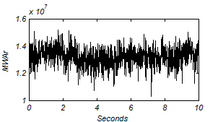

Fig 4. Reactive power consumption of EAF.

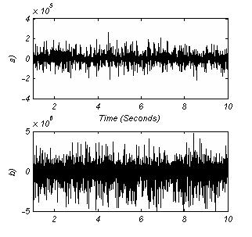Fig 5. Prediction error for a sequence of reactive power a) by GM(0,3) b) by GM(1,3).

In this study, zero and first order rolling Grey System with entry data interval equal to 5 are used to predict the reactive power consumption of one phase.

1. FMF of proposed methods

|  |  |  |  |
| --- | --- | --- | --- |
| FMF | | | |
| GM(1,3) | GM(0,3) | No prediction | Record Number |
| 0.03078 | 0.00262 | 0.08460 | 1 |
| 0.02775 | 0.00249 | 0.09190 | 2 |
| 0.01102 | 0.00070 | 0.08580 | 3 |
| 0.04632 | 0.00093 | 0.07730 | 4 |
| 0.03343 | 0.00048 | 0.10550 | 5 |
| 0.01213 | 0.00087 | 0.05700 | 6 |
| 0.09608 | 0.00398 | 0.12870 | 7 |
| 0.08560 | 0.00111 | 0.06580 | 8 |
| 0.03533 | 0.00057 | 0.06120 | 9 |
| 0.03422 | 0.00057 | 0.06380 | 10 |
| 0.0413 | 0.0014 | 0.0822 | Mean |

1. HMF of proposed methods

|  |  |  |  |
| --- | --- | --- | --- |
| HMF | | | |
| GM(1,3) | GM(0,3) | No prediction | Record Number |
| 0.72166 | 0.06347 | 1.33570 | 1 |
| 0.60878 | 0.05670 | 1.34790 | 2 |
| 0.37455 | 0.02374 | 1.31350 | 3 |
| 1.45129 | 0.03111 | 1.27690 | 4 |
| 1.24936 | 0.01799 | 1.22990 | 5 |
| 0.76150 | 0.05301 | 1.29370 | 6 |
| 0.95285 | 0.04254 | 1.30990 | 7 |
| 2.63203 | 0.03585 | 1.31090 | 8 |
| 0.69878 | 0.01325 | 1.23490 | 9 |
| 0.79795 | 0.01348 | 1.20420 | 10 |
| 1.0249 | 0.0351 | 1.2857 | Mean |

Fig. 5a shows the error of prediction using *GM(1,3)* while Fig. 5b presents the prediction error of *GM(0,3)* for one sequence of reactive power. Furthermore, standard deviation of reactive power at the source side for these two prediction methods and compensation without prediction is brought in Table 1. FMF and HMF of the proposed methods are given in Table 2 and 3 respectively.

According to Tables 1 to 3, both of the proposed methods enhance the performance of compensation systems and reduce flicker. However, *GM(0,3)* performs remarkably better and reduces flicker related indices more than *GM(1,3).* Hence, for flicker reduction and reactive power compensation applications, *GM(0,3)* is much more preferable.

# Conclusions

In this paper Grey system theory was employed to predict the reactive power consumption of EAF at the SVC bus. *GM (0,3)* and *GM(1,3)* rolling model with entry data interval equal to 5 was used for prediction. For the purpose of comparison, three indices were introduced to measure the effectiveness of these approaches. These indices mostly concern about the effects of flicker and evaluate the performance of these approaches in relatively low frequency. It is demonstrated that both of these methods enhance the performance of SVC in comparison to the system which does not use any prediction. Also, the results of these two methods were compared with each other. It is confirmed that *GM(0,3)* has better performance than *GM(1,3)*.

##### References

1. H. Samet and M. Parniani, "Predictive Method for Improving SVC Speed in Electric Arc Furnace Compensation," *IEEE Trans. on Power Delivery, vol. 22, no. 1, Pages 732_734,* January 2007
2. H. Samet and M.E.H Golshan, "Employing Stochastic Models for Prediction of Arc Furnace Reactive Power to Improve Compensator Performance," *IET Generation, Transmission & Distribution, vol. 2, issue 4, Pages 505_515,* July 2008
3. S. Liu and J. Forrest, "The Current Developing Status on Grey System Theory," *The Journal of Grey System2 (*2007*)*
4. D. Proske and P.H.A.J.M Van Gelder, "Prediction of Complex Systems Using Grey Models," *ECI Conference on Geohazards*, 2006
5. E. Kayacan, Y. Ozin and O. Kaynak, "Grey System Modeling Approach for Sliding-Mode Control of Antilock Braking System," *IEEE Trans. on Industrial Electronics, vol. 56, no. 8 pp.3244_3252,* August 2009
6. S. Hui, F. Yang, Z. Li, Q. Li and J. Dong, "Application of Grey System Theory to Forecast the Growth of Larch," *International Journal of Information and Systems Sciences, vol. 5, no. 3-4, Pages 522_527*, 2009
7. Y. Huang and T. Yu, "The Hybrid Grey-Based Models for Temperature Prediction," IEEE Trans. on Systems, Man, and Cybernetics, Part B: Cybernetics, vol. 27, no. 2, Pages 284_292, April 1997
8. H. Yang, T. Liang, K. Shih and C.Huang, "Power System Yearly Peak Load Forecasting: A Grey System Modeling Approach," *International Conference on Energy Management and Power Delivery, vol. 1, Pages 261_266,* November 1995
9. E. Kayacan, B. Ulutas and O. Kaynak, "Grey System Theory-Based in Time Series Prediction," *Expert Systems with Applications, vol. 37, issue 2, Pages 1784_1789,* March 2010
10. C. Fan, Z, Jin and W. Tian, "A Hybrid Grey-Based Model for Drift Signal of DTG," IEEE International Conference on Neural Networks and Signal Processing, vol. 2, Pages 1702_1705, December 2003
11. Y. F. Wang, "Predicting of Stock Price Using Fuzzy Grey Prediction Systems," *Expert Systems with Applications, vol. 22, issue 1, Pages 33_38,* January 2002
12. M. E. Hamedani Golshan and H. Samet, "Updating Stochastic Model Coefficients for Prediction of Arc Furnace Reactive Power," *Electric Power Systems Research, vol. 79, issue 7, Pages 1114_1120,* July 2009
13. M. E. Hamedani and H. Samet, "Updating Stochastic Models of Arc Furnace Reactive Power by Genetic Algorithm," *14th International Conference on Harmonics and Quality of Power, Pages 1_9,* September 2010
14. H. Samet, A. Mojallal and T. Ghanbari, "Employing Grey System Model for Prediction of Electric Arc Furnace Reactive Power to Improve Compensator Performance," *PRZEGLĄD Elektrotechniczny, R. 89 NR 12, Pages 110-115, 2013*.
15. D. Julong, "Introduction to Grey System Theory," *The Journal of Grey System 1 (*1989*), Pages 1_24*
16. N. Shimizu, O. Ueno and C. Komata, "Introduction of Time Series Data Analysis Using Grey System Theory," *2nd International Conference on Knowledge-Based Intelligent Electronic Systems, Pages 67_72,* April 1998
17. H. Samet, M. R. Farhadi and M.R.B. Mofrad, "Employing Artificial Neural Networks for Prediction of Electrical Arc Furnace reactive Power to Improve Compensator Performance," *IEEE International Energy Conference and Exhibition (ENERGYCON), Pages 249_253,* September 2012
18. P. Stoica and R. L. Moses, "Introduction to Spectral Analysis," *Prentice Hall,* 1997
19. IEC Standard 868, Flicker Meter-Functional and Design Specifications, 1996