Locating Partial Discharge in Power Transformers
Using Signal Energy

Mehdi Allah Bakhshi
Assistant Professor
Electrical and Computer Engineering
Shiraz University
Shiraz, Iran
Email: Allahbakhshi@shirazu.ac.ir

Masoud Karami
M.Sc Student
Electrical and Computer Engineering
Shiraz University
Shiraz, Iran
Email: Masoudkarami2011@gmail.com

Davood Keshavarzi
M.Sc Student
School of Electrical and Computer Engineering
Shiraz University
Shiraz, Iran

Abstract— Partial discharge is one of the most important factors in the gradual destruction of the transformer insulation which ultimately may cause complete failure. This paper locates partial discharge in power transformer based on the ratio of signal energy received from bushing to neutral of the winding in response to the occurrence of partial discharge. To evaluate this method, partial discharge current pulses are injected into different parts of the windings of a 63/20 Kv transformer in MATLAB simulation and partial discharge is located by the proposed method. Simulation results confirm the suitable performance of the proposed method.

Introduction
Power transformers are one of the most important components in electrical power system. It is important to have the transformer more in service, transformer are the high percentage of the investment of a power system and out of networks, have many losses for Power Department and consumers.
When an electrical discharge between the electrodes do not bridge completely connected, is called partial discharge (PD). This type of PD will be limited to one part of the insulation. PD occurs in parts due to non-uniform distribution of electrical field or the presence of impurities in the parts, the electric field intensity in the area of the insulation exceeds of the supportable level. The insulation system is always under electrical, mechanical and thermal stresses, PD is the biggest problem that arises from this stresses, which reduces the insulation strength and reduced system performance and ultimately will lead to complete failure of insulation, these partial discharges can occur in any part of the insulation system, but usually when insulation system has defects such as scratches, voids, sharp electrode, surface contamination, the more it happens, with the beginning of PD activity gradually the thermal and chemical stresses caused by PD, insulation system have gradual weakness and ultimately for a prolonged period of several months or several years of high stress as a short circuit and or a lightning strike damage will occur.
There are many PD symptoms, including gas, light, heat, electromagnetic waves and sound waves. Methods of locating PD in transformer can be divided into several categories including dissolved gas analysis [1], UHF signals utilization [2], acoustic partial discharge location [3,4] and electrical partial discharge location are the most common methods. Methods can be used alone or can be used in combination to overcome the problems. The most important tools for quality assessment of power transformers are PD detection, measurement, and classification.
PD measurements are one of the most important nondestructive test methods to evaluate the integrity of the insulation system of power transformers. Physical location of fault is very important in the transformer, determine the scope of damage that might be inside the bushing, close to the beginning or end of the winding, middle of winding or inside the tap changer winding, will saving a lot of time and money of troubleshooting and repairing. Locating a fault in the transformer in action is not easy, PD pulses which generated at a point in the transformer in the effect of crossing through the winding affected by the transfer function of the winding, may be weak and deformed. In high frequency transformer winding consists of a complex network of self’s and capacitors, there are resonance frequencies and different coupling between the winding, significantly cause to change the frequency of PD pulses. To measuring the transformer winding there are only the bushing and neutral points available, therefore, the information about the patterns of PD pulses that occur in different parts of the winding are not in access, the classification based on the location of PD pulses in accordance with a large size of transformer is readily not possible. When pulses are mixed when measured with different noise locating PD pulses can be more difficult. The advantage of electrical method is the ability to detect the presence and amount of the PD and also can detect the fault location.
In this contribution using electrical PD location and accurate modeling power transformer using self and mutual inductances model [5]. Inject PD signals to different points of the winding, measuring and examine in details the signal energy received from bushing and neutral, then using energy ratio of bushing and neutral to locate PD source.

PROPOSED METHOD

TRANSFORMER MODEL
To locate PD using electrical methods, model of transformer is needed. There are different methods for modeling transformer. Some of these models are as follows:
- Black-Box model: In this model, windings are modeled based on input and output signals and inside of the winding is not considered. [6,7]
- Multi conductor transmission line model: In this method, each turn or disk is intended as a transmission line and will be in series with other turns. Then both of the bushing and neutral transfer function obtained, this transfer function is used and the received pulse shape is utilized to locate PD [8].
- Location using detailed model: In this method, each turns or discs are modeled as a separate element and then RLCM model of winding will be evaluated for PD locating [9,10].
- PD Locating using continuous parameter model of winding: In this method, the whole winding is assumed to be a transmission line. By extracting the transfer function of each point over the bushing and neutral, PD can be located using the waveform received at these points [11].
- Using statistical quantities of the received PD waveforms: PD signal crossing from winding will change its waveform. In this method, according to the statistical properties such as variance, PD signal is located [12].
In this paper power transformer is modeled based on the self and mutual inductances. For high frequency modeling of a power transformer winding, the equivalent circuit shown in Fig.1 is used [13].
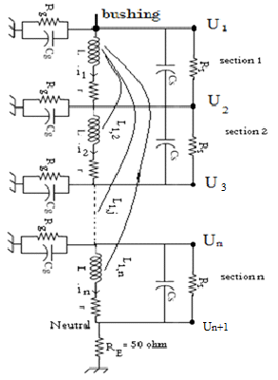
Fig 1
Elements shown in the equivalent circuit are as follows: L is inductance of each section of the winding, r is resistance losses of each section in the winding, Lij is mutual inductance between sectors i and j of the winding, Cs is capacitance between the windings of each section, Cg is capacitance between each section and ground, Rs is dissipation insulation resistance in each section, Rg shows insulation resistance losses between each section and the ground or adjacent winding, RE is impedance between the end of winding and the ground, If expresses the Current that is injected in to different points.
After calculating the parameters of the model [14], analyzing the circuit of the model in order to obtain voltage and current across the winding is explained. It is possible to calculate transfer function between any point of transformer up to bushing and neutral and calculate Sectional Winding Transfer Function (SWTF). [11]
Equivalent circuit shown in Fig. 1 is considered with N winding sections and N+1 points. Using KVL and KCL equations can be used to analyz winding model.

(1)

(2)

(3)
$$L={\left[\begin{matrix}L_{1} & L_{\text{12}} & \text{.}\text{.}\text{.}\text{.}\text{.}\text{.} & L_{1N} & 0 \\ L_{\text{21}} & L_{2} & \text{.}\text{.}\text{.}\text{.}\text{.}\text{.} & L_{2n} & 0 \\ \text{.} & \text{.} & \text{.} & \text{.} & \text{.} \\ L_{N1} & \text{.}\text{.}\text{.}\text{.}\text{.} & & L_{\text{NN}} & 0 \\ 0 & 0 & \text{.}\text{.}\text{.}\text{.}\text{.} & 0 & 0\end{matrix}\right]}_{(N+1)∗(N+1)}$$
(4)
Desired parameters are voltage and current in each point of Circuit and are shown below.
(5)
(6)

Using Kirchhoff's laws, the following equations can be obtained.
$\text{AU}=(R+\text{jwL})I$ (7)
$I_{f}−A^{T}=(G+\text{jwC})U$ (8)
Therefore, Circuit voltage and current of all sections of circuit are calculated. Since, voltages and currents are in relationship with frequency (such as impedance and admittance are a function of frequency), the voltages and currents can be calculated for a customized range of different frequencies. By having voltages and currents at different frequencies, it is possible to obtain a desired transfer function.

ENERGY ANALYSIS
Since the high frequency transformer winding is made up of a complex network of inductance and capacitors, as PD pulses approach from bushing to neutral. The high frequency signals have more energy ratio compared to low frequency signals in bushing and neutral, but energy ratio of bushing to neutral positions, have a linear relationship. This property of transformer is used to locate PD in transformer.
Signal energy is calculated by (9)
$E=\sum_{f1}^{f2}{{\left|x\left(f\right)\right|}^{2}}$ (9)

SIMULATION RESULT
The geometrical and insulating information of simulated transformer is shows in TABLE I [14]
TABLE I
TRANSFORMER DATA
30MVA | Transformer Power
63/20 Kv | Transformer ratio
2,2 | dielectric permittivity of oil
4 | dielectric permittivity of wire insulation
76 | Number of disks
6 | Number of turns per a disk
369mm | Inner radius of HV winding
429mm | External radius of HV winding
25mm | Distance between LV and HV
4.5mm | Distance between disks( oil channel)
0.4mm | Thickness of wire insulation
2.576m | Mean length of one turn
4*2.24mm | wire width
11.2mm | wire height
The Simulated transformer is a 63/20Kv 30 MVA power transformer. The high voltage winding used in this study has sixty seven continuous disk type sections, each having six turns.
The flowchart of simulation steps is shown in Fig 2

Fig 2 flowchart Simulation

The parameters of the winding is calculated by simulation. The transfer function of the sections is calculated using mentioned method. With injecting PD pulses (If) to each 10th disk, the result obtained on bushing and neutral are shown in Fig. 3 and Fig. 4, where Ui is the number of the points that PD pulse is injected.
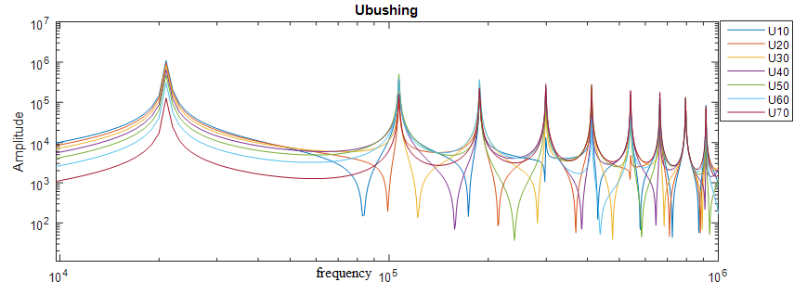
Fig 3 injecting I_{f} to different points and receive on bushing

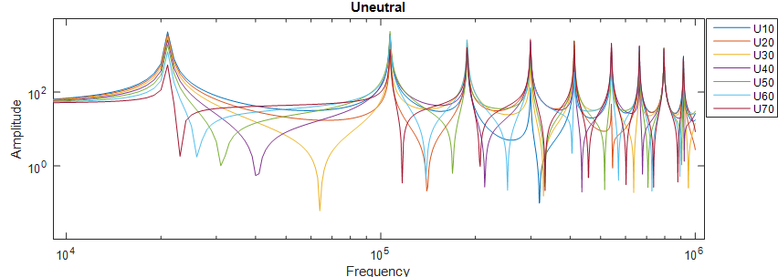
Fig 4 injecting If to different points and receive on neutral

After measuring output signals from bushing and neutral for mentioned points, two filters are utilized. One filter is a high-pass filter with Pass frequency between 100 kHz to 500 kHz and a low-pass filter with Pass frequency between 10 kHz to 100 kHz. With this operation signals are divided into two parts, high-frequency and low frequency. Next, (9) is used to calculate energy of the low-frequency and high-frequency signals. After calculating the ratio of the low frequency signal energy to high-frequency signal energy in different parts of winding for bushing and neutral, then the calculated results are plotted based on the considered points. Ratio of the low frequency signal energy into high-frequency signal energy in the bushing of mentioned transformer is shown in Fig 5. Fig 6 shows the ratio of the low frequency signal energy to high-frequency signal energy in the neutral. In Fig 7 the ratio of the low frequency signal energy to high-frequency signal energy in bushing to the ratio of the low frequency signal energy to high-frequency signal energy in neutral is shown. The dots on Figs are the points where PD pulse are injected.
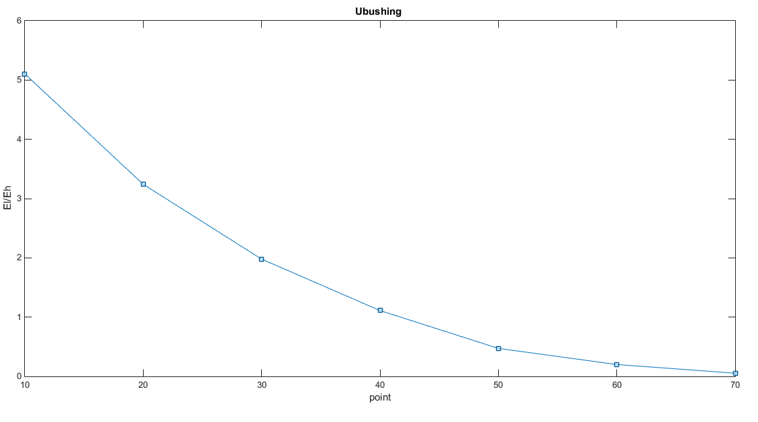
Fig 5 ratio of the low frequency signal energy into high-frequency signal energy in the bushing

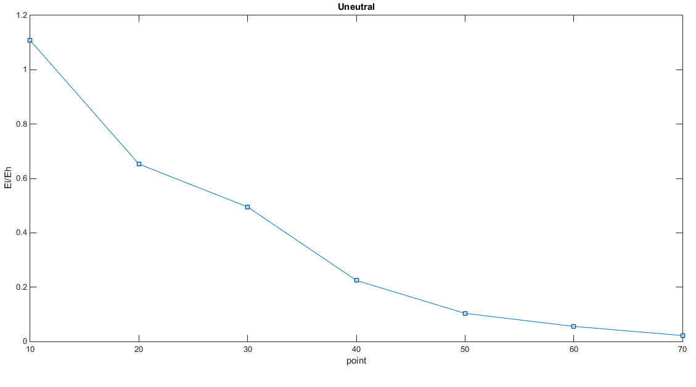
Fig 6 ratio of the low frequency signal energy into high-frequency signal energy in the neutral

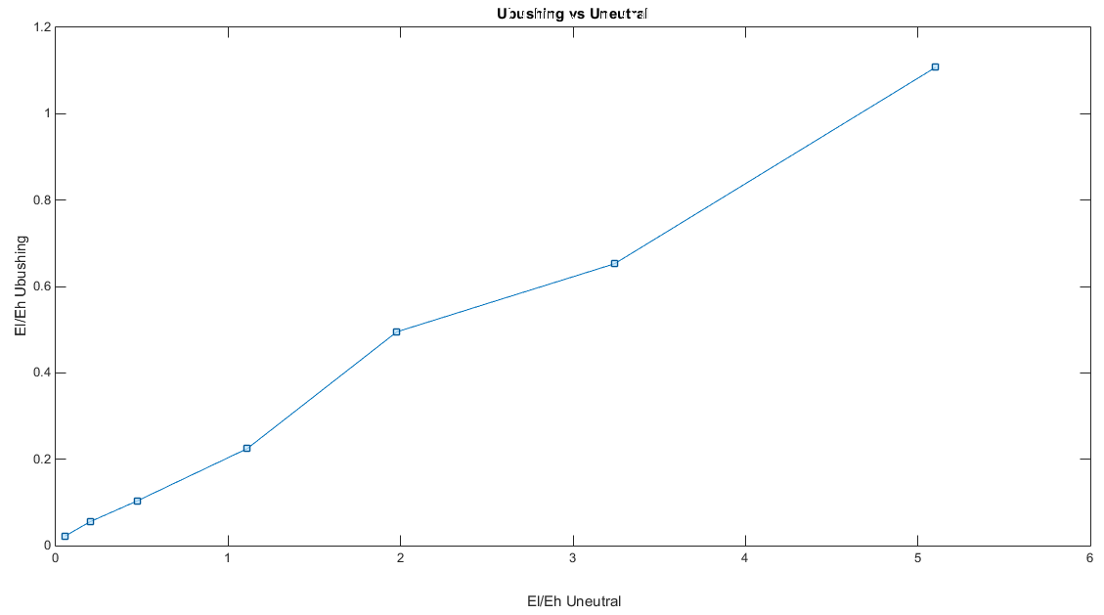
Fig 7 ratio of the low frequency signal energy into high-frequency signal energy in the bushing to the ratio of the low frequency signal energy into high-frequency signal energy in the neutral

As shown in Fig 7, the ratio of PD signal energy on bushing to neutral in different parts of the transformer winding is a linear function. In Fig. 7 form right to left, shows bushing to neutral of the transformer. Thus, using simulations can the energy ratio can be calculated and then the PD can be located.

RESULT CONCLUSION
In this paper, an analytical solution based on signal energy using bushing and neutral signals to locate PD pulses in winding of power transformer is presented.
This subject reason is that the ratio of energy signals received from bushing and neutral of the winding contain information about the locations of the PD pulses.
The proposed method verified by simulating a 63/20 Kv distribution transformer disk winding. The results show that PD locating using this method have a good ability to identify the location of the PD pulse in the transformer windings.

References

- Duval, M. “A review of faults detectable by gas-in-oil analysis in transformers”, Electrical Insulation Magazine, IEEE
- Coenen, S.; Tenbohlen, S, “Location of PD sources in power transformers by UHF and acoustic measurements”, Dielectrics and Electrical Insulation, IEEE Transactions on, 2012
- Markalous, S.; Tenbohlen, S.; Feser, K., “Detection and location of partial discharges in power transformers using acoustic and electromagnetic signals”, Dielectrics and Electrical Insulation, IEEE Transactions on, 2008
- Hooshmand, R.A.; Parastegari, M.; Yazdanpanah, M., “Simultaneous location of two partial discharge sources in power transformers based on acoustic emission using the modified binary partial swarm optimisation algorithm”, Science, Measurement & Technology, IET , 2013
- D.J. Wilcox, W.G. Hurley and M. Conlon, „Calculation of Self and Mutual Impedances between Sections of Transformer Windings”, IEE Proceedings, Part C,September 1989, Vol.136, No.5, pp. 308-314
- Vaessen PTM (1988) Transformer model for high frequencies.IEEE Trans Power Deliv 3(4):1761–1768
- Morched A, Marti L, Ottewangers J (1993) A high frequency transformer model for the EMTP. IEEE Trans Power Deliv 8(3):1615–1626
- Naderi, M.S.; Vakilian, M.; Blackburn, T.R.; Phung, B.T.; “A hybrid transformer model for determination of partial discharge location in transformer winding”, Dielectrics and Electrical Insulation, IEEE Transactions on, 2007I. S. Jacobs and C. P. Bean, “Fine particles, thin
- Okabe, S.; Ueta, G.; Wada, H., “Partial discharge signal propagation characteristics inside the winding of gas-filled power transformer - study using the equivalent circuit of the winding model”, Dielectrics and Electrical Insulation, IEEE Transactions on 2011
- Jeyabalan, V.; Usa, S., “Frequency domain correlation technique for PD location in transformer winding”, Dielectrics and Electrical Insulation, IEEE Transactions on, 2009.
- Asghar Akbari , Peter Werle, Hossein Borsi, Ernst Gockenbach, “Transfer Function-Based Partial Discharge Localization in Power Transformers: A Feasibility Study”, IEEE Dielectrics and Electrical Insulation Society, Electrical Insulation Magazine, 2002
- Jeyabalan, V.; Usa, S., “Statistical Techniques for Partial-Discharge Location in Transformer Windings”, Power Delivery, IEEE Transactions on, 2011
- Rahimpour, E., Christian, J., Feser, K., Mohseni, H.: ‘Transfer function method to diagnose axial displacement and radial deformation of transformer windings’, IEEE Trans. Power Deliv., 2003, 18, (2), pp. 493–505.
- Firoozi, H.; Akbari, A.; Ghiasi, M. I. “An Experimental Effort to Understand how Behaves Winding High Frequency Response in Power Transformers”, International Review of Electrical Engineering;Mar/Apr2012, Vol. 7 Issue 2, p3916

