A low profile band pass DGS filter for harmonic suppression

Ali Barzgar
student
Electrical engineering
Iran university of technology
Tehran, Iran, 1665876754
Email: a_barzgar@elec.iust.ir

Homayoon Oraizi
Lecturer
Electrical engineering
Iran university of technology
Tehran, Iran, 1665876754
Email: h_oraizi@iust.ac.ir

3rd Author
Position
Department
University
City, Country, Zip code
Email: email address

Abstract—this paper introduces a novel low profile microstrip bandpass DGS filter for blocking undesired resonant frequencies when higher modes are excited. The proposed filter is combined with a microstrip inset-fed rectangular patch antenna. The higher modes are excited for implementation of DGS band pass filter harmonic rejection. This filtenna structure performs as the combination of a low profile BPF and an antenna.The bandwidth of proposed filter varies from 150 MHz to 4.5 GHz according to whether a single mode or several modes are selected which could be adjusted by changing the series capacitance in the ground plate. This DGS filter uses FR4 epoxy as substrate (with dielectric constant=4.3, tangent loss=0.025, thickness of 63 mil). The BPF reaches to 90% efficiency in insertion loss and 20dB/GHz attenuation rate for the transition band region. In addition, the proposed BPF has a compact size of 10mm*14mm for notch filter and 10mm*10mm for ultra-wide-band (UWB) antenna with input impedance of 50.
Index Terms — Microstrip antenna, Band-pass filter, Defected ground surface (DGS), Ultra wide band (UWB), Filtenna (filter-antenna)
Introduction
Recently interest in the wide-band-width performance of electronic devices and communication systems has increased. The Wide-band-width characteristics makes it possible for several transmitters in a communication system to share the same antenna which decreases the whole size of the electronic device and also the cost of system. The UWB system is used for short distances and high bandwidth applications, such as personal area network (PAN), radar and imaging systems [1].These systems provide high data rate transmission with low transmitting power [8]. The DGS in the microstrip line uses slots or defects on the ground plane and provides a band-rejection characteristics due to the resonance property [6].
Several techniques have been reported to achieve an ultra-wide-band filter, such as the use of coplanar wave guide [2], [3], hybrid microstrip structures [5] and CPW structures [7]. These filters can be optimized to reach the best attenuation rate with good insertion loss, but all of them suffer from large sizes affecting the radiation pattern as well as reflection coefficient of antenna. DGS filters having low profile and also high attenuation in the stop-band region could be a good alternative to these conventional filters.
Microstrip antennas have several propagation modes which are normally far from each other. At high frequencies without reducing the antenna size for obtaining high gain, it is proposed to excite higher modes [11]. The excitation of higher modes yields multiple bands at the lower frequencies, but good band pass filters with high stop-band attenuation should be utilized in the feeding part of microstrip antenna to select the desired frequency.
In this paper a combination of low profile DGS filter and a microstrip patch antenna is proposed as a filtenna, which doesn’t affect its radiation pattern and reflection coefficient.

proposed BPF filter

BPF Type
The band-pass filter used in this paper is a cascade connection of two H-shape defected surface on the ground plate as well as defects on the microstrip structure, commonly called defected microstrip structure (DMS). The DMS consists of slots on the patch, which may be modeled series and parallel capacitances. The geometry of the proposed UWB BPF using DGS and DMS is shown in Fig.1. Figs. 1(a) and (b) show its top and bottom views.

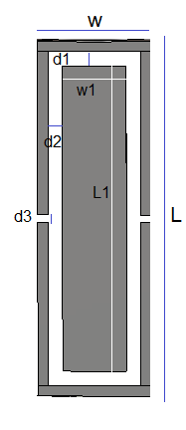
(a)
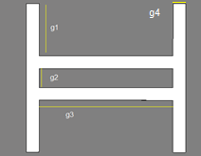

(b)

Fig. 1. Geometry of the proposed UWB BPF

DGS and DMS Equivalent circuits
The equivalent circuits of slots on a microstrip patch or ground plate have been studied in [3]. The electrical performance of vertical or horizontal slots can be modeled by an LC resonant circuit which can be extracted from computer simulations [3],[10]. The inductance and capacitance values mat be computed by the following formulas:

(1)

(2)
Where fc is the cut-off frequency, fo is the resonant frequency and zo is the characteristic impedance. Fig.2 shows the equivalent circuit of proposed DGS and DMS.

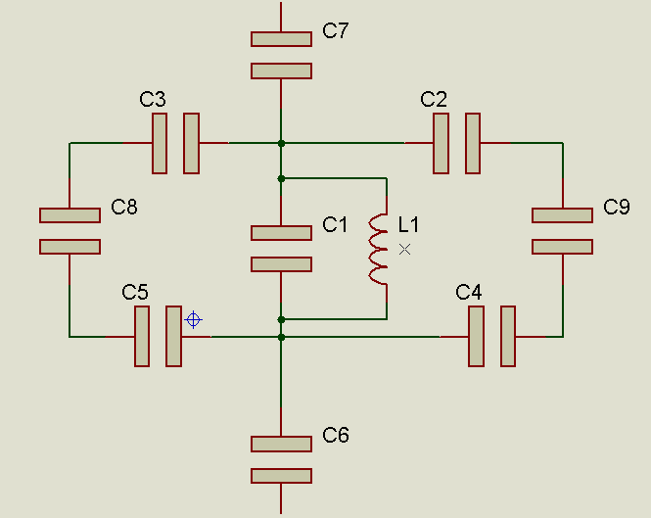
(a)

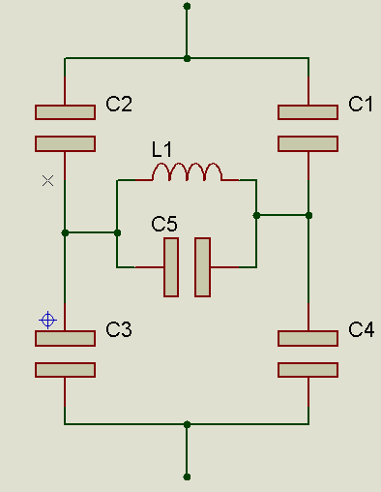
(b)
Fig. 2. Equivalent circuit of (a) DMS (b) DGS

The slots on DGS and DMS result in electrically long paths for the surface current, so the ohmic losses may not be negligible for the precise filter synthesis [13]. These losses could be modeled with a resistor in parallel with the equivalent LC circuit. The equivalent resistances could be extracted directly from simulation results or scattering parameters [4], [9].
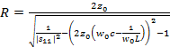 (3)

simulation result
Fig.1 is the configuration of a proposed DGS and DMS connected to a 50 feed line. The resonant frequency of reflection coefficient is inversely proportional to the equivalent capacitance. The variation of g3 in Fig.1 (b) results in the variation of C₅ in Fig. 2(b). Since C₅ is directly proportional to the equivalent capacitance, increasing g₃ results in decreasing the resonant frequency of reflection coefficient. Fig. 3 shows the reflection coefficient in dB for various values of g_{3,} from g₃=4 mm to g₃=6.8 mm.
The simulation results show that when the value of g₃ decreases, the second pole of BPF starts to resonance. The UWB performance could be achieved when these two poles are near each other and resonate efficiently.

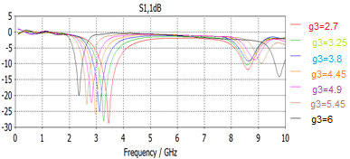

Fig.3 .Simulated transfer characteristics of the DGS

Fig. 4 shows the reflection and insertion coefficients of the UWB filter with 4.5 GHz bandwidth for insertion loss better than 5 dB.

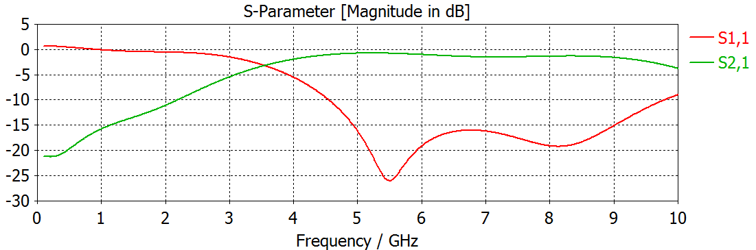

Fig. 4. Transfer characteristic of UWB filter

Table. 1 shows the Q factor and bandwidth of BPF for various configurations.

g₃ | Resonant frequency(GHz) | Bandwidth 3dB  (MHz) | Q factor
2.7 | 3.55 | 440 | 8.05
4.45 | 2.9 | 331 | 8.6
6 | 2.45 | 272 | 9.2

Table. 1. The CALCULATED Q FACTORS AND BANDWIDTH VARIATION by SLOT LENGTH (g₃) (g₁=4mm g₂=2mm g₄=0.3 mm)

validation of proposed filter
The microstrip antennas inherently have infinite propagation modes, but far from each other. For the communication system designs requiring high gain antennas without utilizing large antenna sizes, higher modes of microstrip antennas are utilized. The excitation of antenna higher modes would result in multiple bands in the reflection coefficient at lower frequencies. A low profile and highly sharp narrow-band filter is desired for the selection of single mode and a UWB filter is required for the selection of several modes. The proposed DGS filter has this feature, which could be utilized in the antenna feed system. The result is a filtenna, which resonates at desired frequency.
For the proof of the proposed concept, a microstrip patch antenna operating at 2.45 GHz is excited to operate at higher modes by a rectangular slot. Figs. 5(a) and (b) show the microstrip antenna without the filter and with the combination of filter and antenna, respectively. As shown in Fig. 6, the second mode resonates at 3.9 GHz. The DGS filter is designed to operate at 3.9 GHz. Fig. 7 shows the simulation results and measured data of reflection coefficient of DGS filter and filtenna.

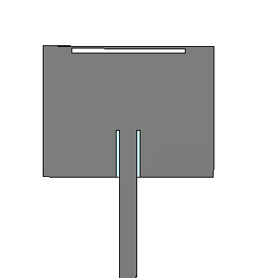

(a)

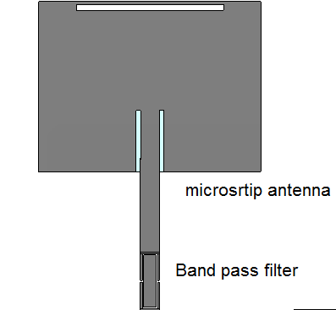

(b)
Fig. 5. Rectangular patch antenna. (a) Without filter (b) with filter

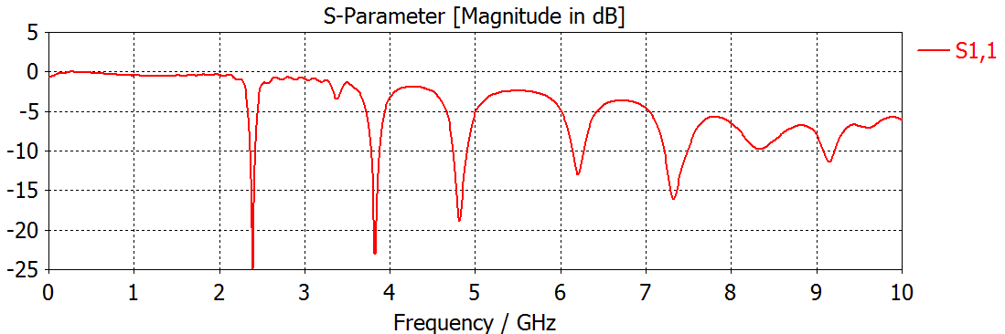

Fig. 6 Reflection coefficient of patch antenna

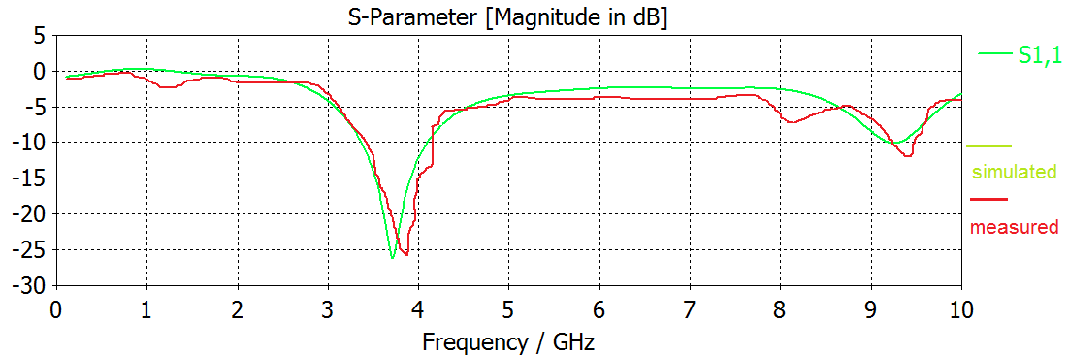

(a)
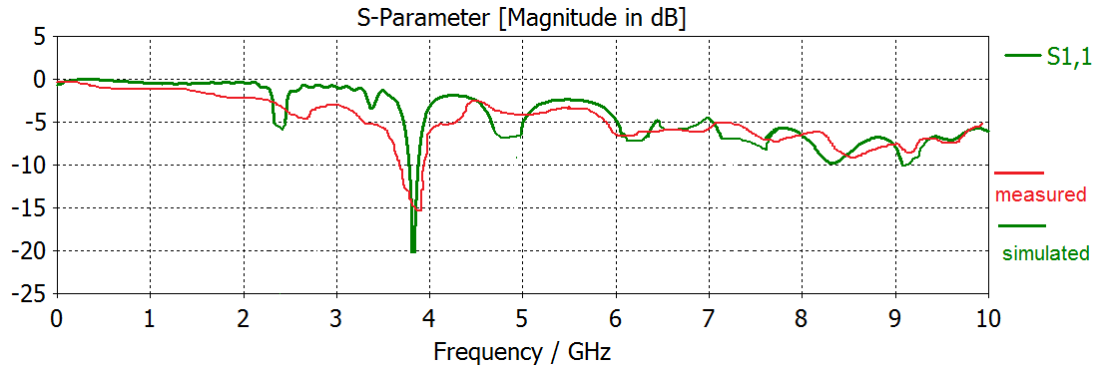
(b)

Fig. 7. Reflection coefficients. (a) DGS filter; (b) filtenna.

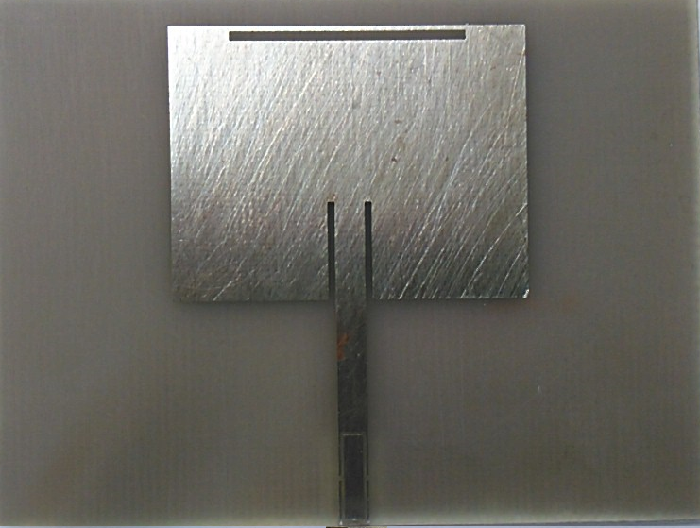



Fig. 8.Photographs of fabricated filtenna.

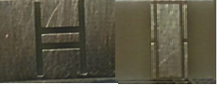

Fig. 9.Photographs of fabricated BPF

conclusion
In this paper a novel low profile DGS band-pass filter is proposed for the selection of a desired frequency and also a UWB filter is proposed for the selection of a set of frequencies. The connection of the low profile filters to the microstrip antenna prevents the distortion of the antenna radiation pattern. For the effective reduction of reflection coefficients at the higher antenna modes of the proposed combined DGS filter and microstrip antenna, prototype antennas are fabricated and measured. It is shown that the total selectivity of the proposed system is high at the desired design frequency without causing any distortion of their radiation properties.

References

- G. Eason, B. Noble, and I. N. Sneddon, “On certain integrals of Lipschitz-Hankel type involving products of Bessel functions,” Phil. Trans. Roy. Soc. London, vol. A247, pp. 529–551, April 1955. (references)
- J. Clerk Maxwell, A Treatise on Electricity and Magnetism, 3rd ed., vol. 2. Oxford: Clarendon, 1892, pp.68–73.
- I. S. Jacobs and C. P. Bean, “Fine particles, thin films and exchange anisotropy,” in Magnetism, vol. III, G. T. Rado and H. Suhl, Eds. New York: Academic, 1963, pp. 271–350.
- K. Elissa, “Title of paper if known,” unpublished.
- R. Li and L. Zhu, “Ultra-Wideband (UWB) Bandpass Filters With Hybrid Microstrip/Slotline Structures,” IEEE Microw. Wireless Compon. Lett., vol. 17, no. 11, pp. 778–780, 2007.
- D.-J. Woo , T.-K. Lee , J.-W. Lee , C.-S. Pyo and W.-K. Choi "Novel U-slot and V-slot DGSs for bandstop filter with improved Q factor", IEEE Trans. Microw. Theory Tech., vol. 54, pp.2840 -2847 2006.
- K. Li, D. Kurita, and T. Matsui, “An Ultra-Wideband Bandpass Filter Using Broadside-Coupled Microstrip-Coplanar Waveguide Structure,” in IEEE Int. Microwave Symp., pp. 675–678, June 2005.
- Aiello, G. R. and G. D. Rogerson,ultra-wideband wireless systems IEEE Microw. Mag.,Vol. 4, No. 2, 36-47, 2003.
- C. S. Kim , J. S. Lim , K. Y. Kang , J. I. Park , G. Y. Kim and D. Ahn "The equivalent circuit modeling of defected ground structure with spiral shape", IEEE MTT-S Int. Microw. Symp. Dig., vol. 3, pp.2125 -2128 2002.
- J.-K. Xiao1 and W.-J. Zhu2, " New Defected Microstrip Structure Bandstop Filter", Progress In Electromagnetics Research Symposium Proceedings, Suzhou, China, Sept. 12_16, 2011.
- Mohammad AA, Subhi H, Ahmad AK, Juma SM. Cavity model analysis of rect-angular microstrip antenna operating in TM03mode. In: Information andCommunication Technologies, vol. 2218–2223. 2006.

