***System Level Estimation***

***of PCB Electromagnetic Radiated Emission***

Milad Mehri

Advanced VLSI Lab, School of ECE, College of Engineering,

University of Tehran, Tehran, Iran

[mehri@ut.ac.ir](mailto:mehri@ut.ac.ir)

Nasser Masoumi

Advanced VLSI Lab, Faculty of ECE, College of Engineering,

University of Tehran, Tehran, Iran,

nmasoumi@ut.ac.ir

*Abstract*—in this paper, a statistical approach is proposed to estimate the radiated emission from an electronic system implemented on a printed circuit board (PCB). The radiated emission of the board is modeled by infinitesimal dipoles. The current of the modeling dipoles are estimated based on a statistical method using the power consumption of the board. The power distribution for each dipole is considered as Maxwell-Boltzmann function. The method is verified by applied on a simple PCB and CST full wave simulations are done to compare the analytic method. An average error of 10% between simulation result and statistic method shows a moderate accuracy. The computational cost (memory and speed) of simulation is much better than full wave simulation for modern PCBs. Proposed method is suitable for a fast check to estimate the radiation level for complex PCB structures.

*Keywords***: Electromagnetic Compatibility (EMC), Electromagnetic Interference (EMI), Radiated Susceptibility, PCB Trace Distribution**

# Introduction

Modern high dense populated printed circuit board (PCB) with numerous constituents and circuit elements convinces the electronic system designer to use statistical method for trace routing and component placement. The statistical nature and complex wiring of dense state-of-the-art board as well as the combination of mixed analog and digital circuits make it impossible to estimate the antenna effect of multilayer adjacent traces. Undoubtedly, for any system with large numbers of building parts interacting with each other, talking with just a single component is unreasonable. The complexity of handling such large numbers of wires and interconnects in PCBs are obvious. A statistical method is the only answer to this question. The radiated emission from a PCB fully depends to the orientation of the traces emitting the electromagnetic energy.

The radiated emission from a PCB is modeled by infinitesimal dipoles, [1] and [2]. The modeling dipoles parameters are obtained based on near field measurement. A rigorous measurement is needed to obtain the far field emission. Also, there is no analytical derivation for the estimation of the board radiated emission. Yu in [2] improved dipole moment model for estimation of IC radiated emission, but it entails complex calculations for congested wiring on modern PCBs.

In this work it is tried to propose a novel approach to estimate the radiated emission from a PCB based on statistical method. The estimation of modeling dipoles parameters are based on the system level specification of the PCB. Prior to any PCB implementation, system designer can estimate the radiated emission level of the PCB and decide whether the system can proceed in development chain or not.

The paper is organized as follows. After a brief literature review, analytical derivations are obtained in Section II. Simulations and comparisons are done in Section III. Finally, the paper ends with conclusion and references.

# Radiated Emission of PCBs

Radiated emission from a PCB can be modeled by some infinitesimal electric dipoles as shown in Fig. 1. The main problem of the previous works is the method for estimation of dipole momentum. All the researches are based on experimental method; First, they should measure the near filed of the PCB radiation and then convert the results to far field emission using near field to far field transformation. This work is somehow tedious and time consuming. Also, the radiated emission strongly depends to the operating condition of the system implemented on the PCB. Any variations of the signaling on the PCB trace during the operation of the system in time will change the radiation and the result. Also, it is very complicated and time consuming the process of simulation for modern PCBs with huge number of components and different digital and analog signals.

It should be very useful to have an estimation of radiated emission of a PCB prior to any real fabrications. It will hasten the process of system development and EMC standard collection.



Fig. 1 Estimation of PCB radiated emission using equivalent dipoles

The electric field at distance $r$ from the source end of an electrically short trace, as shown in Fig. 2, can be estimated by (1), [3],

(1)

$$\vec{E}≈\frac{2πμ_{0}f^{2}}{c_{0}}\left(\frac{e^{-jk_{0}r}}{r}\right)ha\frac{V_{s}}{Z_{s}+Z_{L}}\left\{\left(\cos{φ}-\frac{Z_{L}}{Z_{c}}\frac{\sqrt{ε_{r,eff}}}{ε_{r}}\sin{θ}\right)\hat{θ}-\cos{θ}\sin{φ}\hat{φ}\right\}$$

where $c_{0}$ is the speed of light in free space, $ε_{r}$ is the relative permittivity of the board substrate dielectric, and $f$ is the frequency of voltage source $V_{s}$. Also, $Z_{s}$ and $Z_{L}$, are the impedance of source and load and $Z_{c}$ is the characteristic impedance of the trace. The electric far field of the trace has two sections; the electric dipole share in $\hat{φ}$ direction and magnetic loop share in $\hat{θ}$ direction.

The PCB radiated emission in a desired point in far field of the board can be estimated by gathering all the trace share in the point. Based on [4], two coordination systems are defined. First one is tied to the board named primary coordination system with variables $(R,Θ,Φ)$ and the second one is tied to each trace named secondary coordination system with variables $(r, θ,φ)$. Due to different oriention of each trace it is needed to transform the desired point $(R,Θ,Φ)$ variable in primary cordination system to each trace variable $(r, θ,φ)$ in secondary cordination system. A simple transformation between these two coordination system is explained in [4].

$$Z$$

$$X$$

$$Y$$

$$y$$

$$y$$

$$r$$

$$h$$

$$\overline{E}$$

$$w$$

$$a$$

$$z$$

$$x$$

$$φ$$

$$θ$$

Fig. 2 Electric field of a microstrip.

For estimation of total radiated emission from a PCB, all traces effect should be gathered in desired point of view. For estimation of electric far field of each trace in the land, two parameters should be known, including

1. The current of modeling dipole
2. The orientation of the trace regarding the desired point

Successive sections explain how to estimate all the needed parameters. In Section I.A the current of the modeling dipole is obtained using a statistical approach based on the power consumption of the system implemented on the PCB. In Section II.B the orientation of the trace regarding the desired point is obtained based on definition of two coordination systems.

## Modeling Dipole - Current Estimation

For estimation of the modeling dipole current, first we slice the PCB board like a chess board, Fig. 3. Each slice on the PCB is named *land*. The parameter $a$ can be calculated from (2). This selection guarantees the assumption of being lumped element (infinitesimal) of the land trace in comparison with both the wavelength of incident external electromagnetic wave ($λ_{min⁡_ext}$) and the wavelength of operating signal on the trace ($λ_{min⁡_s}$).

(2)

$$a=min\left(\frac{λ_{min⁡_ext}}{10},\frac{λ_{min⁡_s}}{10},w\right)$$

For example, if $λ_{min⁡_ext}=6.9cm (for f_{max⁡_ext}=2.45GHz @ FR4)$, $λ_{min⁡_s}=1.7cm (for f_{max⁡_s}=10GHz @ FR4)$, and $w=1.88mm (for Z_{c}=50Ω @ FR4)$, then,

$$a=min\left(\frac{6.9cm}{10},\frac{1.7cm}{10},1.88mm\right)=1.7mm$$

There are some distribution functions for the energy of each particle in a system with numerous particles in equilibrium condition in an absolute temperature *T*. Boltzmann-Maxwell, Fermi-Dirac, and Bose-Einstein distributions are three main statistics in thermodynamics which we want to use for distribution of power (energy) in each *land* of the PCB.

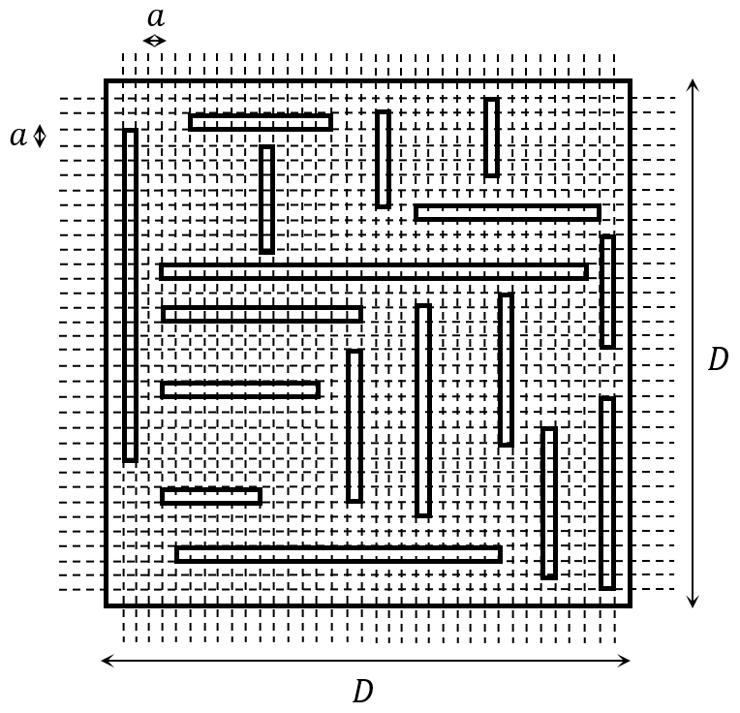

Fig. 3 PCB with grid of lands

Each land exchanges energy with its neighbor lands in steady state. If the number of lands are numerous enough, we can use mentioned distribution functions for power of the lands. The occupation probability of energy $ε$ for each particle can be estimated from (3),

(3)

$$P_{Maxwell-Boltzmann}\left(ε\right)=\frac{1}{kT}e^{-\frac{ε}{kT}}$$

where $k=1.3806×{10}^{-23} [m^{2}.kg.s^{-2}.K^{-1}]$ is Boltzmann constant, and *T* is the absolute temperature in Kelvin degrees. Similarly, for power distribution of each land, one can write,

(4)

$$P_{Maxwell-Boltzmann}\left(p_{sq}\right)=\frac{1}{p_{avg}}e^{-\frac{p_{sq}}{p_{avg}}}$$

where $p_{avg}$ is the average power of each land. For the average power in each land $p_{avg}$, one can suppose a uniform distribution for the power, we will have

$$p_{avg}\left(f\right)=\frac{P\left(f\right)-P_{blocks}\left(f\right)}{D^{2}}×a^{2}$$

where $P\left(f\right)$ is the total complex power consumption of the board and $P_{blocks}\left(f\right)$ is the total complex power consumption of the building parts of the system implemented on the PCB. Based on [5], the hypothetical voltage and current can be estimated from (6).

(5)

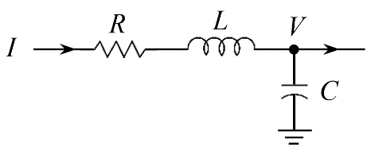

Fig. 4 Circuit model for a land

$p_{sq}\left(f\right)=\frac{1}{2}VI^{*}=2jω\left(\frac{1}{4}LII^{*}-\frac{1}{4}\frac{II^{*}}{ω^{2}C}\right)+\frac{1}{2}RII^{*}=2jω\left(W_{m}-W_{e}\right)+P_{σ}$

(6)

As the ohmic resistance of the traces are very small, one can ignore the real part of the (6). As explained in [4], the final result for hypothetical operating voltage can be estimated from (7),

$V_{operating}\left(f\right)=\sqrt{\frac{Im\left\{p_{sq}\left(f\right)\right\}}{πf\left(C+\frac{L}{Z_{c}^{2}}\right)}}$

(7)

Since $p_{sq}$ is a random variable, the hypothetical voltage and current for each land will be random variables and their probability distribution function (pdf) are related to $p_{sq}$ pdf. Based on [6], if $y$ is a function of $x$ and the pdf of $x$ is $f_{X}\left(x\right)$, the pdf of $y$, $f_{Y}\left(y\right)$ can be calculated as,

(8)

$$y=g\left(x\right) ⟹ f_{Y}\left(y\right)=f_{X}\left(g^{-1}\left(y\right)\right)\left|\frac{d}{dy}g^{-1}\left(y\right)\right|$$

Therefore, for the average value we have,

(9)

$$V_{operating-AVG}=\int{vf_{V}\left(v\right)dv}=\frac{1}{p_{avg}}\int_{0}^{∞}{\left\{\sqrt{\frac{Im\left\{p_{sq}\right\}}{πf\left(C+\frac{L}{Z_{c}^{2}}\right)}}e^{-\frac{p_{sq}}{p_{avg}}}\right\}dp_{sq}}$$

For estimation of electric far field of each trace, the phase of current is important as much as its amplitude. The phase of the current for each trace is a random variable. In this research, this random variable has considered to have a uniform distribution as (10)

$pdf:f_{δ}\left(δ\right)=\left\{\begin{matrix}\frac{1}{π} & 0≤δ≤π \\ 0 & o.w.\end{matrix}\right.$

(10)

## Modeling Dipole – Orientation

The total PCB radiated emission in a desired point in far field of the board can be estimated by gathering all the trace share in the point.

${\vec{E}}_{i}\left(θ,φ\right)=M\left(k_{1}\left(θ,φ\right)\hat{θ}+k_{2}(θ,φ)\hat{φ}\right)$

(11)

where,

$k_{1}\left(θ,φ\right)=\left(\frac{e^{-jk_{0}r}}{r}\right)\left(\cos{φ}-\frac{Z_{L}}{Z_{c}}\frac{\sqrt{ε_{r,eff}}}{ε_{r}}\sin{θ}\right)$

(12)

$k_{2}\left(θ,φ\right)=\left(\frac{e^{-jk_{0}r}}{r}\right)\cos{θ}\sin{φ}$

(13)

$M=\frac{2πμ_{0}haf^{2}}{c_{0}\left(Z_{s}+Z_{L}\right)}V_{si}e^{iδ_{i}}$

(14)

To be able to gather the effect of all trace on the board in a desired point in the primary coordination system variables $(R,Θ,Φ)$, the $k_{1}\left(θ,φ\right)\hat{θ}$ and $k_{2}\left(θ,φ\right)\hat{φ}$ should be transferred to the Cartesian variable in secondary coordination system; different electric vectors can not be added to each other in spherical coordination system.

$\left[\begin{matrix}r \\ θ \\ φ\end{matrix}\right]=\left[\begin{matrix}\sqrt{x^{2}+y^{2}+z^{2}} \\ \tan^{-1}\left(\frac{\sqrt{x^{2}+y^{2}}}{z}\right) \\ \tan^{-1}\left(\frac{y}{x}\right)\end{matrix}\right]$

(15)

$\left[\begin{matrix}\hat{r} \\ \hat{θ} \\ \hat{φ}\end{matrix}\right]=\left[\begin{matrix}\sin{θ}\cos{φ} & \sin{θ}\sin{φ} & \cos{θ} \\ \cos{θ}\cos{φ} & \cos{θ}\sin{φ} & -\sin{θ} \\ -\sin{φ} & \cos{φ} & 0\end{matrix}\right]\left[\begin{matrix}\hat{x} \\ \hat{y} \\ \hat{z}\end{matrix}\right]$

(16)

$k_{1}\left(θ,φ\right)\hat{θ}+k_{2}\left(θ,φ\right)\hat{φ}=k_{x}\left(x,y,z\right)\hat{x}+k_{y}\left(x,y,z\right)\hat{y}+k_{z}\left(z,y,z\right)\hat{z}$

(17)

For gathering the effect of all trace emission, a transformation should be done between two coordination systems variables using (18)

$\left[\begin{matrix}x \\ y \\ z\end{matrix}\right]=\left[\begin{matrix}X \\ Y \\ Z\end{matrix}\right]-\left[\begin{matrix}X_{0} \\ Y_{0} \\ 0\end{matrix}\right]$

(18)

As $V_{si}$ and $δ_{i}$ are independent random variables, ${\vec{E}}_{i}$ is random variable too. The average of $M_{i}$ can be estimated from (20).

$M_{i-AVG}=AVERAGE\left(\frac{2πμ_{0}haf^{2}}{c_{0}\left(Z_{s}+Z_{L}\right)}V_{si}e^{iδ_{i}}\right)=\frac{2πμ_{0}haf^{2}}{c_{0}\left(Z_{s}+Z_{L}\right)}AVERAGE\left(V_{si}\right)\int_{δ_{i}=0}^{δ_{i}=π}{\frac{1}{π}e^{iδ_{i}}dδ_{i}}$

(19)

$M_{i-AVG}=\frac{4iμ_{0}haf^{2}}{c_{0}\left(Z_{s}+Z_{L}\right)}V_{operating-AVG}$

(20)

Therefore, the total average radiated emission from the PCB can be estimated from (21).

(21)

$${\vec{E}}_{AVG}(X,Y,Z)=M_{i-AVG}\left(\hat{x}\sum_{i=1}^{N^{2}}{k_{xi}\left(X-X_{0},Y-Y_{0},Z\right)}+\hat{y}\sum_{i=1}^{N^{2}}{k_{yi}\left(X-X_{0},Y-Y_{0},Z\right)}+\hat{z}\sum_{i=1}^{N^{2}}{k_{zi}\left(X-X_{0},Y-Y_{0},Z\right)}\right)$$

Finally, the total effect of all traces should be transferred to spherical variables in primary coordination system using

$\left[\begin{matrix}X \\ Y \\ Z\end{matrix}\right]=R\left[\begin{matrix}\sin{Θ}\cos{Φ} \\ \sin{Θ}\sin{Φ} \\ \cos{Θ}\end{matrix}\right]$

(22)

$\left[\begin{matrix}\hat{x} \\ \hat{y} \\ \hat{z}\end{matrix}\right]=\left[\begin{matrix}\sin{Θ}\cos{Φ} & \cos{Θ}\cos{Φ} & -\sin{Φ} \\ \sin{Θ}\sin{Φ} & \cos{Θ}\sin{Φ} & \cos{Φ} \\ \cos{Θ} & -\sin{Θ} & 0\end{matrix}\right]\left[\begin{matrix}\hat{R} \\ \hat{Θ} \\ \hat{Φ}\end{matrix}\right]$

(23)

${\vec{E}}_{AVG}\left(R,Θ,Φ\right)=M_{i-AVG}\left(k_{R}\left(R,Θ,Φ\right)\hat{R}+k_{Θ}\left(R,Θ,Φ\right)\hat{Θ}+k_{Φ}\left(R,Θ,Φ\right)\hat{Φ}\right)$

(24)

Now, all the parameters are known and total radiated emission from the PCB can be estimated in any desired far field point $\left(R,Θ,Φ\right)$.

# Simulations and Verification

The proposed method is applied to a PCB shown in Fig. 5. The board contains twenty traces with different lengths. In most of the time, for simplicity of routing in real PCBs, three are only three orientation angles, including $φ=0^{o}$, $φ={45}^{o}$, and $φ={90}^{o}$.

Table 1 Physical parameters of PCB for Radiated emission

|  |  |  |
| --- | --- | --- |
| Load Impedance, $Z_{L}$ | | 50 Ω |
| Source Impedance, $Z_{s}$ | | 0 Ω |
| Voltage Source, $V_{s}cos(2πft)$ | Frequency, $f$ | 200 MHz |
| Amplitude, $V_{s}$ | 1 V |

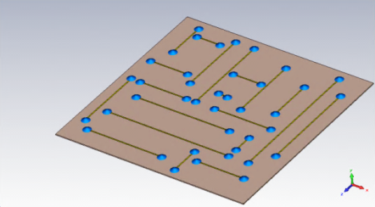

**X**

**Y**

**Z**

Fig. 5 The test board in CST Studio Suit

The simulation results are compared with the proposed statistical method in Table 2. The relative error shows a moderate and acceptable accuracy.

Table 2Maximum Electric Far Field

due to Vertical and Horizontal Traces at r=10m

|  |  |  |  |
| --- | --- | --- | --- |
| Voltage Source Excitation | Statistical Approach | CST full wave Simulations | Relative Error |
| Horizontal Traces | 71.2 V/m | 69.21 V/m | 2.9 % |
| Vertical Traces | 70.4 V/m | 68.73 V/m | 2.4 % |
| Horizontal and Vertical (Simultaneously) | 73.81 V/m | 67.8 V/m | 8.1 % |

# Summary and Conclusions

In this paper, a statistical approach is proposed to estimate the radiated emission from an electronic system implemented on a PCB. The radiated emission of the board is modeled by infinitesimal electric dipoles. The current of the modeling dipoles are estimated based on a statistical method using the power consumption of the board. The power distribution for each dipole is considered as Maxwell-Boltzmann function. The method is verified by applied on a simple PCB and CST full wave simulations are done to compare the analytic method. An average error of 10% between simulation result and statistic method shows a moderate accuracy. The computational cost (memory and speed) of simulation is much better than full wave simulation. Proposed method is suitable for a fast check to estimate the radiation level for complex PCB structures.

# References

[1] X. Tong, D. W. P. Thomas, A. Nothofer, P. Sewell, and C. Christopoulos, “Modeling Electromagnetic Emissions From Printed Circuit Boards in Closed Environments Using Equivalent Dipoles,” *IEEE Transactions on Electromagnetic Compatibility*, vol. 52, no. 2, May 2010.

[2] Z. Yu*,* J. A. Mix, S. Sajuyigbe, K. P. Slattery, and J. Fan, “An Improved Dipole-Moment Model Based on Near-Field Scanning for Characterizing Near-Field Coupling and Far-Field Radiation From an IC,” *IEEE Transactions on Electromagnetic Compatibility*, vol. 55, no. 1, Feb. 2013.

[3] M. Leone, “Closed-Form Expressions for the Electromagnetic Radiation of Microstrip Signal Traces,” *IEEE Transactions on Electromagnetic Compatibility*, vol. 49, no. 2, May 2007.

[4] M. Mehri, N. Masoumi, and J. Rashed-Mohassel, “Trace Orientation Function for Statistical Prediction of PCB Radiated Susceptibility and Emission,” *IEEE Transactions on Electromagnetic Compatibility,* vol.57 no.52015.

[5] R. E. Collin, *Foundations for Microwave Engineering*, 2nd ed., Willy, 2001.

[6] S. Ross, *A First Course in Probability,* 9th ed., Pearson, 2014.